SHEGUARD: AI POWERED WOMEN'S SAFETY PLATFORM

A project report submitted in partial fulfilment of the requirements for the award of the degree of
BACHELOR OF TECHNOLOGY
in
COMPUTER SCIENCE AND ENGINEERING (DATA SCIENCE)
Submitted by
CH.AARTHI | 23K91A6741
D.PRANATHI | 23K91A6748
BALA VIGNESH | 23K91A6717
A.VISHAL | 23K91A6704
Batch A7 (CSE - Data Science, Section A)
Under the esteemed guidance of
[GUIDE NAME]
[DESIGNATION]
[COLLEGE LOGO]
DEPARTMENT OF COMPUTER SCIENCE AND ENGINEERING (DATA SCIENCE)
[COLLEGE NAME]
[COLLEGE ADDRESS / AFFILIATING UNIVERSITY]
[ACADEMIC YEAR]

[COLLEGE LOGO]
[COLLEGE NAME]
DEPARTMENT OF COMPUTER SCIENCE AND ENGINEERING (DATA SCIENCE)
CERTIFICATE
This is to certify that the project report entitled "SHEGUARD: AI Powered Women's Safety Platform" is a bonafide record of the work carried out by CH.AARTHI (23K91A6741), D.PRANATHI (23K91A6748), BALA VIGNESH (23K91A6717), A.VISHAL (23K91A6704), in partial fulfilment of the requirements for the award of the degree of Bachelor of Technology in Computer Science and Engineering (Data Science), during the academic year [ACADEMIC YEAR], under my supervision.

Project Guide  [GUIDE NAME]  [DESIGNATION] | Head of the Department  [HOD NAME]  Department of Computer Science and Engineering (Data Science) | External Examiner  [NAME AND SIGNATURE]
DECLARATION
We hereby declare that the project report entitled "SHEGUARD: AI Powered Women's Safety Platform", submitted to the Department of Computer Science and Engineering (Data Science), [COLLEGE NAME], in partial fulfilment of the requirements for the award of the degree of Bachelor of Technology in Computer Science and Engineering (Data Science), is a record of original work carried out by us under the guidance of [GUIDE NAME], [DESIGNATION]. The results embodied in this report have not been submitted to any other university or institution for the award of any degree or diploma.

CH.AARTHI | 23K91A6741
D.PRANATHI | 23K91A6748
BALA VIGNESH | 23K91A6717
A.VISHAL | 23K91A6704
Place: [PLACE]
Date: [DATE]
ACKNOWLEDGEMENT
We express our sincere gratitude to our project guide, [GUIDE NAME], [DESIGNATION], for valuable guidance, encouragement and constructive suggestions throughout this project.
We thank [HOD NAME], Head of the Department of Computer Science and Engineering (Data Science), for providing the facilities and support needed to complete this work, and [PRINCIPAL NAME], Principal, [COLLEGE NAME], for the encouragement given to us.
We thank the project coordinators and all faculty and staff members of the department for their help, and our families and friends for their constant support.
We also acknowledge the authors of the base paper, Kushal Agrawal, Aviral Srivastava, Kanishk Sharma and their co-authors, the publishers of the open Kaggle datasets on crimes against women in India (rajanand and balajivaraprasad), the OpenStreetMap contributors and the maintainers of OSRM and Nominatim, Google for the Gemini API, and the authors and maintainers of the open-source software on which SHEGUARD is built, in particular FastAPI, SQLAlchemy, scikit-learn, React, Vite and Leaflet.

CH.AARTHI
D.PRANATHI
BALA VIGNESH
A.VISHAL
ABSTRACT
Women face harassment, stalking and assault in isolated and in crowded public places. Most safety applications rely on the user opening the application and pressing an SOS button during the emergency, and most stop at sending one alert: they do not help to avoid risk beforehand, they do not keep guardians informed as the situation changes, and they rarely preserve evidence. The base paper by Agrawal et al. (IEEE Access, 2024) clusters districts by crime, police presence and infrastructure and designs a cab-service alert for deviations into unsafe areas, but its results are anticipated outcomes and it has no emergency functions.
This project builds SHEGUARD, an installable web application for the whole emergency lifecycle. District-level crimes against women data for 2001-2012 are reduced to one feature, the average number of counted crimes per reporting year, and K-Means (k = 3) groups 467 geocoded districts into 278 low, 148 medium and 41 high tiers. Alternatives returned by the OSRM routing service are scored by the tier of the nearest district at sampled points, with a night multiplier. In an emergency the user taps SOS or speaks a registered SafePhrase; a session starts, a private tracking link is created, and the position is pushed over a WebSocket to a read-only page that guardians open without logging in. Photographs and audio are stored with a time, a location and a SHA-256 hash; a three-second hold cancels the alert; and a Gemini-backed assistant answers safety questions. The back end is FastAPI with SQLite, the front end is React with TypeScript, and access is scoped to the logged-in user in the code. The batch abstract names Flutter, Supabase and Row Level Security; none of these was used.
The study shows what the data and code actually deliver. The clustering has a silhouette of 0.580 and a Davies-Bouldin index of 0.531, but it amounts to two cut-offs (213.75 and 529.83 crimes a year) on one count; only 56.5% of districts were geocoded and none exist for Uttar Pradesh, West Bengal or Delhi, so the nearest district to Hyderabad is 149 km away. On 16 real city pairs the night multiplier never changed the recommended route. The SafePhrase matcher, tested on written transcripts, triggered on 54.2% of phrase variants at its default level with no false trigger in 80 checks. A WebSocket push reached a viewer in about 15 ms locally, median API times ranged from 2 to 31 ms for ordinary calls, with login at 279 ms, a 5 MB evidence upload at 61 ms and a live route plan at 1.6 s, and 51 of 57 automated tests pass, the other six documenting real defects. Alert delivery by Telegram and email and the Gemini assistant could not be demonstrated: no credentials were configured, and the assistant key returned quota errors. The report states these limits and defects plainly and lists the work needed to move from a validated prototype to field use.
Keywords: women's safety, safe route, K-Means clustering, emergency SOS, live location tracking, evidence integrity, SafePhrase.
TABLE OF CONTENTS
CHAPTER 1 INTRODUCTION 1
1.1 Introduction to the Project Domain 1
1.2 Background and Motivation 2
1.3 Problem Statement 2
1.4 Need for the Proposed System 3
1.5 Objectives 3
1.6 Scope of the Project 3
1.7 Key Contributions 5
1.8 Limitations and Assumptions 5
1.9 Organisation of the Report 6
CHAPTER 2 LITERATURE SURVEY 7
2.1 Overview of the Literature Survey 7
2.2 Base Paper Analysis 7
2.3 Related Work 9
2.4 Datasets and Algorithms Used in the Literature and in SHEGUARD 11
2.5 Strengths and Limitations of Existing Work 12
2.6 Research Gap 12
CHAPTER 3 FEASIBILITY STUDY 14
3.1 Technical Feasibility 14
3.2 Economic Feasibility 15
3.3 Operational Feasibility 15
3.4 Data, Legal and Ethical Feasibility 16
3.5 Schedule Feasibility 16
3.6 Advantages and Constraints 17
CHAPTER 4 SYSTEM REQUIREMENTS AND ANALYSIS 18
4.1 Existing System and its Limitations 18
4.2 Proposed System and its Advantages 18
4.3 Functional Requirements 20
4.4 Session Lifecycle Requirements 20
4.5 Non-Functional Requirements 21
4.6 Hardware and Software Requirements 21
4.7 User Roles and Constraints 22
CHAPTER 5 SYSTEM DESIGN 23
5.1 System Architecture 23
5.2 High-Level Workflow 24
5.3 Data-Flow Diagrams 25
5.4 UML Diagrams 27
5.5 Database Design 29
5.6 Module Design 31
5.7 User Interface Design 31
CHAPTER 6 METHODOLOGY AND SOFTWARE IMPLEMENTATION 34
6.1 Overall Methodology 34
6.2 Dataset 35
6.3 Preprocessing 36
6.4 Algorithm Choice and Justification 37
6.5 Mathematical Formulation 38
6.6 Model Training and Evaluation Procedure 39
6.7 Application Architecture 41
6.8 Key Code Walkthroughs 42
6.9 Implementation Decisions and Reasoning 44
6.10 API Design 45
6.11 Security and Error Handling 46
6.12 Installation and Execution 47
CHAPTER 7 SYSTEM TESTING 48
7.1 Testing Strategy 48
7.2 Unit Testing 48
7.3 Integration Testing 49
7.4 Functional Testing 50
7.5 Security Testing 51
7.6 Validation and Edge Cases 52
7.7 Performance Testing 54
7.8 User Acceptance Testing 55
7.9 Limits of the Testing Done 56
CHAPTER 8 RESULTS AND OUTPUT SCREENS 57
8.1 Output Screens 57
8.2 Model Performance 60
8.3 Software Verification Results 64
8.4 Comparison with the Base Paper 67
8.5 Sample Inputs and Outputs 68
8.6 Success and Failure Analysis 69
8.7 Limits of the Results 70
8.8 Objectives Against Outcomes 70
CHAPTER 9 CONCLUSION 72
9.1 Summary of the Work 72
9.2 Objectives Achieved 72
9.3 Key Findings 72
9.4 Practical Applications 73
9.5 Known Limitations 73
CHAPTER 10 FUTURE SCOPE 75
10.1 Improvements 75
10.2 Additional Features 75
10.3 Scalability and Deployment 75
10.4 Further Research 76
REFERENCES 77
APPENDIX A IMPORTANT CODE 79
A.1 Route Risk Scoring 79
A.2 Training the Area-Risk Model 79
A.3 Starting an Emergency 79
APPENDIX B INSTALLATION AND USER GUIDE 81
B.1 Installation Guide 81
B.2 User Guide 81
APPENDIX C ADDITIONAL SCREENS 83

LIST OF FIGURES
Fig. 5.1: System architecture of SHEGUARD 23
Fig. 5.2: High-level workflow 24
Fig. 5.3: Data-flow diagram, level 0 (context) 25
Fig. 5.4: Data-flow diagram, level 1 26
Fig. 5.5: Data-flow diagram, level 2: Plan safe route (process 2.0) 26
Fig. 5.6: Use-case diagram 27
Fig. 5.7: UML class diagram 28
Fig. 5.8: Sequence diagram: from SOS trigger to cancellation 29
Fig. 5.9: Entity-relationship diagram (6 tables) 30
Fig. 5.10: Landing page for visitors 32
Fig. 5.11: Dashboard: SOS button, status tiles and SafePhrase state 32
Fig. 5.12: Safe Routes: two alternatives scored by district risk 32
Fig. 5.13: SafePhrase settings: phrases, fingerprint, sensitivity 32
Fig. 5.14: Emergency screen with hashed photo and audio evidence 33
Fig. 5.15: Guardian's tracking page, no login 33
Fig. 6.1: Share of each counted crime category in the district file 35
Fig. 6.2: Distribution of the crime rate with the two cut-offs found by K-Means 38
Fig. 7.1: Automated tests by area 50
Fig. 7.2: SafePhrase recall and false triggers by sensitivity (written transcripts) 53
Fig. 7.3: API latency, median and 95th percentile (logarithmic axis) 55
Fig. 8.1: Dashboard 57
Fig. 8.2: Delhi to Jaipur: two scored alternatives 57
Fig. 8.3: Hyderabad to Vijayawada 58
Fig. 8.4: AI Guardian chat 58
Fig. 8.5: SafePhrase settings 58
Fig. 8.6: Emergency screen after SOS 58
Fig. 8.7: Evidence captured 59
Fig. 8.8: Guardian's live tracking page 59
Fig. 8.9: Dashboard after cancelling 60
Fig. 8.10: Guardian's page after cancel 60
Fig. 8.11: Silhouette and Davies-Bouldin index against the number of clusters 61
Fig. 8.12: Distribution of the crime rate with the two cut-offs that K-Means found 62
Fig. 8.13: Distance from city centres to the nearest district in the risk table (20 farthest of 40 cities) 63
Fig. 8.14: Route scores by day and at night for the pairs that returned two alternatives 64
Fig. C.1: Landing page 83
Fig. C.2: Registration form 83
Fig. C.3: Profile with three trusted guardians 83
Fig. C.4: Destination search 83
Fig. C.5: Route cards and the assistant panel 84
Fig. C.6: Second SafePhrase added 84
Fig. C.7: Hold-to-cancel 84
Fig. C.8: Profile with recent activity 84

LIST OF TABLES
Table 1.1: Organisation of the report 6
Table 2.1: Papers in the batch literature survey and the three papers added 7
Table 2.2: Base paper and SHEGUARD compared 9
Table 2.3: Datasets in the survey and in the project 11
Table 2.4: Techniques and the references behind them 11
Table 2.5: Strengths and limitations of the surveyed work 12
Table 2.6: Research gap and the project response 12
Table 3.1: Technical risks and their handling 14
Table 3.2: Cost elements of the project 15
Table 3.3: Project schedule (indicative) 16
Table 3.4: Advantages and constraints of the project 17
Table 4.1: Limitations of the existing system 18
Table 4.2: Features of SHEGUARD 18
Table 4.3: How the proposed system answers the limitations 19
Table 4.4: Functional requirements 20
Table 4.5: Session state transitions 20
Table 4.6: Non-functional requirements 21
Table 4.7: Hardware and software requirements 21
Table 4.8: Actors and permissions 22
Table 5.1: Database tables 30
Table 5.2: Modules of SHEGUARD 31
Table 6.1: Pipeline of SHEGUARD 34
Table 6.2: Data used by SHEGUARD 35
Table 6.3: Main decisions of the implementation 37
Table 6.4: Evaluation of the area-risk model 40
Table 6.5: Technology stack of the implementation 41
Listing: Clustering and tier naming in ml/train_risk_model.py 42
Listing: Route score in backend/app/services/risk.py 42
Listing: Phrase matching in frontend/src/lib/safephrase.ts 43
Listing: Guardian alert fan-out in backend/app/routes/sos.py 43
Listing: Evidence hashing and storage in backend/app/routes/evidence.py 43
Table 6.6: Implementation decisions 44
Table 6.7: API endpoints 45
Listing: Route request and response (shape) 46
Table 6.8: Installation and execution 47
Table 7.1: Unit tests (12) 48
Table 7.2: Integration tests (39 passing) 49
Table 7.3: Automated test inventory (pytest, 26 October 2026) 49
Table 7.4: Smoke test of the live API 50
Table 7.5: Functional test cases (browser walk-through) 51
Table 7.6: Access-control probes on the live API 51
Table 7.7: The six known defects, asserted as expected failures 52
Table 7.8: SafePhrase matcher on written transcripts 53
Table 7.9: Triggered transcripts per kind and sensitivity 53
Table 7.10: Validation and edge cases 53
Table 7.11: API response times (live server) 54
Table 8.1: Headline results of the area-risk model and the route scorer 60
Table 8.2: Cluster-quality indices for k = 2 to 8 on the standardised crime rate 61
Table 8.3: Value ranges of the three tiers 61
Table 8.4: Scores of eight of the 16 routed pairs (lower is safer; the first number is OSRM's first route) 63
Table 8.5: Automated test results by area 64
Table 8.6: The six documented defects 65
Table 8.7: API response times (server and client on 127.0.0.1, one client, sequential calls) 65
Table 8.8: Access-control and input probes against the live API 66
Table 8.9: The product's SafePhrase matcher on written transcripts 66
Table 8.10: SHEGUARD and the base paper 67
Table 8.11: Sample inputs and outputs 68
Listing: A real route-plan response (coordinates shortened) 68
Listing: The start-SOS response of the captured session (read back from the database and the screenshot) 68
Listing: The guardian's tracking payload after the session was cancelled (timestamps rounded to seconds) 69
Listing: The two evidence records of the session (capture times omitted) 69
Table 8.12: Failure and weakness analysis 69
Table 8.13: Objectives against outcomes 70
Listing: score_route() in backend/app/services/risk.py 79
Listing: K-Means fit and tier naming in ml/train_risk_model.py 79
Listing: Session creation and guardian alerts in backend/app/routes/sos.py 79
Table B.1: User guide 81

LIST OF ABBREVIATIONS
Abbreviation | Expansion
AI | Artificial Intelligence
API | Application Programming Interface
ARI | Adjusted Rand Index
ASR | Automatic Speech Recognition
bcrypt | Adaptive password-hashing function
CORS | Cross-Origin Resource Sharing
CRUD | Create, Read, Update, Delete
CSS | Cascading Style Sheets
DB | Davies-Bouldin (index)
DFD | Data-Flow Diagram
ER | Entity-Relationship
FK | Foreign Key
GMM | Gaussian Mixture Model
GPS | Global Positioning System
GSM | Global System for Mobile Communications
HTTP | Hypertext Transfer Protocol
IoT | Internet of Things
IPC | Indian Penal Code
JSON | JavaScript Object Notation
JWT | JSON Web Token
LLM | Large Language Model
ML | Machine Learning
OSM | OpenStreetMap
OSRM | Open Source Routing Machine
ORM | Object-Relational Mapping
PWA | Progressive Web App
REST | Representational State Transfer
RLS | Row Level Security
SHA-256 | Secure Hash Algorithm, 256-bit
SMTP | Simple Mail Transfer Protocol
SOS | Save Our Souls (distress signal)
SQL | Structured Query Language
UI | User Interface
UML | Unified Modeling Language
URL | Uniform Resource Locator
VAD | Video Anomaly Detection
WS | WebSocket

CHAPTER 1
INTRODUCTION

1.1 Introduction to the Project Domain
Women's safety in public places is a continuing social concern. Harassment, stalking and assault occur on isolated streets late at night and also in crowded places such as buses, markets and stations. Technology has long been proposed as a remedy. A systematic review of Internet-of-Things (IoT) devices for women's safety covering studies from 2016 to 2022 [2] describes wearables with pulse and pressure sensors, alert transmission over GPS, GSM and Raspberry Pi boards, and a few machine-learning classifiers, and concludes that systems with automatic activation, less human interaction and better accuracy are still needed. Smartphone applications that send a location with an emergency message are the cheapest form of the same idea [3], [4], [5], [6].
The domain of this project is personal safety on a smartphone, across the whole emergency lifecycle: before a journey (choose a route with less exposure to risk), at the moment of danger (start help with as little effort as possible), during the emergency (keep trusted people informed of where the user is) and after it (keep evidence that cannot be quietly altered). It sits between several established areas. Location intelligence supplies routes and maps from OpenStreetMap data [17], [18]. Unsupervised learning supplies a way to group areas into risk tiers when no labelled ground truth exists [9], [10], [14], [15]. Real-time web communication supplies the live location channel [20]. Speech recognition in the browser supplies a hands-free trigger [25]. Cryptographic hashing supplies a fingerprint for evidence files [22], and a large language model supplies an assistant that answers safety questions [26].
SHEGUARD, the system built in this project, combines these ideas into one installable web application. A user registers, adds trusted guardians, and can plan a route between two places in India; each OpenStreetMap routing alternative is scored against a table of 467 districts that K-Means has grouped into low, medium and high risk tiers. In an emergency the user taps SOS or speaks a pre-registered SafePhrase; the application creates a session, shares a private tracking link with the guardians, streams the user's position to anyone viewing the link over a WebSocket, lets the user capture photographs and audio that are stored with a time, a location and a SHA-256 hash, and can be cancelled only by a three-second hold. A Gemini-backed assistant answers safety questions. Everything is scoped to the logged-in user, and guardians need no account.
One point of wording must be made at the outset. The batch abstract names Flutter, Supabase and Postgres Row Level Security. What was built and measured is a React and TypeScript web application that installs as a progressive web app, a FastAPI back end and a SQLite database, with per-user filtering in the code in place of database row-level security. The reasons and consequences are explained in Chapters 4 to 6, and the difference is stated again wherever it matters.

1.2 Background and Motivation
Four observations motivated the project, and they follow the batch introduction. First, women face harassment, stalking and assault in isolated as well as crowded places, so a safety aid cannot assume that help is nearby or that the user is alone. Second, most safety applications reduce the problem to an SOS button: the user must open the application, find the button and press it, and in a real emergency a frightened user may be unable to do several things in sequence. Government helplines and panic-button applications connect the user to a call centre or a contact, and IoT wearables send a GPS position when a button is pressed [2], [6], but each of them needs a deliberate action at the worst moment.
Third, most applications stop at the alert. Map applications suggest the fastest route and do not consider safety, so prevention is left to the user; guardians receive a one-time message rather than a position that keeps updating, so the people who want to help cannot follow the user; and evidence such as audio, images, times and places is rarely captured securely, so after an incident there is little that can be relied on. Fourth, research systems that do use data, such as the base paper [1], concentrate on the area-risk side, clustering regions by crime, police presence and infrastructure, and treat the in-the-moment side as outside their scope.
Taken together, these observations show a gap between what a route-risk study provides and what a user needs from a single application at each stage of an incident. The base paper [1] demonstrates that unsupervised clustering of district-level data can produce safety zones and that map services can carry them to the traveller. This project asks whether the same safe-route idea can be placed inside a complete platform, with hands-free activation, a live guardian link and tamper-evident evidence, and how honestly such a platform can be built and measured by a student team without access to police data, a deployed alert gateway or a field trial.

1.3 Problem Statement
Women face safety threats in both isolated and crowded public places. Existing applications require manual SOS activation, which is difficult in an emergency. Most solutions stop at sending an alert and do not support prevention or follow-up. Emergency evidence is rarely captured or stored securely.
Formal statement. Given a user's start point and destination, a set of trusted guardians, and the user's position during an emergency, (i) rank the routing alternatives between two places by the risk of the districts they pass through, with a higher weight at night; (ii) start an emergency session from a single tap or from a spoken phrase that the user registered; (iii) deliver a private tracking link to every guardian and update their view of the user's position as it changes, without requiring them to log in; (iv) capture photographs and audio during the session and store each with a time, a location and a hash that exposes later alteration; (v) answer the user's safety questions; and (vi) allow only the user to see and change their own guardians, sessions and evidence.
The problem is a systems problem as much as a modelling problem: six functions have to work together, on a phone, at short notice, and be linked to the same emergency record.

1.4 Need for the Proposed System
A safety platform is needed that helps prevent risk, activates help with minimal effort, keeps guardians informed and preserves evidence. Separate tools for each task leave the user to combine them at the moment when the user is least able to, and an alert without a live position or without evidence is of limited use afterwards. The need can be stated as four requirements.
- Prevention. The user should be able to compare routes before travelling and see which pass through districts of higher recorded risk.
- Low-effort activation. Help should start from one tap or one spoken phrase, and a stray tap must not end an alert once it has begun.
- Continuous information. Guardians should see a position that keeps moving, through a link that needs no account, until the user confirms safety.
- Traceable evidence. Photographs and audio should be kept with a time, a place and a hash, and every record should be visible only to its owner and to those holding the session link.
SHEGUARD is proposed to meet these four requirements in one application, and the evaluation in Chapter 8 states how far each is met.

1.5 Objectives
The project has six objectives, taken from the batch objectives document:
1. Provide Safe Route guidance using available safety information.
2. Enable quick emergency activation through SafePhrase and Smart SOS (delivered as a one-tap SOS and a spoken SafePhrase; there is no shake, power-button or automatic trigger).
3. Share live location with trusted guardians during an emergency session.
4. Preserve emergency evidence such as timestamps, location, audio and images securely.
5. Offer AI-powered safety assistance using the Gemini API.
6. Protect user data with role-based access and Row Level Security (delivered as per-user filtering of every query and a share-token view for guardians; there is no database row-level security and no role beyond the user).
Chapter 8 measures each of these objectives against the results, and states where an objective was met only in part.

1.6 Scope of the Project

1.6.1 In scope
- User registration and login with bcrypt-hashed passwords and a signed token, and a profile of trusted guardians (name, phone, email, Telegram chat id).
- Safe Route: place search, route alternatives from the public OSRM server, a 467-district risk table from K-Means (k = 3) on district-level crimes-against-women data for 2001-2012, a per-route risk score with a night multiplier, and a map with a risk layer.
- Emergency activation by a one-tap SOS button or by a SafePhrase heard through the browser's speech recognition, with sensitivity levels and hold-for-three-seconds cancellation.
- A live location session that streams the user's position about every four seconds to a read-only tracking page over a WebSocket, with no guardian login.
- Alert messages to guardians by Telegram and email (implemented, but not exercised with real credentials in this work).
- Evidence capture: photograph and audio clip saved with timestamp, location and SHA-256 hash.
- A safety assistant that forwards questions to the Gemini API with a safety-focused system prompt.
- An installable progressive web application, a SQLite database of six tables, and an automated test suite with measured API latencies.

1.6.2 Out of scope
- A native Flutter application and a Supabase back end, which the batch abstract names; the platform is a React web application with a FastAPI and SQLite back end.
- Postgres Row Level Security and an administrator or police role; access control is per-user filtering in the code.
- Automatic triggers such as shaking the phone, pressing the power button, fall detection or listening while the screen is off.
- Wearable hardware, IoT sensors, cab-vendor integration and deviation alerts of the kind designed in the base paper [1].
- Live police, crowd or lighting data, population-normalised crime rates, and any validation of the risk tiers against real incidents.
- Video evidence, cloud storage of evidence, and integration with official emergency services; the application tells the user to call the emergency number and does not call it.
- Production hardening such as HTTPS termination, rate limiting, a hosted database, migrations and load testing.

1.6.3 Assumptions
- The user's browser is Chrome or Edge (for speech recognition), has location permission and a network connection, and the page is open in the foreground.
- A guardian has a Telegram chat id, an email address, or the tracking link by some other route; delivery of the link is best-effort.
- District-level crime counts for 2001-2012 are an acceptable, if coarse and old, proxy for the relative exposure of an area.
- The application runs on one machine with a single SQLite database for one demonstration deployment, and the public OSRM and Nominatim servers are available.

1.7 Key Contributions
1. An integrated platform for the whole emergency lifecycle. One application that links route guidance, one-tap and spoken activation, live guardian tracking, hashed evidence and an assistant, with 19 REST endpoints, one WebSocket route and six database tables, extending the safe-route idea of the base paper [1] into a working system.
2. An area-risk table with its limits measured. K-Means (k = 3) on one feature, the average number of counted crimes per reporting year, groups 467 geocoded districts into 278 low, 148 medium and 41 high tiers (silhouette 0.580, Davies-Bouldin 0.531). The study shows that this amounts to two cut-offs (213.75 and 529.83 crimes a year), compares other tiering methods (agreement 49% to 83%), and shows that 56.5% of districts were geocoded and that none exist for Uttar Pradesh, West Bengal or Delhi.
3. A route scorer evaluated on real routes. Alternatives from OSRM are scored by sampling the polyline and weighting the nearest district's tier 1.0, 2.5 or 5.0. On 16 real city pairs, 10 had two alternatives; the night multiplier of 1.6 never changed the recommended route, and the safest alternative cost 3.7 minutes more on average.
4. A SafePhrase matcher with a measured trade-off. A word-window matcher over the browser transcript, with four sensitivity levels, triggered on 54.2% of 24 written phrase variants at the default level with no false trigger in 80 checks, and on 100% at the most sensitive level with 10% false triggers.
5. Live guardian tracking and tamper-evident evidence. Position pushes reach a viewer in about 16 to 20 ms on the local machine; each photograph or audio file is stored with a SHA-256 hash that changes if a single bit is flipped.
6. A tested and honestly documented code base. A suite of 57 automated tests (51 pass, 6 expected failures that document real defects), live access-control probes, measured latencies and the defects found by testing are reported instead of hidden.
Contributions 1, 5 and 6 are engineering contributions; contributions 2, 3 and 4 are those whose quality was measured. Compared with the base paper [1], which clusters multi-source district data (population, literacy, expenditure, police strength, forest cover) with K-Means and Gaussian mixtures and designs a cab-service deviation alert, this project uses one feature and a simpler tiering, and adds the in-the-moment functions the base paper does not have. The data, features and tasks differ, so no numeric head-to-head is claimed.

1.8 Limitations and Assumptions
- Old, coarse, count-based data. The risk table uses district counts for 2001-2012, not rates per population, and 40% of the counted crimes are cruelty by husband or relatives, which says little about street safety. Populous and well-reporting districts rank high.
- Partial geocoding. Only 467 of 827 district entries (56.5%) were geocoded; Uttar Pradesh, West Bengal, Delhi, Uttarakhand and Tripura have none. The nearest district to Hyderabad is 149.0 km away and to Lucknow 231.3 km, and the scorer has no distance limit.
- One-feature clustering without ground truth. The tiers are two thresholds on one number, fitted on all 467 points with no held-out set and no validation against incidents. Assignments near the cut-offs move with the K-Means initialisation (adjusted Rand index against the shipped tiers: minimum 0.659, mean 0.790 over 30 runs).
- The night multiplier does not change the recommendation. It scales every route by the same factor (16 of 16 pairs unchanged), and 6 of 16 trips returned only one route.
- Alert delivery and the assistant were not demonstrated. The Telegram and Gmail credentials were empty, so every delivery reports not sent; the Gemini key returned quota errors (0 of 10 probes answered), and a provider timeout returns a 500 error.
- SafePhrase accuracy is unknown on real speech. The matcher was tested on written transcripts only; the browser's recogniser accuracy was not measured, and it needs an open Chrome or Edge tab and an online service.
- Defects found by testing. Stored evidence files can be fetched without a token if the link is known; there is no upload size limit, no login lockout, no check of coordinate ranges, and no check of a WebSocket token; the tracking page keeps its location trail after a session ends.
- Differences from the abstract. There is no Flutter application, Supabase service, Row Level Security or automatic Smart SOS trigger; the application is a browser-based progressive web app.
- Single machine, single database, no load, concurrency or penetration testing, no test on real phones or with a screen reader, and no user study.
- No numeric comparison with the base paper. It reports anticipated outcomes and cluster-selection tables on multi-feature data; SHEGUARD reports measurements on one feature.

1.9 Organisation of the Report
Table 1.1: Organisation of the report
Chapter | Title | Content
1 | Introduction | Domain, motivation, problem statement, objectives, scope, contributions, limitations
2 | Literature Survey | Base paper, related work by theme, datasets and algorithms, strengths and limitations, research gap
3 | Feasibility Study | Technical, economic, operational and schedule feasibility
4 | System Requirements and Analysis | Existing and proposed system, requirements, platform, user roles
5 | System Design | Architecture, workflow, DFDs, UML, database, modules, user interface
6 | Methodology and Software Implementation | Pipeline, data, algorithms, mathematics, application, API, security, installation
7 | System Testing | Strategy, unit, integration, functional, security, validation, performance, acceptance, limits
8 | Results and Output Screens | Output screens, measured results, comparison, failure analysis, objectives against outcomes
9 | Conclusion | Summary, objectives achieved, findings, applications, limitations
10 | Future Scope | Improvements, features, deployment, research

CHAPTER 2
LITERATURE SURVEY

2.1 Overview of the Literature Survey
The survey covers five groups of work. The first is the base paper [1], a clustering and GPS-integration approach to safe routes for women. The second is the systematic review of IoT devices for women's safety [2]. The third is work on smartphone and wearable safety applications with alerts and location tracking [3]-[7]. The fourth is a recent benchmark for camera-based detection of crimes against women [8]. The fifth is the clustering, routing and software techniques from which SHEGUARD is built [9]-[30].
The batch literature survey lists five papers [1]-[5]. The base paper [1] and the IoT review [2] were read in full from their PDFs. Papers [3]-[5] could not be retrieved independently during this work, so they are described here by title, year and venue as listed in the batch survey, and no result is attributed to them. To avoid resting the review on titles alone, three further papers whose full text is in the project's archive of candidate base papers were read and are reported: an Android application with an ESP32 camera and crime-zone classification [6], a safe-route recommendation system [7] and a video-anomaly benchmark for women's safety [8].
Table 2.1: Papers in the batch literature survey and the three papers added
No. | Paper (as listed) | Year | Venue | Status in this survey
1 | SafeRoutes: charting a secure path, a holistic approach to women's safety through advanced clustering and GPS integration [1] (base paper) | 2024 | IEEE Access | Read in full
2 | The role of IoT in woman's safety: a systematic literature review [2] | 2023 | IEEE Access | Read in full
3 | A mobile-based women safety application with real-time emergency alert and location tracking [3] | 2026 | Int. Scientific J. of Engineering and Management | Listed; not retrieved
4 | Shake-to-Alert: an automated mobile safety application for women with emergency notification via motion detection [4] | 2025 | ITIKD conference | Listed; not retrieved
5 | Cross-platform women safety mobile application with real-time alert system and GPS tracking [5] | 2026 | ICESIC conference | Listed; not retrieved
6 | Women safety mobile application using ESP32 camera and real-time crime data analysis [6] | 2025 | Int. J. of Electrical, Electronics and Computer Systems | Added; read
7 | SafeGuard: safe route recommendation system [7] | 2025 | IRJMETS | Added; read
8 | ExtrAnom: a VAD benchmark emphasizing the need for women's safety in society [8] | 2026 | arXiv:2605.25806 | Added; read

2.2 Base Paper Analysis
Base paper. K. Agrawal, A. Srivastava, K. Sharma, S. K. Satapathy, S.-B. Cho, S. Mishra, A. Chowdhury, and A. Pal, "SafeRoutes: Charting a secure path - A holistic approach to women's safety through advanced clustering and GPS integration," IEEE Access, vol. 12, pp. 166368-166378, 2024, doi: 10.1109/ACCESS.2024.3488784.
Problem and scope. Agrawal et al. address the safety of women in urban environments, and argue that traditional safety initiatives anchored in law enforcement and infrastructure need to be complemented by data analytics, because conventional methods suffer from subjective labelling and from too little labelled data about women's safety. They propose SafeRoutes, a framework with three parts: a data-ingestion pipeline connected to public and government sources, unsupervised machine-learning models that cluster regions by safety, and an integration with map services and cab vendors that visualises rides, draws a safety radius around a recommended path and alerts a driver who drifts into an unsafe area.
Data and preprocessing. All data are taken from the Open Government Data Platform India (data.gov.in): district-wise population for 2001 and 2011, crimes reported under the Indian Penal Code in 2013 with a focus on women, literacy, per-capita total expenditure, police-inspector strength for 2013, an additional district population table with demographic and social indicators, and forest cover. Preprocessing consists of missing-value imputation by mean, median or k-nearest-neighbour imputation, feature engineering such as population growth rate, scaling with a standard or min-max scaler, and feature selection through a correlation matrix and principal component analysis or model-based importance. The paper does not state how many districts the final table holds.
Method. Parameters judged relevant to women's safety, such as rape and kidnapping cases, police presence and infrastructure, are chosen from domain knowledge and ranked with the Pearson and Spearman correlation indices. K-Means and Gaussian mixture models are then compared [9], [14], and three to four clusters are reported to fit the data. Because no cluster can be called safe without a label, the authors add dummy data for cities described as the safest in the world and give a score of 100 to the cluster that contains the most of them. For travel, the paper describes a flow chart in which a cab service requests a safe path, a 1.96 times safety buffer (a confidence interval) tolerates construction diversions, a deviation into a red zone raises alerts and rerouting, and persistent deviation escalates to authorities.
Reported results. The results section is a description of the study. It offers correlation matrices (Pearson and Spearman), a label-encoded table, and an ablation of clustering choices: explained variance against the number of clusters, Gaussian-mixture Bayesian information criterion scores, a Ward dendrogram [15], and three validity indices. As printed in its tables, the silhouette values are 0.440 for two clusters and 0.416 for three, the Calinski-Harabasz index [13] is 264.7 for two clusters, 221.0 for three and 222.7 for four, and the Davies-Bouldin index [12] is 1.021, 0.970 and 1.011 for two, three and four clusters; three clusters give the lowest Davies-Bouldin value of the three. The abstract and conclusion describe the outcomes as anticipated: heatmaps, classified regions and a benchmark for future research. The paper gives no accuracy, precision or latency figure, and the cab integration is described but neither implemented nor evaluated. (The paper's silhouette plot shows values near 0.25 to 0.31, which differ from its Table 3; the tables are quoted here as printed.)
Strengths. The paper uses several public sources, justifies its feature selection statistically, compares clustering algorithms with several validity indices, discusses bias in crime data and under-reporting, and links area risk to the act of travelling, which most clustering studies do not.
Limitations, as we read them. The results are anticipated outcomes rather than measured system performance; the number of districts and the final feature set are not stated; the 'safest city' reference data are dummy values; the 2013 crime year is a single snapshot; and the cab integration, which is the part that touches the traveller, has no implementation or user evidence.
What SHEGUARD adopts. The central idea: group districts by recorded crime into a small number of risk tiers without labels using K-Means, and use the tiers to guide travellers on a map. SHEGUARD also uses the Davies-Bouldin and silhouette indices [11], [12] to check the clustering.
What differs. SHEGUARD uses one feature (average counted crimes per reporting year, 2001-2012) rather than a multi-source table; it fixes three tiers rather than choosing the number from the data; it has no population, literacy, expenditure or police data and no Gaussian mixture analysis in the product; and instead of a cab-vendor alert it implements a route scorer on routing alternatives, plus SafePhrase and one-tap activation, a live guardian link, hashed evidence, an assistant and an installable web app. Because data, features and tasks differ, the validity indices of the two works are not comparable and no claim of superiority is made.
Table 2.2: Base paper and SHEGUARD compared
Aspect | Base paper [1] | SHEGUARD
Data | data.gov.in: population 2001 and 2011, IPC 2013, literacy, expenditure, police strength, forest cover | Kaggle district-wise crimes against women, 2001-2012, one derived feature; coordinates from Nominatim
Clustering | K-Means and Gaussian mixture, 3-4 clusters chosen with indices | K-Means, k = 3 fixed, on one feature; tiers are two cut-offs
Cluster indices reported | Silhouette, Calinski-Harabasz, Davies-Bouldin, BIC (tables) | Silhouette 0.580, Davies-Bouldin 0.531, Calinski-Harabasz 1155.4 on 467 points
Travel integration | Cab-vendor safe path, 1.96 times buffer, deviation alerts (designed, not evaluated) | OSRM alternatives scored by district tier and time of day (implemented, measured)
Emergency functions | None in the paper | One-tap SOS, SafePhrase, live guardian link, hashed evidence
Assistant, user interface | None in the paper | Gemini-backed assistant; installable React web application
Reported evidence | Anticipated outcomes; cluster-selection tables; no accuracy | Measured clustering quality, route-scoring study, 57 tests, API latencies; assistant and alert delivery not demonstrated

2.3 Related Work

2.3.1 IoT devices and wearables for women's safety
Farooq et al. [2] carried out a systematic literature review of research studies on IoT devices for women's safety, examining articles published between 2016 and 2022 in well-regarded venues. They report that pulse-rate and pressure sensors are the most commonly used sensors, that alerts are transmitted over GPS, GSM and Raspberry Pi hardware, and that machine-learning methods such as logistic regression, hidden Markov models and decision trees are used to identify women under threat. They propose a taxonomy and an architectural model, and conclude that systems which generate alerts automatically, with less human interaction and better accuracy, still need to be developed. This conclusion matches the first gap noted in the batch survey: an alert that needs a deliberate action is hard to give in an emergency. SHEGUARD addresses it only in part, with a spoken phrase and a one-tap button, and not with automatic sensing.

2.3.2 Mobile applications with emergency alert and tracking
The batch survey lists three recent application papers [3], [4], [5]: a mobile-based application with real-time emergency alert and location tracking, Shake-to-Alert, which from its title notifies contacts through motion detection, and a cross-platform application with a real-time alert system and GPS tracking. Their text could not be retrieved, so only their topics are stated and no result is quoted. They show the common pattern: an alert triggered by a button or by phone motion, plus GPS tracking of the user.
Thawale et al. [6] describe an Android application with the Google Maps API, Firebase cloud storage and an ESP32-CAM module that captures time-stamped images during an emergency, together with an area-wise crime-intensity classification into low, medium and high zones. They report a crime-zone classification accuracy of 93% on pre-defined test locations, SOS delivery in 4 to 6 seconds, a location accuracy of 7 metres, an image upload under 8 seconds, a map render time of 2 seconds, and a battery use of 12% per hour, with a 100% success rate on stable networks that fell to 80% at first attempt on a poor network. These are the authors' own figures, on their own test locations. The system pairs a risk map with evidence capture, as SHEGUARD does, but depends on extra hardware.
Shinde et al. [7] present SafeGuard, an Android navigation application that analyses crime reports, traffic congestion and crowd density to recommend safe routes, with a one-touch SOS, live location sharing, incident reporting with a heatmap, voice commands for location and messages, and interval safety checks. It is the closest functional relative of SHEGUARD, and it shows that route safety, voice activation and sharing belong together in one application. The paper describes the design; no performance figure is quoted here.

2.3.3 Clustering for area risk
K-Means [9], [10] partitions points into k groups by minimising the within-cluster sum of squares, and the base paper uses it with Gaussian mixture models fitted by expectation maximisation [14]. The silhouette [11], Davies-Bouldin [12] and Calinski-Harabasz [13] indices measure how compact and separated the clusters are, and hierarchical clustering with Ward linkage [15] gives a dendrogram. These indices measure the geometry of a clustering; none of them shows that the clusters correspond to safety. SHEGUARD reports all three indices, compares Ward and Gaussian mixture tiers with K-Means, and states this limit.

2.3.4 Camera-based detection of crimes against women
Sangeeta et al. [8] present ExtrAnom, a video-anomaly benchmark of 1001 videos in five crime categories with four textual annotations each, of which 50% are normal videos; the anomaly videos include harassment (18.9%), chain snatching (17.6%), kidnapping (7.3%), stalking (3.9%) and assassinations (2.3%), and the set contains low-light (8%), low-resolution (13%) and long-shot (15%) material. They find that existing datasets are insufficient for women-centric anomalies. This line of work detects an incident from a camera after it begins; it is complementary to a personal application, and SHEGUARD uses no video.

2.3.5 Routing, mapping and real-time communication
OSRM [17] computes routes on OpenStreetMap data [18] and can return alternatives, which makes it a free source of candidate routes; its public demo server is rate limited and has no service guarantee. WebSocket [20] gives a persistent two-way channel suited to pushing a moving position. JSON Web Tokens [19] carry the identity of a logged-in user without server-side session storage, and bcrypt [21] stores passwords in a form that is slow to guess. SHA-256 [22] produces a fixed-length fingerprint of a file, so a later change to the file changes the fingerprint. The browser's speech-recognition interface [25] turns speech into text in Chrome and Edge, and the Gemini API [26] generates text from a prompt.

2.4 Datasets and Algorithms Used in the Literature and in SHEGUARD

2.4.1 Datasets
Table 2.3: Datasets in the survey and in the project
Dataset | Content | Use in SHEGUARD
Crime in India, district-wise crimes against women [23] | 9,017 rows (8,597 after removing total rows), 35 states and union territories, 2001-2012, 827 district entries, 7 crime columns; CC0 | Source of the risk feature (average counted crimes per reporting year)
Crimes against women in India 2001-2021 [24] | 736 state-year rows, 2001-2021; CC0 | Not used by any feature; available for a trend view
District coordinates from Nominatim [29] | 467 of 827 district entries geocoded (56.5%), the rest dropped | Location of each district for nearest-district lookup
Routing alternatives from OSRM [17] | Live responses, cached for the study in 16 city pairs | Candidate routes to score
Base-paper data (data.gov.in) [1] | District population, IPC 2013, literacy, expenditure, police strength, forest cover | Not used; listed to show what SHEGUARD lacks

2.4.2 Algorithms and software
Table 2.4: Techniques and the references behind them
Technique | Reference | Role in SHEGUARD
K-Means clustering | [9], [10] | Groups 467 districts into three risk tiers
Silhouette, Davies-Bouldin, Calinski-Harabasz | [11], [12], [13] | Cluster-quality indices
Gaussian mixture, Ward linkage | [14], [15] | Alternative tierings used in the study only
scikit-learn | [16] | K-Means, scaling, indices
OSRM and OpenStreetMap | [17], [18] | Route alternatives and map tiles
JSON Web Token | [19] | Stateless authentication of API calls
WebSocket | [20] | Live location push to guardians
bcrypt | [21] | Password hashing
SHA-256 | [22] | Evidence fingerprint
Web Speech API | [25] | SafePhrase speech recognition in the browser
Gemini API | [26] | Safety assistant
FastAPI, Leaflet, Nominatim, Telegram Bot API | [27], [28], [29], [30] | Back end, map view, place search and geocoding, guardian alerts

The choice between a multi-feature clustering and a single-feature tiering is discussed in Chapter 6. In short, the single count was the only feature available in the district file that could be mapped to a place, and the result is two cut-offs on that count [9], [10].

2.5 Strengths and Limitations of Existing Work
Table 2.5: Strengths and limitations of the surveyed work
Work | Strengths | Limitations for this project
Base paper [1] | Multi-source data; statistical feature selection; several clustering methods and indices; bias discussion; link to travel | Anticipated results only; record counts not stated; cab integration not implemented or evaluated; no emergency functions
IoT review [2] | Systematic coverage of 2016-2022; taxonomy and architecture; identifies the need for automatic activation | A review, no system; hardware-centred
Mobile alert applications [3], [4], [5] | Alert and tracking on a phone; one adds motion detection (from its title) | Not retrieved; no result quoted
ESP32 camera application [6] | Evidence camera plus crime-zone classification; reported 93% zone accuracy and 4-6 s SOS | Extra hardware; accuracy on pre-defined test locations; authors' own figures
SafeGuard route recommendation [7] | Route safety, SOS, voice and sharing in one application | Design description; no result quoted here
ExtrAnom benchmark [8] | 1001 videos for women-centric anomalies; shows data gap | Camera-based; not a personal application
Kaggle district data [23], [24] | Open licence; district granularity | Counts, not rates; 2001-2012 only; no coordinates

Two general lessons follow. A risk map based on historical crime counts is a statement about reporting as much as about danger, which both the base paper and this project must acknowledge; and an alert application is only as useful as the channel that delivers its message, which is why delivery was treated as something to verify and not to assume.

2.6 Research Gap
Women's safety applications and IoT devices mainly focus on sending an SOS alert; few combine safe-route prevention, hands-free activation and evidence preservation in one platform. The reviewed work leaves four gaps, summarised below.
Table 2.6: Research gap and the project response
Gap | Evidence in the surveyed work | How SHEGUARD responds
Alerts are triggered by a deliberate action | The IoT review [2] calls for less human interaction and automatic activation | One-tap SOS and a spoken SafePhrase (no automatic sensing)
Prevention and emergency are separate systems | The base paper [1] covers area risk and travel; applications [3]-[7] cover alerts | One platform: route scoring, SOS, live link, evidence
Guardians receive one-time alerts | Many applications send a single message with a position | A private link with a position that updates over a WebSocket, no login
Evidence is rarely preserved securely | Evidence capture appears only with extra hardware [6] | Photograph and audio with time, place and SHA-256 hash

The project therefore asks a practical question: can route risk, hands-free activation, live guardian tracking and tamper-evident evidence be joined in one application, and how far can that application be trusted when its risk table rests on old, coarse data and its delivery channels cannot be verified? Chapters 6 to 8 answer both parts.

CHAPTER 3
FEASIBILITY STUDY

3.1 Technical Feasibility
SHEGUARD needs seven technical capabilities: scoring areas by risk, finding route alternatives, reacting to a spoken phrase, streaming a live position to people who have no account, storing evidence in a way that shows tampering, calling a language model, and serving all of it to a phone browser. Each was available as a mature, free component that runs on an ordinary computer without a GPU.
Area-risk model. K-Means [9], [10] from scikit-learn [16] groups the 467 geocoded districts into three tiers in well under a second, and the silhouette [11], Davies-Bouldin [12] and Calinski-Harabasz [13] indices evaluate the grouping. Routing and maps. The OSRM public demo server [17] returns driving alternatives with full geometry, Nominatim [29] resolves place names, and Leaflet [28] draws OpenStreetMap [18] tiles in the browser. Voice. The browser's Web Speech API [25] provides continuous recognition; the project adds a word-window matcher that costs about 1.5 microseconds per transcript. Live tracking. FastAPI [27] supports WebSockets [20] natively, so a position can be pushed to every viewer of a session; the measured delay from posting a position to its arrival at a guardian's browser was 15.4 ms on average with one viewer and 14.6 ms with five.
Evidence. SHA-256 [22] of a 1 MB file takes about 1.05 ms, and one flipped bit changes the digest. Security. JWT [19] and bcrypt [21] are standard; bcrypt login takes 285 ms on average (279 ms median), which is the price of slow hashing. Assistant. The Gemini API [26] needs only an HTTPS call and a key. Measured serving cost. On the development machine (12-thread Intel Core i5-12500, 15.7 GB of memory, no GPU) the median response time is 2.1 ms for the health route, 31.1 ms for the 467-row risk list, 14.7 ms for a location push, 13.3 ms for a 100 KB evidence upload and 1.6 s for a route plan that includes the live OSRM call.
Verified by construction. The system was built and run end to end: the 12-step live smoke test passes, 51 of 57 automated tests pass and the other six are expected failures that document defects, and every output screen in Chapter 8 was captured from the running application.
Table 3.1: Technical risks and their handling
Risk | Likelihood and effect | Mitigation in the prototype
No labelled ground truth for 'risky' | Certain; the tiers cannot be validated against incidents | Cluster indices reported as separation only; limits stated in Chapters 8 and 9
Old, coarse, count-based data | Certain; 2001-2012 district counts, not rates per population | Planner screen carries a disclaimer; population normalisation listed as future work
Incomplete geocoding | Certain; 56.5 % of districts, none for 11 states and union territories | Nearest-district fallback keeps the planner working; gap measured (Hyderabad 149 km from the nearest district)
Free services without a guarantee | OSRM demo, Nominatim and the Gemini free tier are rate-limited; Gemini returned 503 and 429 in this run | Errors are mapped to plain messages; a self-hosted router and a paid key are future work
Alert channels need user credentials | Telegram token and Gmail app password were empty; no alert was ever sent | Delivery is reported per guardian; the tracking link still works
Browser limits for speech | Recognition needs Chrome or Edge, a foreground tab and an online recogniser | A clear error is shown; native app listed as future work
Single-process SQLite | Limits concurrent users and has no migrations | Acceptable for a prototype; a server database is listed as future work

Two technical risks are stated openly. First, the risk model is a one-feature clustering of old district counts that cannot be validated, so the technology is feasible but the meaning of the score is limited. Second, the two outward channels that make an alert useful, Telegram and email, were not exercised, so the end-to-end alert to a real guardian is not demonstrated. Both limits are discussed in Chapters 6 to 9.

3.2 Economic Feasibility
Table 3.2: Cost elements of the project
Item | Choice | Cost
Machine learning | scikit-learn K-Means, pandas, NumPy (open source) | No licence fee
Back end | Python 3.11, FastAPI, SQLAlchemy, SQLite, Uvicorn (open source) | No licence fee
Front end | React 19, TypeScript, Vite, Tailwind CSS, Leaflet, a PWA plug-in (open source) | No licence fee
Routing, geocoding, tiles | OSRM public demo server, Nominatim, OpenStreetMap tiles | Free; subject to usage policies and no service guarantee
AI assistant | Gemini API, free tier | Free within a quota; the quota was exhausted during this run
Alerts | Telegram Bot API and Gmail SMTP with an app password | Free to use; credentials needed from the user
Hardware | An ordinary desktop or laptop (development machine: Core i5-12500, 15.7 GB), no GPU, a phone with Chrome for field use | Existing machine
Data | Two Kaggle datasets under CC0; district coordinates from Nominatim (ODbL) | No fee; staff time only
Hosting, SMS, native apps, support | Not used or not costed | Not estimated

Because every component is open source or a free tier, the cost of building and running the prototype is limited to the development machine and the team's time. A monetary estimate of a real deployment was not made: a hosted server and database, a routing service with a service-level agreement, a paid language-model quota, SMS or push notification delivery, a native mobile application and the collection of current, population-normalised crime data would all add cost that this project did not measure. The benefit to users, for example faster help or fewer incidents, was not measured either.

3.3 Operational Feasibility
- Users. A user needs a phone or computer with Chrome or Edge and an account (name, email, password of at least six characters). Guardians need only a browser to open a link.
- Setup. setup.bat creates the Python environment and installs the front end, ml/train_risk_model.py rebuilds the model (a few seconds), run.bat starts both servers, scripts/seed_demo.py creates a demo account, and the README documents the optional keys. Phone testing over HTTPS uses a Cloudflare quick tunnel (run_phone.bat).
- Everyday use. A user adds guardians once, searches a destination to see route alternatives, and in an emergency taps SOS or says a SafePhrase; guardians open the link; the user adds evidence and ends the session with a three-second hold.
- Trust. The planner and the landing page state that route risk comes from historical district data, the SafePhrase screen shows only fingerprints of the phrases, and the emergency screen shows plainly how many guardians were reached.
- Maintenance. The risk table is regenerated by re-running the training script and re-seeding; owner scoping is repeated in each route, so a new route needs the same check; there are no migrations.
- Limits of operation. The prototype is a single-process application with a SQLite file. It has not been load-tested beyond five simultaneous WebSocket viewers, has no hosted deployment, and has not been used by real users in a field trial.

3.4 Data, Legal and Ethical Feasibility
The project handles sensitive data. Account data are a name, an email address and a bcrypt hash; guardian data are names, phone numbers, email addresses and Telegram chat identifiers of third parties; emergency data are a location trail and photo or audio evidence. The two crime datasets are published under CC0 [23], [24] and the district coordinates derive from OpenStreetMap data under the ODbL [29]. The aggregate counts contain no personal information, but labelling a district 'high risk' from counts alone can stigmatise it, because large and well-reporting districts rank high; the screen therefore calls the result a guide to the area, not live conditions.
Two privacy facts need to be stated. Anyone who holds a tracking link can see the person's name and the whole location trail, and the link does not expire; and stored evidence files can be fetched by anyone who knows the file URL, because the static mount has no authentication. A production system would need consent from guardians, expiring links, authenticated evidence download, a retention policy and a privacy notice. The system does not replace emergency services and says so in the interface.

3.5 Schedule Feasibility
The project followed the phases below. The durations are indicative relative weeks for a four-member team; no calendar dates are claimed because the repository history does not record them reliably.
Table 3.3: Project schedule (indicative)
Phase | Indicative duration | Outcome
Problem study and survey | Weeks 1-2 | Problem statement, objectives, base paper and literature survey
Data and model | Weeks 3-5 | Two Kaggle datasets, geocoding of 827 district pairs (467 resolved, at one request per second), K-Means risk tiers, evaluation script
Back end | Weeks 4-7 | FastAPI routers, JWT security, guardians, route scoring, SOS sessions, WebSocket push, evidence hashing, Gemini and alert services
Front end | Weeks 6-10 | React PWA: landing, authentication, dashboard, safe routes with Leaflet, SafePhrase, emergency and tracking screens
Testing and measurement | Weeks 10-12 | Smoke test, 57 automated tests, risk-model, route, API and SafePhrase measurements
Documentation | Weeks 12-13 | Review decks, chapter documents, final report and conference-style paper

The schedule was feasible because each heavy component was an existing library or free service. The work that did not fit is the part that depends on other people: real alert credentials, a field trial with guardians, and current, normalised crime data.

3.6 Advantages and Constraints
Table 3.4: Advantages and constraints of the project
Advantages | Constraints
Runs on one laptop with no GPU and no paid service | Risk score is a one-feature clustering of 2001-2012 district counts; it cannot be validated
One platform joins safe routes, hands-free trigger, live tracking, evidence and an assistant | Only 467 of 827 districts are geocoded; several large cities have no nearby district
Guardians need no account: a link opens a live, read-only page | The tracking link never expires and evidence files are fetchable by URL
Every user's data is scoped to the owner (verified by probes) | No Row Level Security, no administrator role, a single user role
Evidence is stored with time, place and a SHA-256 hash | No verification endpoint; no upload size limit
Measured latencies are low (2 ms to 31 ms median for most routes) | Telegram, Gmail and Gemini were not working in this run; single-process SQLite, no load test

CHAPTER 4
SYSTEM REQUIREMENTS AND ANALYSIS

4.1 Existing System and its Limitations
Today a woman who feels unsafe relies on a mix of tools. Panic-button and SOS apps send an alert to emergency contacts when the user presses a button; government helplines and apps connect the user to the police; IoT wearables with GPS and GSM modules send a location alert when triggered [2]; and ordinary map applications suggest the fastest route without any notion of safety. The literature survey of this project reviews five papers; the closest to this work are an ESP32-camera safety application that classifies crime zones and reports an SOS delivery time of four to six seconds and a crime-zone classification accuracy of 93 % on its own test locations [6], a safe-route recommendation system described at design level [7], and the base paper [1], which clusters regions by crime, police presence and infrastructure and proposes alerts when a cab leaves a safe path.
A systematic review of IoT devices for women's safety [2] found that the devices mostly depend on a button or on sensors worn on the body and concluded that systems with automatic alert activation and less human interaction are still needed. That is the gap this project addresses on a phone: the user should not have to find and press a button while frightened.
Table 4.1: Limitations of the existing system
Limitation of the existing system | Consequence
The SOS must be triggered manually | Hard to do when the user is frightened or cannot reach the phone
Most apps only send an alert | No prevention before and no follow-up after the emergency
Routes are chosen for speed, not safety | Users are led through areas that may be unsafe
Evidence such as audio, images and time is rarely kept securely | Little proof after the event
Guardians receive a one-time alert | They cannot see where the person is moving
Wearable and camera systems need extra hardware [2], [6] | Cost and the habit of carrying a device limit use

4.2 Proposed System and its Advantages
SHEGUARD joins prevention, quick activation, live communication and evidence in one web application. Before a journey, the user searches a destination and sees route alternatives scored against district risk; the safest is highlighted on a map with a risk layer. During an emergency, a tap or a spoken cover phrase starts a session that gives each guardian a link to a live map, sends the position every few seconds and lets the user add photos and audio clips stored with their time, place and SHA-256 hash. A three-second hold ends the session. An assistant answers safety questions with Gemini.
Table 4.2: Features of SHEGUARD
Feature | What it does | Advantage over the existing system
F1 Safe route | OSRM alternatives scored by district tier and time of day; safest first, with a risk heat layer | Route choice considers risk, not only speed (but see the limits of the data)
F2 Area-risk model | K-Means (k = 3) on district crime counts gives low, medium and high tiers and a 0-100 score | A data-driven tiering of 467 districts
F3 SafePhrase | Web Speech recognition plus a word-window matcher with four sensitivity levels | Hands-free start without touching the phone
F4 Smart SOS | One-tap SOS; hold three seconds to cancel | Fast start, protected against accidental cancel
F5 Live tracking | Position every ~4 s pushed over a WebSocket to a no-login guardian page | Guardians see movement, not a single alert
F6 Alerts | Telegram message and email with the tracking link, delivery reported per guardian | Free channels; honest delivery status (not exercised here)
F7 Evidence | Photo or audio with time, location and SHA-256 | Evidence preserved with an integrity fingerprint
F8 AI assistant | Gemini answers safety questions and gives three tips for a selected route | Guidance at the moment of doubt (not demonstrated in this run)
F9 Access control and PWA | JWT, owner-scoped queries, per-session share token; installable PWA | Private data, installable on a phone

The advantages listed are those the built system demonstrates or that the code provides; they do not include a measured reduction in response time or in incidents, which was not tested.
The table below maps each limitation of the existing system to the feature that answers it and states how far the prototype actually goes. 'Demonstrated' means it works in the running application; 'Partial' means only part of the need is met; 'Not demonstrated' means the code exists but the outside service did not work in this run.
Table 4.3: How the proposed system answers the limitations
Limitation of the existing system | Answering feature | Status in the prototype
Manual SOS only | F3 SafePhrase, F4 Smart SOS | Partial: one-tap and phrase trigger work; the phrase matcher was tested on written transcripts only; no shake or automatic trigger
Alert only, no prevention | F1, F2 safe route and risk model | Partial: works, but on old, coarse, count-based data with coverage gaps
Speed-only routes | F1 safe route | Demonstrated on real OSRM routes; the recommended route was the fastest in 11 of 16 test pairs
Evidence not preserved | F7 evidence | Partial: hashed, timed and located; files publicly retrievable; no verify route
One-time alert to guardians | F5 live tracking, F6 alerts | Tracking demonstrated; Telegram and email not configured, so never delivered
Extra hardware needed | Whole platform runs in a phone browser | Demonstrated as software; no field trial

Data requirements. The planner needs the origin and destination coordinates, the 467-row district table and the server clock; the SOS needs the device position and at least one guardian with a Telegram chat id or an email address for an alert to be attempted; the evidence needs a camera or microphone permission; the assistant needs a Gemini key; SafePhrase needs a browser with speech recognition and microphone permission.

4.3 Functional Requirements
Table 4.4: Functional requirements
ID | Requirement | Satisfied by
FR1 | A visitor shall register with a name, a valid email and a password of at least six characters, and log in; the system shall issue a signed token valid for seven days | POST /api/auth/register, /login, GET /me; Register and Login screens
FR2 | A user shall add, edit and delete guardians (name, phone, email, Telegram chat id) and see only their own | GET/POST /api/guardians, PUT/DELETE /{id}; Profile screen
FR3 | The system shall list the 467 district risk areas with tier and score | GET /api/risk/areas; ml/train_risk_model.py
FR4 | A user shall search a destination in India and receive route alternatives scored by risk, sorted safest first | GET /api/places/search, POST /api/routes/plan; Safe Routes screen
FR5 | A user shall store SafePhrases and a sensitivity level and have the system listen for them | lib/safephrase.ts, useVoiceTrigger; SafePhrase screen
FR6 | A user shall start an emergency by one tap or a matched phrase; the system shall create a session with a random share token and alert each guardian by Telegram and email where configured | POST /api/sos/start; Dashboard and navigation SOS button
FR7 | While a session is active the position shall be stored and pushed to viewers of the share token | POST /api/sos/{id}/location, WS /ws/track/{token}; useLiveLocation
FR8 | A guardian shall open the share link without logging in and see status, path and live position | GET /api/track/{token}; Track screen
FR9 | A user shall add photo or audio evidence to an own session; the system shall store its SHA-256, time and position | POST /api/sos/{id}/evidence; Emergency screen
FR10 | A user shall cancel a session by holding a button for three seconds; viewers shall be told | POST /api/sos/{id}/cancel; hold-to-cancel button
FR11 | A user shall ask a safety question and receive an answer from the assistant | POST /api/ai/ask; AI Guardian screen
FR12 | Every owner-scoped route shall refuse another user's data | owner/user id checks in each route; probes in Chapter 7
FR13 | The app shall be installable and usable full-screen on a phone | vite-plugin-pwa manifest and service worker

4.4 Session Lifecycle Requirements
An emergency session has two states, active and cancelled. The rules below are enforced in the SOS routes; a request that breaks them is refused with HTTP 404 (not the owner's session) or 400 (session not active).
Table 4.5: Session state transitions
From | To | Who may do it | Side effect
(none) | active | Signed-in user | Session and first ping created; share token issued; guardians alerted (best effort)
active | active | Owner | Location ping stored; viewers receive a location message
active | cancelled | Owner | ended_at set; viewers receive a cancelled message
cancelled | any | Nobody | Location pushes are refused (HTTP 400); the tracking page stays readable

The trigger value (manual or safephrase) and the coordinates are not validated by the server, and the cancel route does not check that the session is still active (so, by the code, cancelling twice succeeds twice); both are noted among the known gaps.

4.5 Non-Functional Requirements
Table 4.6: Non-functional requirements
ID | Requirement | How it is met / measured
NFR1 Performance | Interactive operations shall respond within a fraction of a second on a laptop | Median 2.1 ms health, 31.1 ms risk list, 4.9 ms profile, 14.7 ms location push, 8.3 ms track page, 13.3 ms evidence 100 KB, 279.0 ms login (bcrypt), 1.6 s route plan with live OSRM
NFR2 Live delay | Guardians shall see a new position quickly | WebSocket delay 15.4 ms mean with 1 viewer, 14.6 ms with 5 (local machine, 30 trials)
NFR3 Security | Passwords hashed, tokens signed, data owner-scoped | bcrypt, HS256 JWT [19], the owner and token probes all pass; known gaps listed (public evidence URL, no lockout, no expiry of links)
NFR4 Integrity | Evidence shall show tampering | SHA-256 at upload; one flipped bit changes the digest (tested); no verify route
NFR5 Reliability | Failures shall be reported plainly | Alert delivery reported per guardian; OSRM failure is 502; assistant failure is shown as a friendly message; a Gemini timeout still returns 500 (known gap)
NFR6 Usability | Few taps in an emergency; plain labels; responsive layout | Persistent SOS button, hold-to-cancel with progress, bottom navigation on phones
NFR7 Portability | Runs on Windows with Python 3.11 and Node.js | Run and measured on Windows 11, Python 3.11.9, Node 24.19.0, Chrome
NFR8 Maintainability | Configuration outside the code; automated tests | .env settings; 57 pytest tests; strict TypeScript, npm run build passes
NFR9 Honesty | Limits of the data shall be visible to the user | Planner and landing page state that scores use 2001-2012 district data

Assumptions. The system assumes that the user's device gives a position, that guardians have supplied at least one reachable channel, that a browser with speech recognition is used for SafePhrase, and that the free outside services are reachable. Constraints. The prototype runs as one process with a SQLite file, the district table is loaded once from the CSV at start-up, and the risk tiers can only be as good as the 2001-2012 counts they come from.

4.6 Hardware and Software Requirements
Table 4.7: Hardware and software requirements
Item | Requirement
Machine used for development and measurement | 12th Gen Intel Core i5-12500 (6 cores, 12 threads), 15.7 GB RAM, Windows 11 Pro, no discrete GPU
Disk | Small: the two CSV datasets, the 467-row tables and a 3 KB model file; evidence files grow with use; the Python environment and node_modules need additional space
User device | A phone or computer with Chrome or Edge, a location permission, and microphone and camera permissions for SafePhrase and evidence; a battery reading is shown only where the browser exposes it
Minimum machine | Not measured; the system was run only on the machine above
Python and Node | Python 3.11.9; Node.js 24.19.0
Back-end libraries | FastAPI 0.115.6, Uvicorn 0.32.1, SQLAlchemy 2.0.36, PyJWT 2.10.1, bcrypt 4.2.1, httpx 0.28.1, websockets 14.1, pandas 2.2.3, NumPy 2.1.3, scikit-learn 1.5.2, joblib 1.4.2, pytest 9.1.1
Front-end libraries | React 19.0.1, Vite 6, Tailwind CSS 4.1, Leaflet 1.9.4, TypeScript 5.8, vite-plugin-pwa 0.21
Database | SQLite (file data/app.db) through SQLAlchemy
External services | OSRM demo server, Nominatim, OpenStreetMap tiles, Gemini API (key), Telegram Bot API (token), Gmail SMTP (address and app password)
Phone testing | A Cloudflare quick tunnel gives an HTTPS address (needed for geolocation, microphone and the PWA install)
Browser | A current Chrome was used for all captures; other browsers were not tested

4.7 User Roles and Constraints
SHEGUARD has one signed-in role and one link-based viewer. The abstract of the project mentions role-based access; in the implementation there is no administrator and no role column. Authorisation is by ownership: every protected route loads the user from the JWT and compares it with the owner of the guardian, session or evidence row.
Table 4.8: Actors and permissions
Actor | Can do | Cannot do
User (signed in) | Manage own guardians; plan routes; set SafePhrases; start, update, cancel and read own SOS sessions; upload and list evidence of own sessions; ask the assistant; search places | Read, update or cancel another user's session, guardians or evidence (404)
Guardian (link holder) | Open /track/{share_token}; read the session status, name, path and last position; receive live pushes | Log in, change anything, or see any other session; the link is the only credential
Visitor (not signed in) | Read the landing page; list the district risk areas (GET /api/risk/areas); register and log in | Call any other protected route (401)

Constraints. A password must have at least six characters and an email must be valid; there is no strength rule. A location push is accepted only for an active session of the caller. Evidence must be of kind photo or audio and non-empty; there is no size limit. The browser, not the server, enforces the three-second hold.
Known gaps. The prototype does not range-check coordinates, does not validate trigger, accepts any WebSocket token, does not expire tracking links, serves stored evidence files without authentication, has no login lockout and has no real Row Level Security. These gaps are recorded as expected-failure tests and discussed in Chapter 7.

CHAPTER 5
SYSTEM DESIGN

5.1 System Architecture
SHEGUARD is a single-machine web application: a React progressive web app, a FastAPI back end, a SQLite database, one trained scikit-learn clustering model whose output is stored as a table, and a handful of free outside services. The abstract of the project names Flutter and Supabase; the implementation uses React and FastAPI with SQLite, and this chapter describes what was built. The figure below shows the layers.
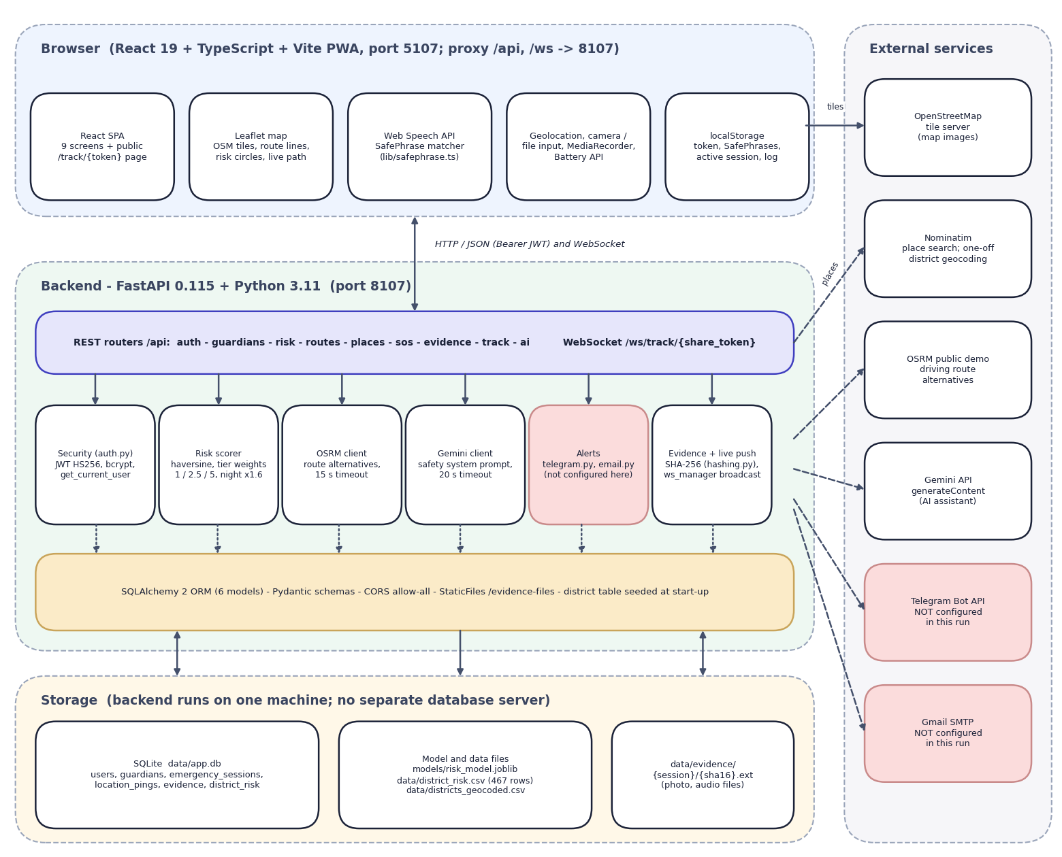
Fig. 5.1: System architecture of SHEGUARD
The diagram has four layers and a column of outside services. At the top is the browser: a React 19 and TypeScript single-page application built with Vite (port 5107, which proxies /api and /ws to the backend) and installable as a PWA. It contains the nine signed-in and signed-out screens plus the public /track/{token} page, a Leaflet map that draws OpenStreetMap tiles, route lines, risk circles and the live path, the Web Speech API with the SafePhrase matcher (lib/safephrase.ts), the device APIs (geolocation, camera or file input, MediaRecorder, battery), and localStorage, which holds the JWT, the SafePhrase list, the active session and a short activity log.
Below it is the FastAPI application on port 8107. Its ten routers (auth, guardians, risk, routes_plan, places, sos, evidence, track, ai and the WebSocket route ws) call six service blocks: security (bcrypt and HS256 JWT, get_current_user), the risk scorer, the OSRM client, the Gemini client, the alert senders (telegram.py, email.py) and the evidence and live-push helpers (hashing.py, ws_manager.py). SQLAlchemy maps six models to one SQLite file; the district table is seeded from data/district_risk.csv when the application starts. Storage is local: the database, the model and data files (risk_model.joblib and the two district CSV files) and the evidence folder. On the right are the outside services: OpenStreetMap tiles (called by the browser), Nominatim for place search, the OSRM public demo server for route alternatives, the Gemini API for the assistant, and the Telegram Bot API and Gmail SMTP for alerts. The last two are shaded because their credentials were empty in this run, so no alert was ever sent.
The design follows five principles. Keep guardians account-free: a guardian never logs in; the alert carries an unguessable 32-character link that opens a read-only page and a read-only WebSocket, so a frightened family member does not have to install or sign in to anything. Scope every query to its owner: guardians, sessions and evidence carry an owner or user identifier and every route compares it with the user in the JWT, which is this project's SQLite-compatible replacement for the Row Level Security named in the abstract. Treat alerts as best effort: each channel reports sent or not sent, the SOS itself never fails because an alert failed, and the screen shows exactly which guardians were reached. Keep the voice phrase on the device: the SafePhrase list is stored only in the browser, and only a SHA-256 fingerprint of each phrase is displayed. Be honest about the data: the planner screen states that routes are scored against district crime data from 2001 to 2012 and are a guide to the area, not live conditions.

5.2 High-Level Workflow
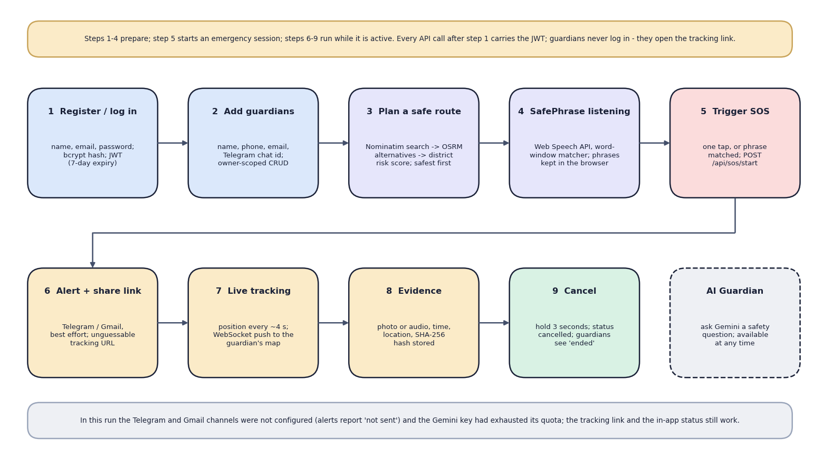
Fig. 5.2: High-level workflow
The nine steps follow one person from sign-up to the end of an emergency. Steps 1 to 4 prepare: register or log in (a bcrypt-hashed password and a JWT valid for seven days), add guardians, plan a safe route (place search, OSRM alternatives, district risk score, safest first) and keep SafePhrase listening. Step 5 starts an emergency by one tap or a matched phrase and calls POST /api/sos/start. Steps 6 to 9 run while the session is active: the alert and tracking link go to the guardians (Telegram and email, best effort), the position is pushed about every four seconds to the guardian's map, photo or audio evidence is stored with a SHA-256 hash, and holding the cancel button for three seconds ends the session. The dashed tenth box is the AI Guardian, which can be used at any time. The note at the bottom states what did not work in this run: the Telegram and Gmail channels were not configured and the Gemini key had run out of quota.

5.3 Data-Flow Diagrams
The data-flow diagrams show how data moves through SHEGUARD at three levels of detail: the context (level 0), the seven main processes with their data stores (level 1) and the expansion of the route-planning process (level 2).
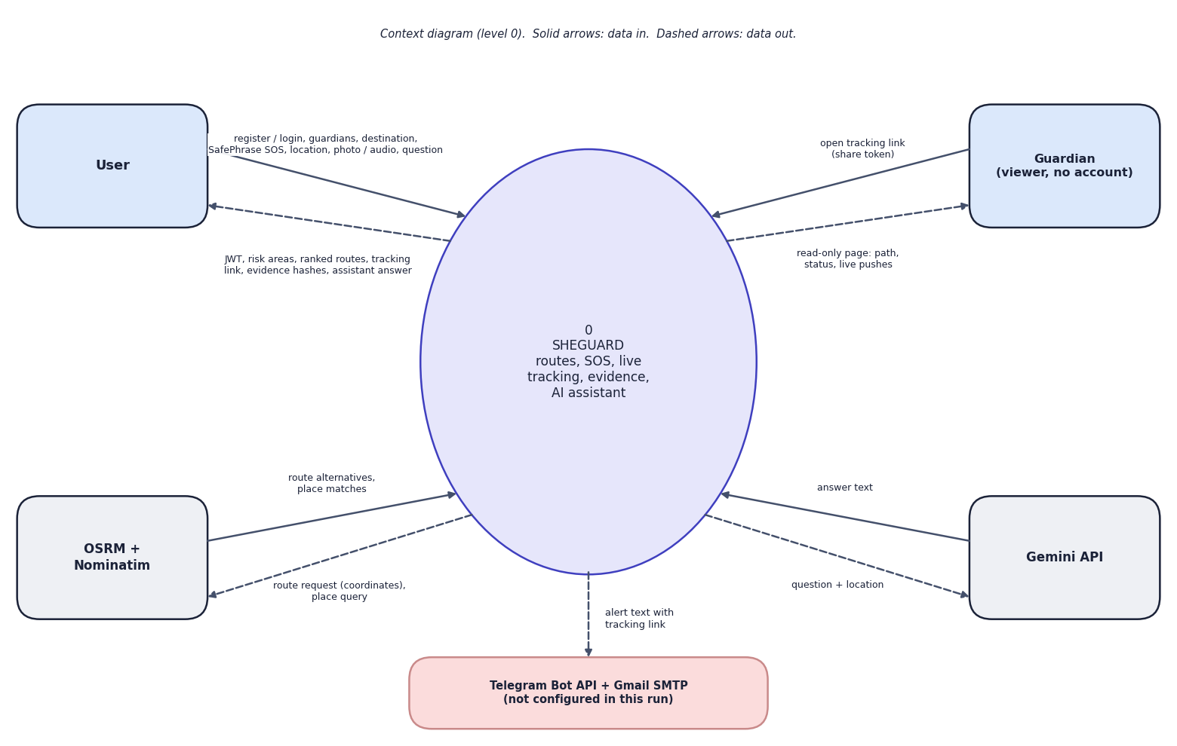
Fig. 5.3: Data-flow diagram, level 0 (context)
At the highest level SHEGUARD is one process with five external entities. The user sends registration and login details, guardians, a destination, the device location, a SafePhrase or tap that starts an SOS, photo or audio evidence and questions for the assistant; the user receives a token, the risk areas, the ranked routes, the tracking link, the evidence hashes and the assistant's answer. The guardian, who has no account, sends only the share token (by opening the link) and receives a read-only page with the path, the status and live pushes. OSRM and Nominatim receive a route request or a place query and return route alternatives or place matches. The Gemini API receives a question with the user's approximate location and returns text. The process sends an alert text with the tracking link to Telegram and Gmail; both are shaded because they were not configured in this run.
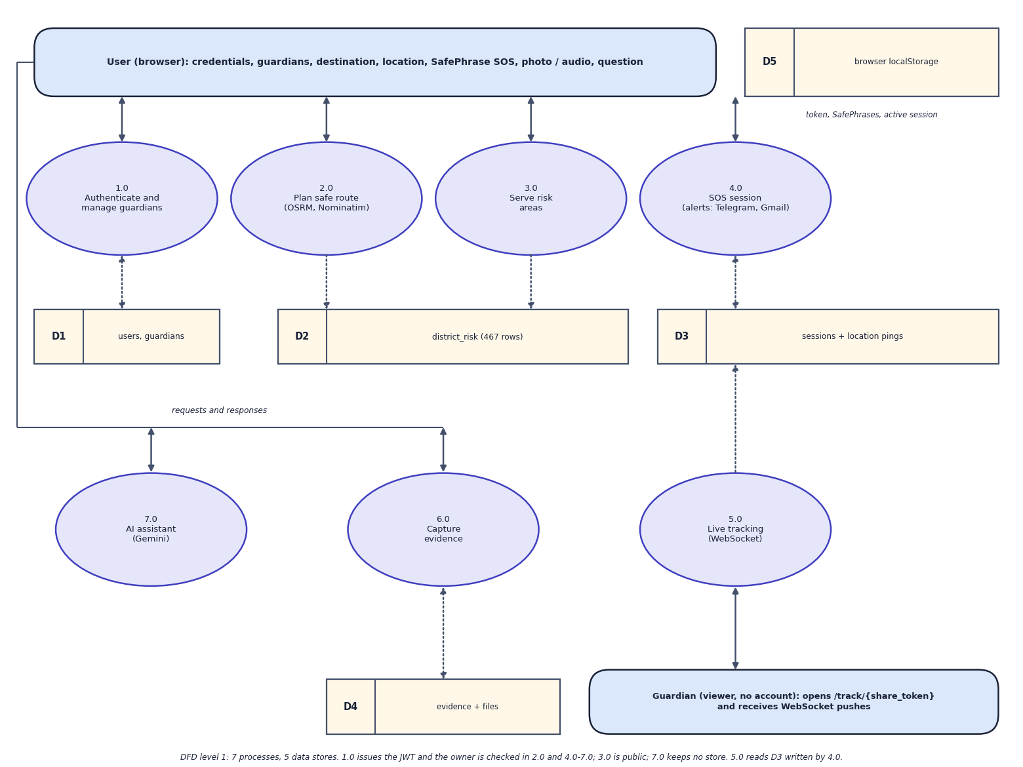
Fig. 5.4: Data-flow diagram, level 1
Level 1 splits SHEGUARD into seven processes: authenticate and manage guardians (1.0), plan a safe route (2.0), serve risk areas (3.0), SOS session (4.0), live tracking (5.0), capture evidence (6.0) and the AI assistant (7.0). Five data stores are used: D1 holds users and guardians, D2 the 467 district-risk rows, D3 the sessions and location pings, D4 the evidence rows and files, and D5 is the browser's localStorage (token, SafePhrases, active session). Process 1.0 issues the JWT; the owner check is made in 2.0 and 4.0 to 7.0, while 3.0 (GET /api/risk/areas) is public. Process 2.0 only reads D2; 4.0 creates the session and the first ping in D3 and sends the alerts; 5.0 reads D3 and pushes new pings to the guardian over the WebSocket; 6.0 writes D4; 7.0 keeps no store because the assistant has no memory between questions.
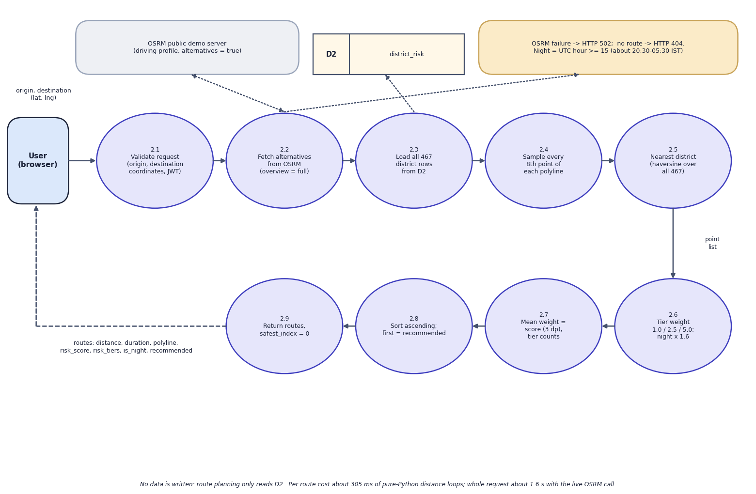
Fig. 5.5: Data-flow diagram, level 2: Plan safe route (process 2.0)
Process 2.0 is expanded into nine steps that follow plan_route() and score_route(). The request with the origin and destination coordinates is validated and the user is identified from the JWT (2.1). The OSRM public demo server returns driving alternatives with the full geometry (2.2); an OSRM failure gives HTTP 502 and an empty result HTTP 404. All 467 district rows are read from D2 (2.3). Every eighth point of each polyline is sampled (2.4) and mapped to the nearest district by haversine distance over all 467 rows, with no distance limit (2.5). The tier weight (low 1.0, medium 2.5, high 5.0) is applied and multiplied by 1.6 when the server clock is in the night window, UTC hour 15 or later (2.6). The mean weight is the route score, rounded to three decimals, together with the tier counts (2.7); routes are sorted by ascending score and the first is marked recommended (2.8), and the list is returned with safest_index = 0 (2.9). Nothing is written to the database.

5.4 UML Diagrams
Three UML views describe the design: the use-case diagram (who does what), the class diagram (what the code contains) and the sequence diagram (how the main flow runs). The two core algorithms are shown as flowcharts in Chapter 6.
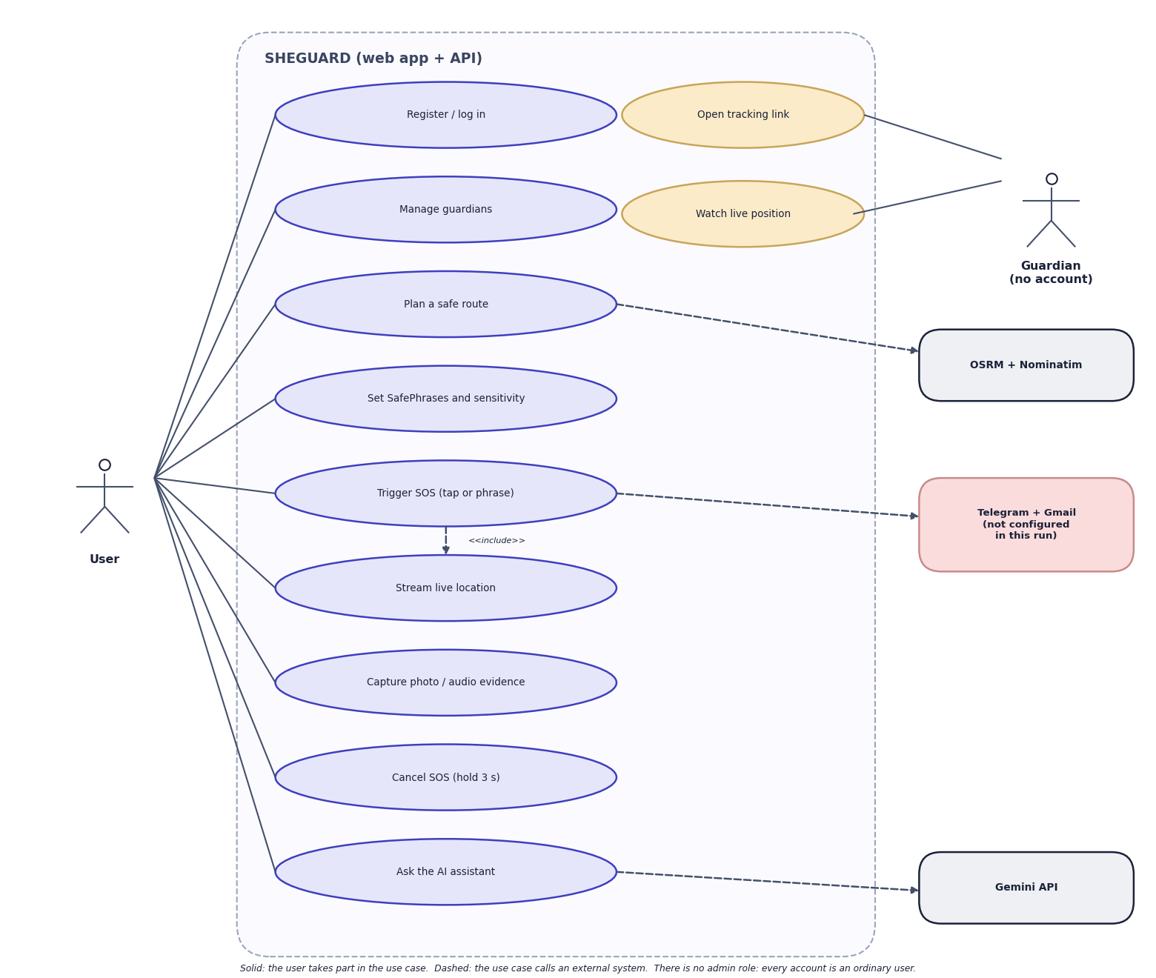
Fig. 5.6: Use-case diagram
There is one signed-in actor, the user. The user registers or logs in, manages guardians, plans a safe route, sets SafePhrases and their sensitivity, triggers an SOS by tap or phrase, streams the live location, captures photo or audio evidence, cancels the SOS by holding the button for three seconds and asks the AI assistant. Triggering an SOS includes streaming the location. The guardian is the second actor and has no account: the guardian can open the tracking link and watch the live position. The dashed arrows show which use cases call an outside system: route planning calls OSRM and Nominatim, the SOS calls Telegram and Gmail (not configured in this run) and the assistant calls Gemini. There is no administrator role: every account is an ordinary user.
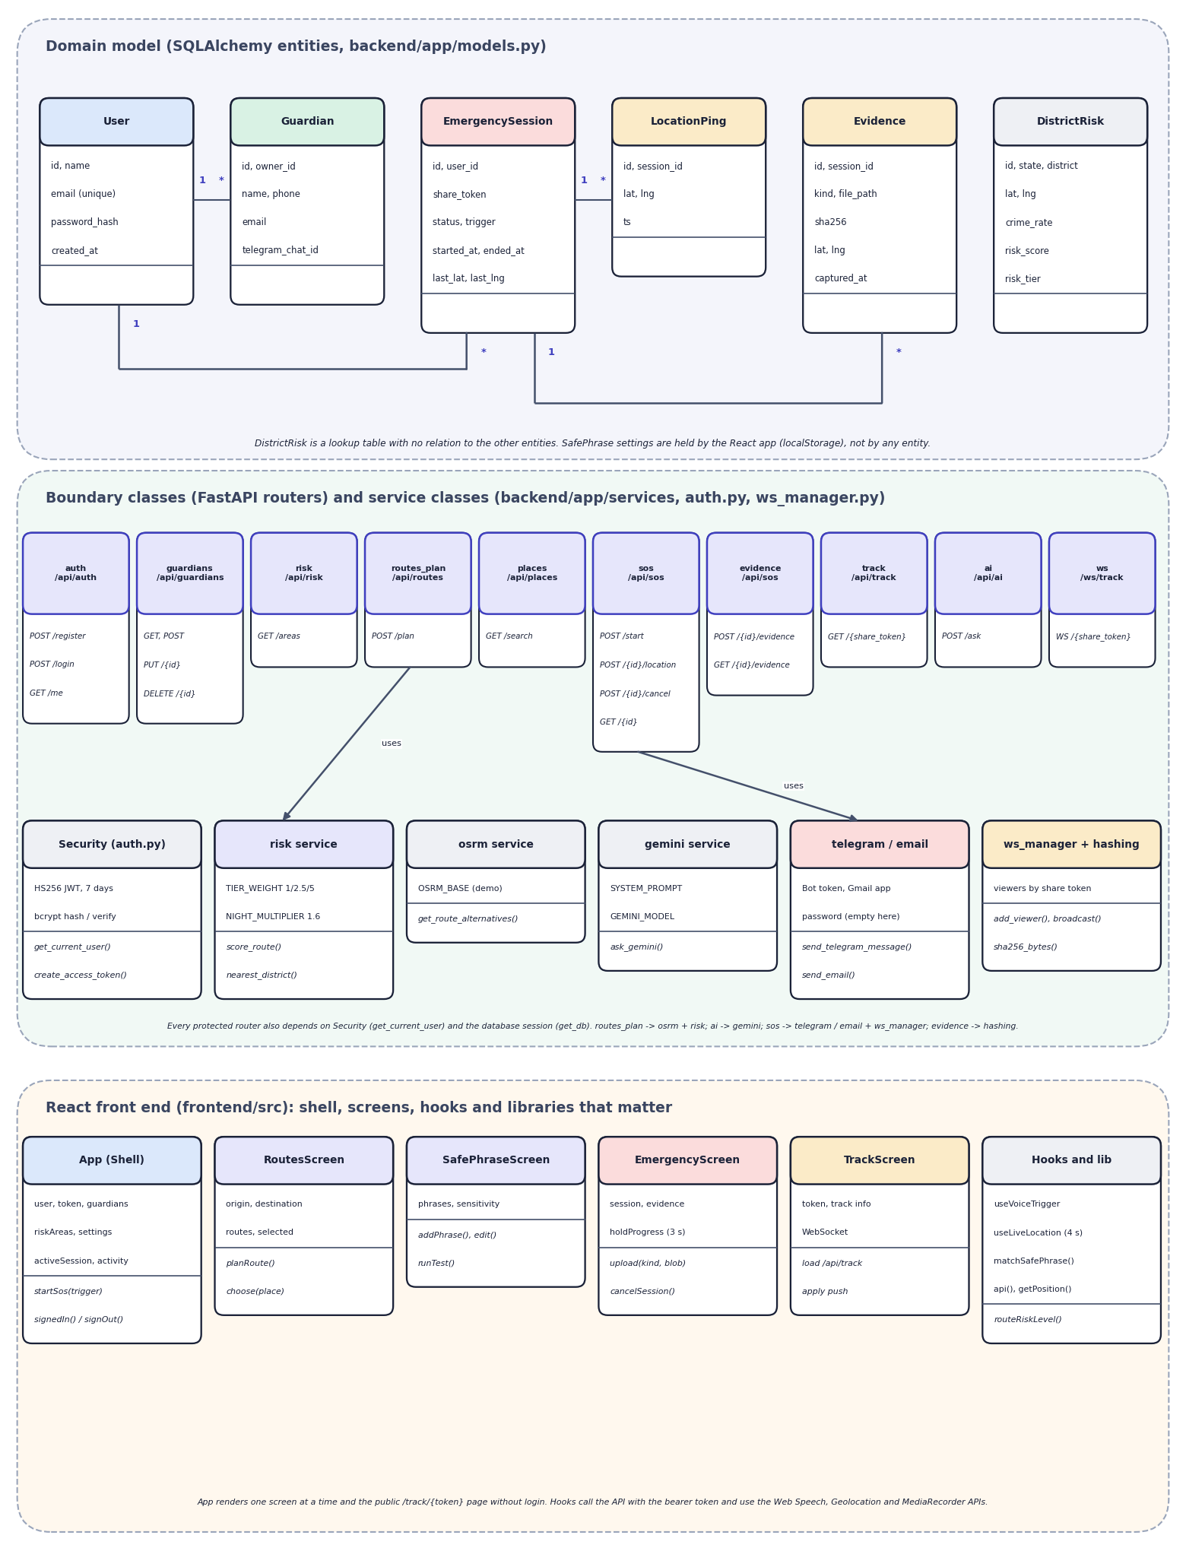
Fig. 5.7: UML class diagram
The upper part shows the six SQLAlchemy entities with their main attributes: User has many Guardian and many EmergencySession; a session has many LocationPing and many Evidence; DistrictRisk stands alone. The middle part shows the boundary classes, the ten routers with their routes, and the service classes behind them: security (get_current_user, create_access_token), the risk service with its tier weights and the night multiplier (score_route, nearest_district), the OSRM client, the Gemini client with its system prompt, the Telegram and email senders, and the connection manager with the hashing helper. Arrows show that routes_plan uses the OSRM client and the risk service and that sos uses the senders and the manager. The lower part shows the React side: the App shell that holds the user, the token, the guardians, the SafePhrase settings and the active session; the route, SafePhrase, emergency and tracking screens; and the hooks and libraries (useVoiceTrigger, useLiveLocation, matchSafePhrase, api, getPosition).
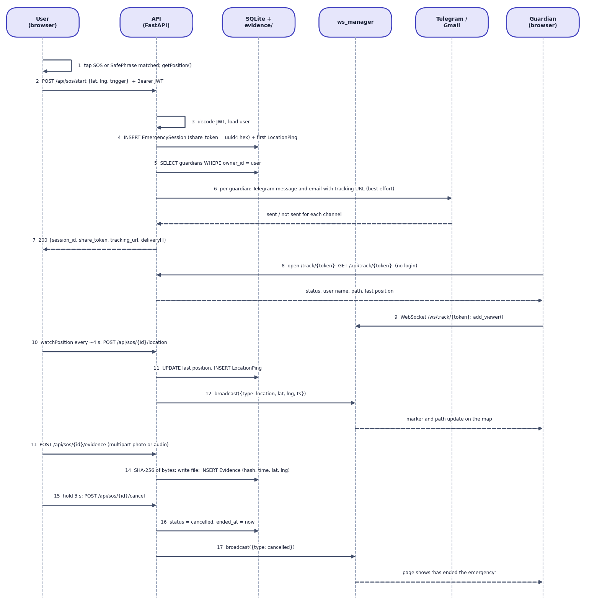
Fig. 5.8: Sequence diagram: from SOS trigger to cancellation
The sequence shows the main flow in 17 numbered steps across six participants. In the browser, a tap or a matched SafePhrase obtains the position and posts POST /api/sos/start with the bearer token (1, 2). The API decodes the JWT (3), inserts the EmergencySession with a random 32-hex share_token and the first LocationPing (4), reads the owner's guardians (5) and asks the alert senders to send a Telegram message and an email with the tracking URL, each reporting sent or not sent (6); the response carries the session id, the token, the URL and the delivery list (7). A guardian opens the link and the page loads the path with GET /api/track/{token} without logging in (8), then opens the WebSocket, which registers the viewer in the connection manager (9). About every four seconds the browser posts a new position (10); the API updates the session and stores a ping (11) and the manager broadcasts it (12), so the marker and path move on the guardian's map. Evidence is uploaded as multipart data, hashed with SHA-256, written to disk and recorded (13, 14). Holding the cancel button for three seconds posts the cancellation (15); the status becomes cancelled (16) and a cancelled message is broadcast (17), after which the guardian's page says that the emergency has ended.

5.5 Database Design
The database is SQLite, created by SQLAlchemy 2 at start-up with create_all; there are no migrations. Timestamps are stored in UTC. Uploaded photographs and audio clips are not stored in the database: they are files under data/evidence/{session id}/, and the table keeps the relative path, the SHA-256 hash, the kind, the capture position and the time.
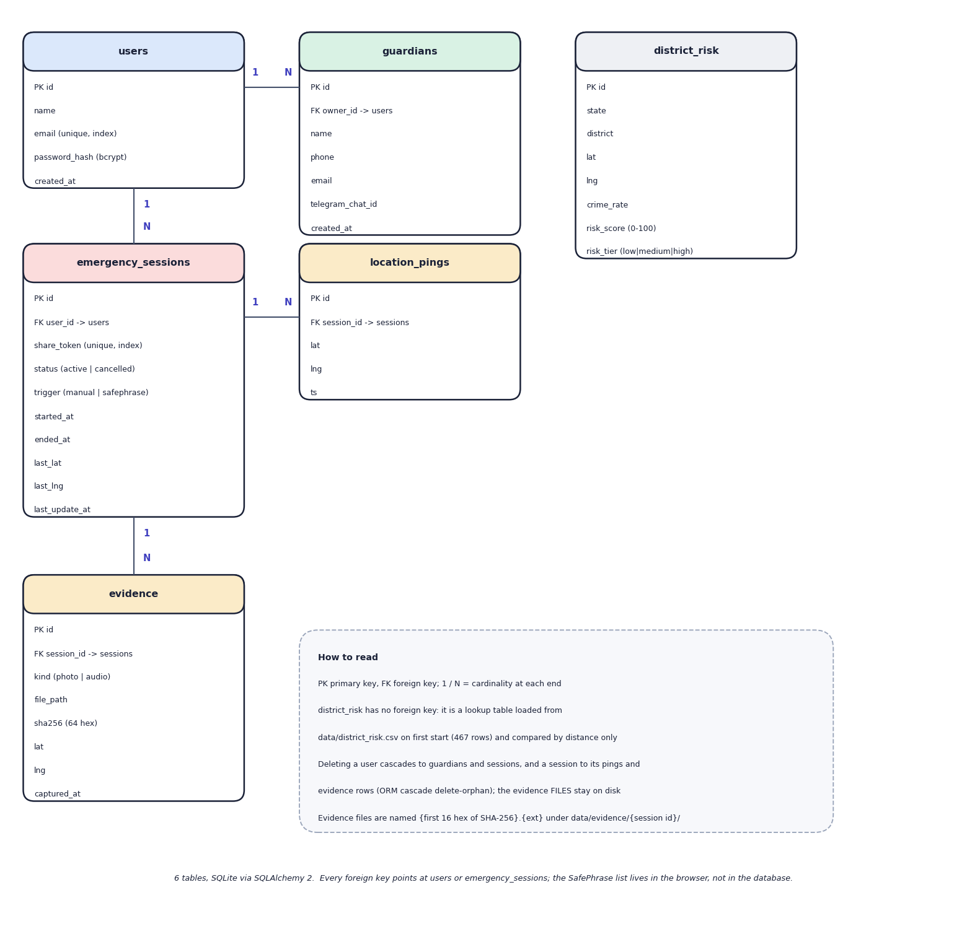
Fig. 5.9: Entity-relationship diagram (6 tables)
Six tables are created by SQLAlchemy in SQLite. A user owns many guardians and many emergency sessions; a session has many location pings and many evidence rows. The district_risk table is a lookup table with no foreign key: it holds the 467 geocoded districts with their crime rate, 0-100 risk score and tier, and is read by distance only. ORM cascades delete a user's guardians and sessions and a session's pings and evidence rows, but the evidence files stay on disk. The SafePhrase list is not in the database: it lives in the browser. The evidence.file_path column holds the path relative to data/, and the file name is the first 16 hexadecimal characters of the SHA-256 followed by the extension.
Table 5.1: Database tables
Table | Purpose | Key columns
users | Accounts | id, name, email (unique, indexed), password_hash (bcrypt), created_at
guardians | Trusted contacts of one user | id, owner_id (FK users), name, phone, email, telegram_chat_id, created_at
emergency_sessions | One emergency | id, user_id (FK users), share_token (unique, indexed, uuid4 hex), status (active, cancelled), trigger (manual, safephrase), started_at, ended_at, last_lat, last_lng, last_update_at
location_pings | The path of a session | id, session_id (FK), lat, lng, ts
evidence | Photo or audio of a session | id, session_id (FK), kind (photo, audio), file_path, sha256 (64 hex characters), lat, lng, captured_at
district_risk | Risk lookup loaded from the model output | id, state, district, lat, lng, crime_rate (crimes per reporting year), risk_score (0-100), risk_tier (low, medium, high); 467 rows

Four design points should be noted. First, status and trigger are plain strings checked only by the application: the API accepts any trigger text, which is one of the known gaps. Second, the share token is the only credential a guardian has, so it is generated with uuid4().hex and stored with a unique index; the tracking route returns 404 for an unknown token but the session never expires, and a cancelled session stays readable. Third, the evidence hash and the evidence path live in the same database, so the hash proves integrity only for someone who recomputes it from the stored file; no route does that. Fourth, the district_risk table is filled once, from data/district_risk.csv, and is not updated when the model is retrained unless the database is recreated.

5.6 Module Design
Table 5.2: Modules of SHEGUARD
Module | Code | Responsibility
Application | backend/app/main.py | Creates the FastAPI app, CORS (all origins), the /evidence-files static mount, table creation and the district seed at start-up, the /api/health route; includes the ten routers
Configuration and database | app/config.py, db.py | Reads .env (ports, JWT secret, keys, database URL), data and evidence folders; engine and session dependency
Security | app/auth.py | bcrypt hashing, HS256 JWT (7 days) creation and decoding, get_current_user
Models and schemas | app/models.py, schemas.py, seed.py | Six SQLAlchemy models, the Pydantic request types (password of at least 6 characters, email validation), the district seed
Auth and guardians API | routes/auth.py, guardians.py | Register, login, current user; guardian list, create, update, delete scoped to the owner
Risk and route API | routes/risk.py, routes_plan.py, places.py | Public district list; route planning (OSRM plus scoring); Nominatim place search for India, five results
SOS API | routes/sos.py, track.py, evidence.py, ws.py | Start, location push, cancel, read; evidence upload with SHA-256 and list; public track page; guardian WebSocket
AI API | routes/ai.py, services/gemini.py | Forwards a question and optional position to Gemini with a fixed safety system prompt (temperature 0.4, 400 output tokens, 20 s timeout)
Services | services/osrm.py, risk.py, telegram.py, email.py, hashing.py, ws_manager.py | OSRM client; haversine, tier weights and night factor; Telegram and Gmail senders (return False without credentials); SHA-256; viewers grouped by share token
Risk model | ml/train_risk_model.py, ml/eval.py | Aggregates 7 crime columns per district, StandardScaler and K-Means (k = 3), tier naming and 0-100 score, silhouette and Davies-Bouldin, route-scorer sanity check
Data scripts | scripts/download_data.py, geocode_districts.py, seed_demo.py, smoke_test.py | Dataset download, Nominatim geocoding (1 request per second), demo account, 12-step live smoke test
Tests and measurements | tests/, scripts/run_experiments.py, measure_api.py, safephrase_eval.mjs, assistant_eval.py | 57 pytest tests (51 pass, 6 expected failures that document defects); risk-model, route, API, SafePhrase and assistant measurements
Web application | frontend/src/ | 26 TypeScript files, about 2,950 lines: the App shell, ten screens, the navigation, the Leaflet map, three hooks (voice trigger, live location, battery) and five libraries (API client, geo helpers, SafePhrase matcher, siren, storage)

The browser, not the server, owns the SafePhrase feature, the three-second hold-to-cancel rule, the battery reading and the local siren (a three-second oscillator tone that never touches the network). The server owns authentication, data and every outside call except the map tiles.

5.7 User Interface Design
The web application has a landing page, a log-in page and a sign-up page for visitors, and a sidebar layout for signed-in users with five destinations: Dashboard, Safe Routes, AI Guardian, SafePhrase and Profile and Guardians, plus a permanent red button that starts or reopens the emergency. On a phone the sidebar becomes a top bar with a small SOS button and a bottom navigation bar, and the route screen adds a floating SOS button. The dashboard shows the number of guardians, the risk tier of the nearest district, the battery level (or 'not shared by this browser'), the SafePhrase listening state, the large SOS button, shortcuts including a local siren, and the recent activity. The Safe Routes screen has a destination search box, a map with route lines and optional risk circles, one card per route with its distance, duration and the share of sampled points per risk tier, and a panel of three short AI tips for the selected route. The emergency screen shows who was alerted, the tracking link with a copy button, the live map, the evidence buttons and list, a call button and the hold-to-cancel button. The public tracking page shows only the person's name, the status, the map and a reminder to call the emergency number.
Design decisions follow from the situation. The emergency flow needs few taps, so the SOS button is always visible and a stray tap cannot end an alert because cancelling needs a three-second hold with a visible progress bar. Colour is paired with text (a risk badge says LOW, MODERATE or HIGH). Failures are shown in plain words: when the assistant is unavailable the screen says so instead of showing a provider error. The planner's disclaimer states that the scores come from 2001-2012 district data.
Two limitations of the interface are stated. The route screen asks the assistant for tips every time a route is selected, so each planning action also spends a Gemini request; and the emergency screen's call button reads 'Call 911' while India's emergency number is 112. The screens below were captured from the running application; the complete set is in Chapter 8 and Appendix C.
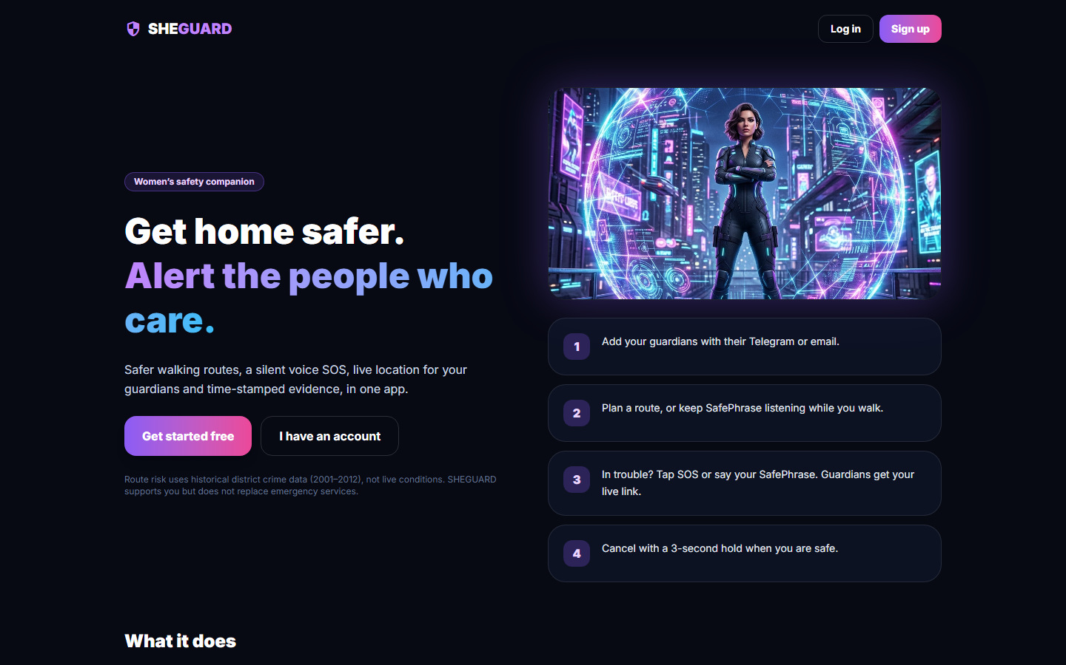  Fig. 5.10: Landing page for visitors | 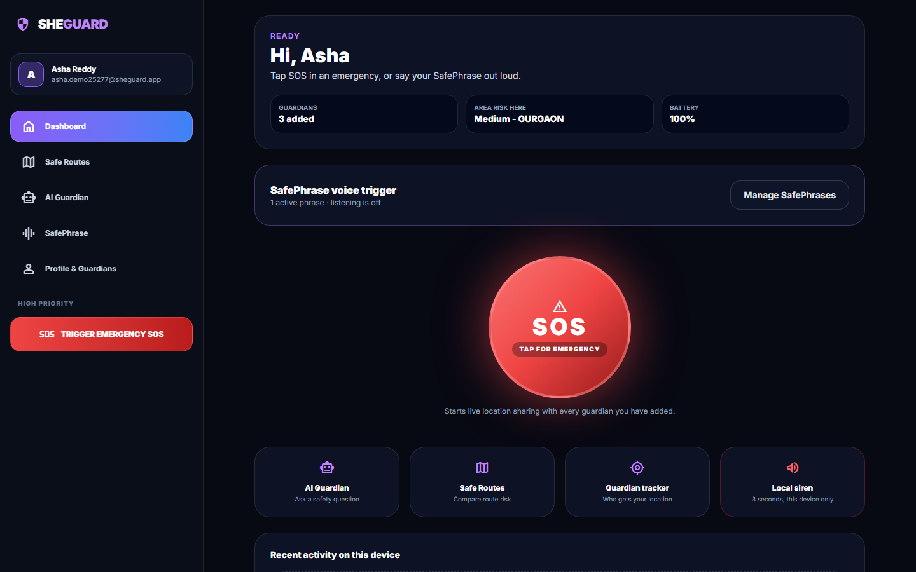  Fig. 5.11: Dashboard: SOS button, status tiles and SafePhrase state

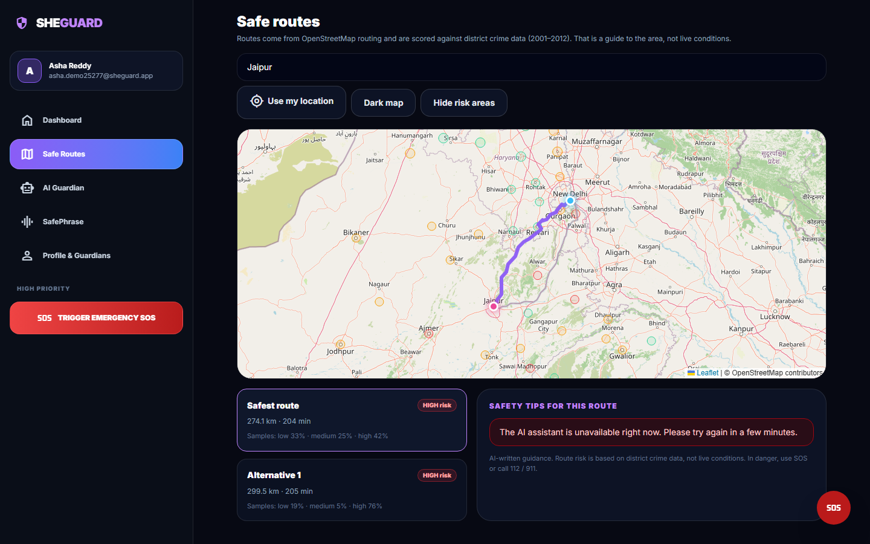  Fig. 5.12: Safe Routes: two alternatives scored by district risk | 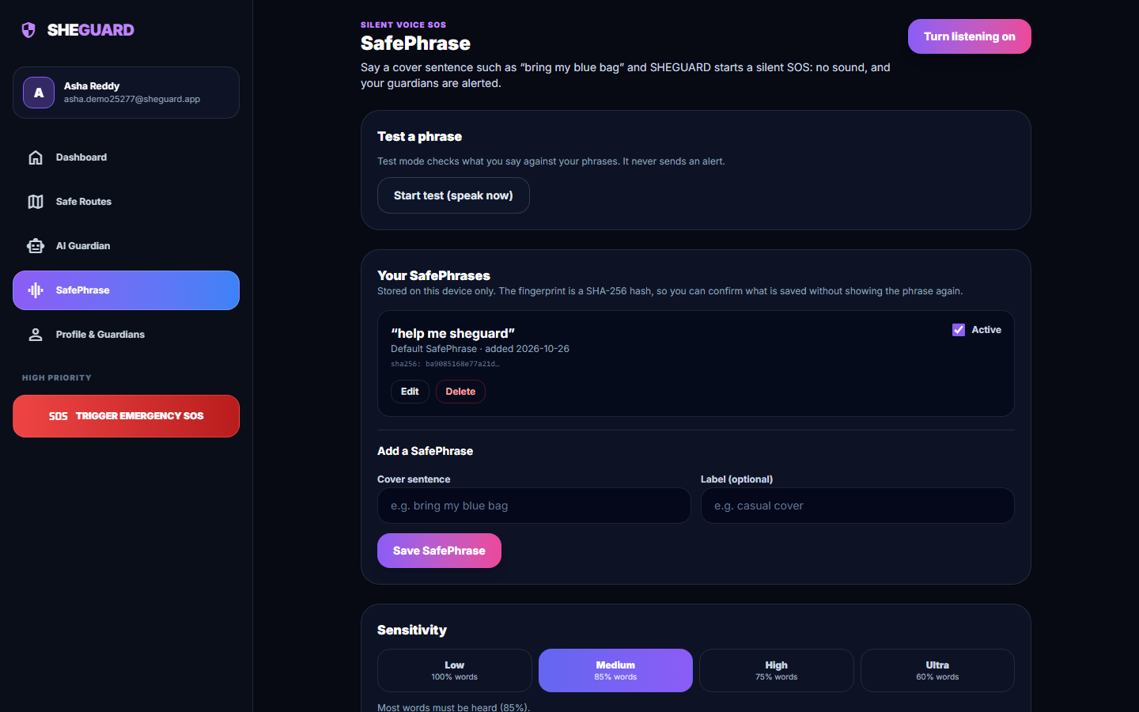  Fig. 5.13: SafePhrase settings: phrases, fingerprint, sensitivity

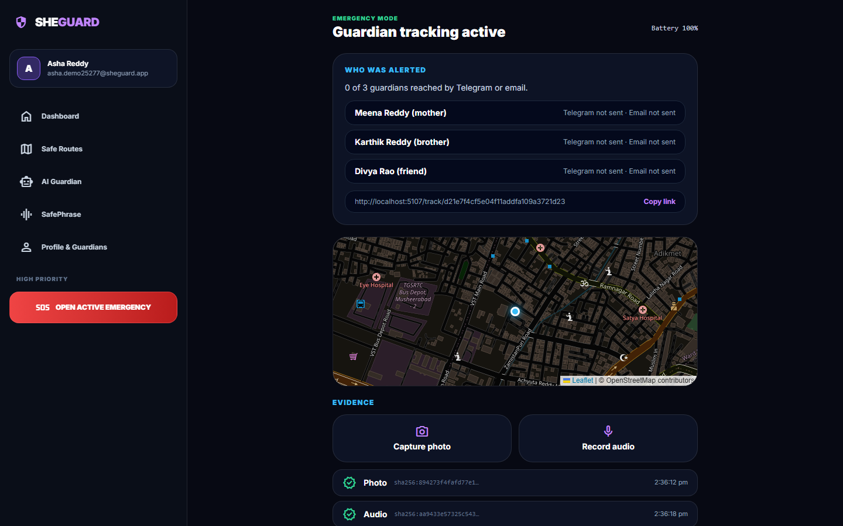  Fig. 5.14: Emergency screen with hashed photo and audio evidence | 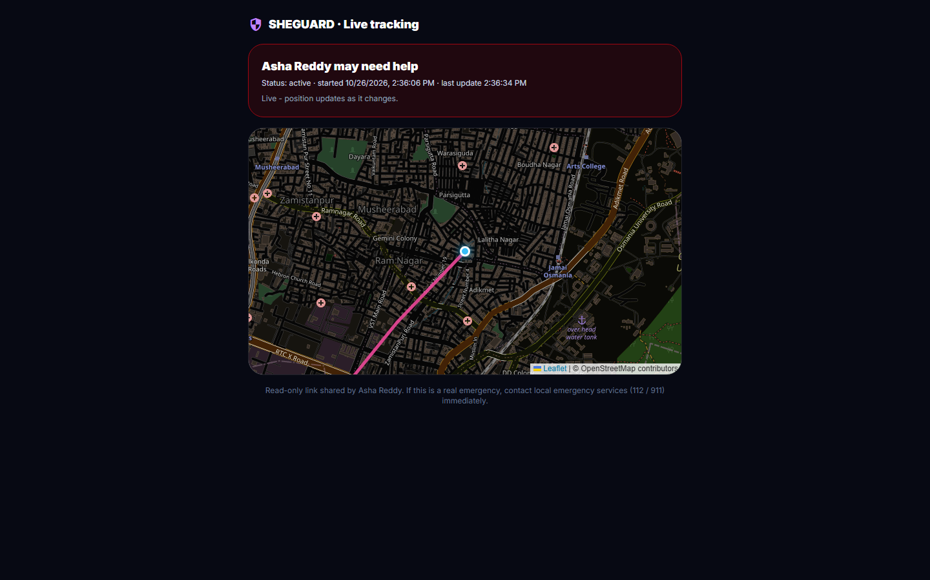  Fig. 5.15: Guardian's tracking page, no login

CHAPTER 6
METHODOLOGY AND SOFTWARE IMPLEMENTATION

6.1 Overall Methodology
SHEGUARD follows the lifecycle of an unsafe journey: before it, while it happens and after it. Before the journey the user plans a route; OpenStreetMap-based routing (OSRM) returns driving alternatives and each is scored against a table of district-level risk tiers that was built from public crime statistics with K-Means clustering. During an emergency a single tap, or a spoken cover phrase recognised in the browser, starts a session: the position is streamed to guardians over a WebSocket on a link that needs no login, alerts are attempted by Telegram and e-mail, and the user can add photo or audio evidence. After the emergency the evidence is already stored with a timestamp, a location and a SHA-256 hash, and an AI assistant (Gemini) is available for advice.
The base paper [1] builds the first stage only: it clusters regions with K-Means and Gaussian mixtures on crime, population, literacy, expenditure, police and forest data, and proposes a cab-service integration that raises alerts when a ride deviates into an unsafe cluster. SHEGUARD keeps the idea of a clustering-based risk map feeding route guidance, simplifies it (one feature, one algorithm, three tiers) and adds the hands-free activation, live guardian tracking, evidence preservation and assistant stages around it.
One difference from the batch abstract must be stated at the outset. The abstract names Flutter, Supabase and Postgres Row Level Security. The implementation is a React 19 and TypeScript web application, installable as a progressive web app, on a FastAPI and SQLite back end. Access control is enforced in code: every query filters on the user id carried in the JWT, and guardians have no account at all, they hold only an unguessable per-session link. "Smart SOS" is a one-tap button with a three-second hold to cancel; there is no shake, power-button or fall-detection trigger.
Table 6.1: Pipeline of SHEGUARD
Stage | Method | Output
1 Collect | Public district-wise crimes-against-women table 2001-2012 (Kaggle, CC0); districts geocoded once with Nominatim | 9,017 rows, 827 districts, 467 with coordinates
2 Prepare | Drop TOTAL rows; sum seven crime columns; average per reporting year; join with coordinates | One crime_rate per district
3 Cluster | StandardScaler and K-Means with k = 3; tiers named by mean crime rate; 0-100 risk_score by min-max | 467 district rows (low 278, medium 148, high 41)
4 Plan route | OSRM alternatives; every 8th point mapped to the nearest district (haversine); tier weights 1 / 2.5 / 5, night factor 1.6 | Routes sorted by risk score; first is recommended
5 Trigger | One-tap button, or the Web Speech API plus a word-window matcher against stored phrases | POST /api/sos/start with the trigger name
6 Share | Session row with a 32-hex share_token; position pings every 4 s; WebSocket broadcast; Telegram and Gmail attempts | Public read-only tracking page; delivery report
7 Preserve | Multipart upload, SHA-256 of the bytes, stored file, row with kind, time and position | Evidence list with 64-hex hashes
8 Assist | Gemini generateContent with a safety system prompt and the approximate location | Short answer (not demonstrated in this run: quota error)

6.2 Dataset
The only learned component of the product, the area-risk model, is trained on public statistics; there is no synthetic data and no labelled ground truth. Two Kaggle datasets were committed to the repository and the district coordinates were produced once from OpenStreetMap.
Table 6.2: Data used by SHEGUARD
Item | Source and licence | Size and use
District crimes file | Kaggle "Crime in India" (rajanand) [23]; CC0 public domain | district_wise_crimes_against_women_2001_2012.csv: 9,017 rows, 8,597 after dropping TOTAL roll-ups; 35 states and union territories; years 2001-2012; 827 (state, district) pairs; seven crime columns. Trains the model
State-year file | Kaggle "Crimes against women in India 2001-2021" (balajivaraprasad) [24]; CC0 | crimes_against_women_2001_2021.csv: 736 rows, 70 state labels, 2001-2021. Committed, not used by any feature
District coordinates | Nominatim over OpenStreetMap (ODbL) [29]; one request per second | districts_geocoded.csv: 467 of 827 pairs (56.5 %); the rest (railway divisions, sub-district entries) were dropped, not guessed
Routes | OSRM public demo server [17]; place search by Nominatim | Fetched live per request; nothing stored

The seven counted categories are Rape, Kidnapping and Abduction, Dowry Deaths, Assault on women with intent to outrage her modesty, Insult to modesty of Women, Cruelty by Husband or his Relatives and Importation of Girls. Their combined shares are Cruelty by husband or relatives 40.0 %, assault on modesty 25.8 %, rape 13.0 %, kidnapping 11.7 %, insult to modesty 5.2 % and dowry deaths 4.2 %. The risk score therefore mostly counts domestic-violence reports, which say little about danger on a street at night; this is a property of the data and is repeated among the limitations.
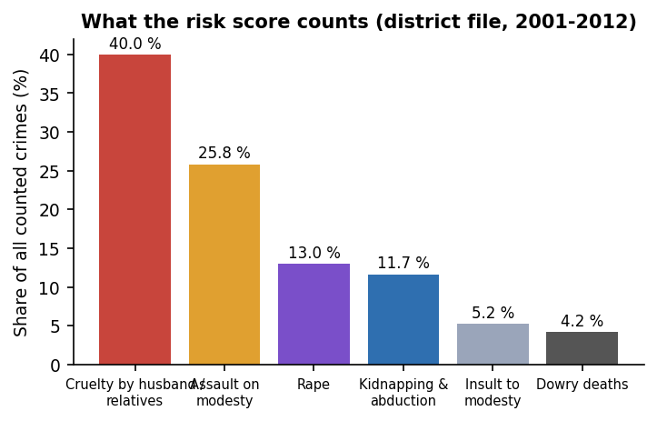
Fig. 6.1: Share of each counted crime category in the district file
Districts report between one and twelve years: 638 of 827 report all twelve and 34 report a single year; the geocoded districts average 11.71 reporting years. The feature is an average per reporting year, so a district with five years of data is not penalised for its missing years, but the average of a few years is noisier. The counts are raw numbers, not rates per population: the file contains no population, so a large district ranks above a small one with the same per-person risk.
Geocoding left 11 of 35 states and union territories with no district at all (A & N Islands, Chandigarh, D & N Haveli, Daman & Diu, Delhi, Lakshadweep, Puducherry, Tripura, Uttar Pradesh, Uttarakhand, West Bengal), and the geocoded points are otherwise plausible: none lies outside India's bounding box and 2 districts share a coordinate (466 distinct points). There is no train and test split, because the model is unsupervised and there is no ground-truth risk label to hold out.

6.3 Preprocessing

6.3.1 Building the district feature table
ml/train_risk_model.py prepares the data in five steps:
1. Remove roll-ups. Rows whose district name contains TOTAL (state totals) are dropped, leaving 8,597 of 9,017 rows.
2. Sum the categories. The seven crime columns are added into total_crimes for each row (one district-year).
3. Average per reporting year. Rows are grouped by state and district; crime_rate is the sum of total_crimes divided by the number of distinct years the district reported.
4. Attach coordinates. An inner join with districts_geocoded.csv keeps the 467 districts that have a latitude and longitude.
5. Scale. StandardScaler converts crime_rate to a z-score before clustering; the scaler is saved with the model.
After clustering, the tier names are assigned by sorting the three clusters on their mean crime_rate (lowest is low, highest is high), so the names do not depend on the arbitrary cluster numbers, and risk_score is a min-max rescaling of crime_rate to 0-100 computed within the fitted data. The table is written to data/district_risk.csv and loaded into the district_risk database table when the back end starts.

6.3.2 Geocoding
scripts/geocode_districts.py asks Nominatim for "District, State, India" once per district, at most one request per 1.1 seconds, and saves its progress after every row so an interrupted run resumes. A district with no result is skipped. The cache is committed, so the step never has to run again.

6.3.3 Route preprocessing
The OSRM response is requested with alternatives=true, overview=full and GeoJSON geometry; its [longitude, latitude] pairs are swapped to [latitude, longitude]. The scorer takes every eighth point of the polyline (sample_every_n = 8) so that a long route is judged by a few dozen sample points rather than thousands.

6.3.4 Voice and input preprocessing
SafePhrase text, both the stored phrases and the speech transcript, is normalised by normalizeText: lower-cased, every character outside a-z, 0-9 and space replaced by a space, runs of spaces collapsed and the ends trimmed. The transcript buffer keeps only the last 200 characters so that old speech cannot trigger a new match. A stored phrase is shown to the user only as a SHA-256 fingerprint of its normalised text. Request bodies are validated by Pydantic models (e-mail format, password of at least six characters, required coordinates); the evidence upload checks the kind (photo or audio) and rejects an empty file.

6.4 Algorithm Choice and Justification
Table 6.3: Main decisions of the implementation
Decision | Chosen | Alternatives measured or considered | Why
Risk tiers | K-Means, k = 3 on the standardised crime rate [9], [10] | Ward hierarchical [15] (83.3 % agreement), Gaussian mixture [14] (72.6 %), equal-count terciles (49.2 %), fixed 100 / 300 cut-offs (54.6 %) | Simple, deterministic given a seed, fits in milliseconds, matches one of the two algorithms of the base paper; the tier boundaries come from the data instead of being invented
Number of tiers | k = 3 | k = 2 to 8 swept (below) | A UI choice (low, medium, high); not the optimum of the indices
Features | One: average crimes per reporting year | Base paper: crime, population, literacy, expenditure, police, forest | Only the crime counts were available in the committed data; no population to normalise by
Route score | Mean of tier weights over sampled points, times a night factor | Distance-weighted interpolation between districts; learned weights | Transparent: every score can be explained from three weights; no labelled routes exist to learn from
Spatial lookup | Nearest district by haversine distance over all 467 rows | Polygon containment; k-d tree | No district boundaries were available; 467 rows need no index (but there is no distance limit)
Routing | OSRM public server [17] over OpenStreetMap [18] | Commercial map APIs | Free, returns alternatives and full geometry, no key
Voice trigger | Web Speech API [25] plus a word-window matcher | Exact substring only; edit distance; an on-device keyword spotter | Runs in the browser with no extra service; tolerates one missed word at higher sensitivity; no model to train
Live location | WebSocket broadcast keyed by share token [20] | Polling the tracking endpoint | Guardians receive a position 15 ms on average after the update (measured locally, one viewer); no polling load
Evidence integrity | SHA-256 of the uploaded bytes [22] | Digital signatures; blockchain anchoring | Cheap (about 1 ms per MB), standard, detects any change to the file if it is recomputed
Authentication | bcrypt [21] and HS256 JWT [19] | Sessions; OAuth | Stateless, standard, small code

6.4.1 Why k = 3, and what the indices say
Silhouette [11] and Davies-Bouldin [12] scores were computed for k = 2 to 8 on the 467 standardised values. k = 3 gives silhouette 0.580 and Davies-Bouldin 0.531. k = 2 has the highest silhouette (0.662) and k = 4 beats k = 3 on both indices (silhouette 0.596, Davies-Bouldin 0.493). The choice of three clusters is therefore a presentation decision, three colours on the map and three weights in the scorer, not the metric optimum. The base paper [1] also reports 3-4 clusters; its tables give silhouette 0.416 and Davies-Bouldin 0.970 at k = 3 on its multi-feature data, which are not comparable with a single-feature result.

6.4.2 What the clustering actually does
Because the data have one dimension, K-Means reduces to two cut-offs on the crime rate: districts below 213.75 crimes per year are low, those from there up to 529.83 are medium and the rest are high. A threshold rule reproduces the K-Means tiers for 100 % of districts. The "model" is therefore a data-driven pair of thresholds, and it is described as such in this report. The consequence for stability is measured in section 6.6.
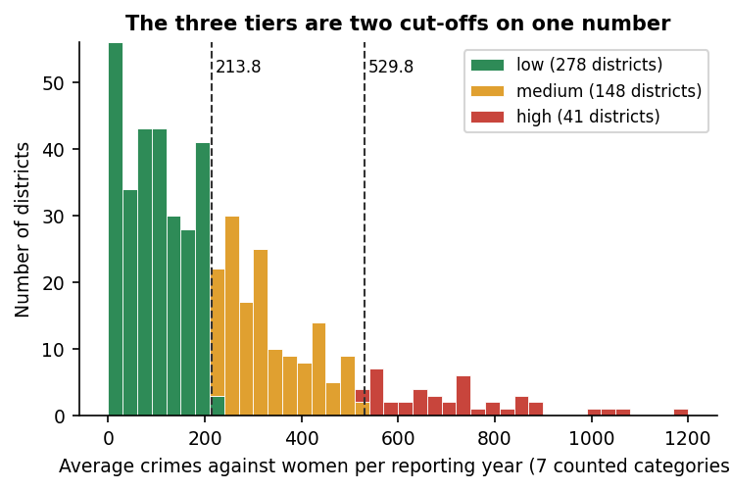
Fig. 6.2: Distribution of the crime rate with the two cut-offs found by K-Means

6.5 Mathematical Formulation
The quantities used by the implementation are written below; the symbols are those of the code.

6.5.1 Crime rate, scaling and risk score
crime_rate(i) = ( sum over years y reported by district i of sum over the 7 categories c of count(i, y, c) ) / n_years(i) (1)
z(i) = ( crime_rate(i) - mu ) / sigma mu, sigma = mean and standard deviation over the 467 districts (2)
risk_score(i) = 100 x ( crime_rate(i) - min ) / ( max - min ) (3)

6.5.2 K-Means and its quality indices
K-Means [9], [10] chooses cluster centres that minimise the within-cluster sum of squares, with k = 3, random_state 42 and ten initialisations:
WCSS = sum over clusters j = 1..k of sum over districts i in C_j of ( z(i) - c_j )^2 (4)
silhouette s(i) = ( b(i) - a(i) ) / max( a(i), b(i) ), a = mean distance to own cluster, b = mean distance to the nearest other (5)
Davies-Bouldin DB = (1/k) sum over j of max over l != j of ( s_j + s_l ) / d(c_j, c_l) lower is better (6)

The reported values are the mean silhouette 0.5798, DB 0.531 and the Calinski-Harabasz index [13] 1155.4.

6.5.3 Route risk score
For a route with coordinates p_1 ... p_n, the sample is every eighth point, P = {p_1, p_9, p_17, ...}. Let tier(p) be the risk tier of the district nearest to p, with the great-circle distance
haversine(p, q) = 2 R asin( sqrt( sin^2(dphi / 2) + cos(phi_p) cos(phi_q) sin^2(dlambda / 2) ) ), R = 6371 km (7)
w(low) = 1.0, w(medium) = 2.5, w(high) = 5.0 (8)
night(t) = 1.6 if UTC hour >= 15 (about 20:30-05:30 IST), else 1 (9)
score(route) = night(t) x ( 1 / |P| ) x sum over p in P of w( tier(p) ) (10)

The route with the smallest score is recommended. Because night(t) multiplies every route by the same constant, it changes the size of the score but cannot change which of two routes is smaller; this is proved by the unit test test_night_never_reorders_two_routes and observed on all 16 test pairs (section 6.6 and Chapter 7). The UI also derives a LOW, MODERATE or HIGH label from the tier shares: HIGH when at least 20 % of the sampled points are in high-risk districts, MODERATE when any is or at least half are medium, otherwise LOW.

6.5.4 SafePhrase matching
Let T be the set of words of a normalised stored phrase (m words) and let the spoken transcript be the word sequence u_1 ... u_L. The matcher returns the best window share
share = max over windows i = 1..max(1, L - m + 1) of | { t in T : t in {u_i ... u_(i+m-1)} } | / m (11)
trigger if the normalised transcript contains the normalised phrase or share >= threshold(sensitivity) (12)
threshold: Low 1.00, Medium 0.85, High 0.75, Ultra 0.60 (13)

Word order inside the window is ignored, and a phrase of three words needs all three at Low and Medium, because two of three is 0.67, below 0.85.

6.5.5 Evidence integrity, tokens and tracking links
sha256(file bytes) -> 64 hexadecimal characters, stored with the evidence row; the stored file is named by its first 16 characters (14)
JWT claims: sub = user id, exp = issue time + 7 days; signed HS256 with the server secret (15)
share_token = random UUID in 32 hexadecimal characters = 128 random bits, one per emergency session (16)

6.6 Model Training and Evaluation Procedure
ml/train_risk_model.py loads the two CSV files, builds the feature table of section 6.3, fits StandardScaler and KMeans(n_clusters=3, random_state=42, n_init=10), names the tiers, and writes four artefacts: models/risk_model.joblib (scaler, K-Means model and the cluster-to-tier map; 3,064 bytes), data/district_risk.csv (467 rows), experiments/metrics.json and the console summary. On the development machine (Intel Core i5-12500, 15.7 GB, no GPU used) loading the data takes about 0.05 s and the K-Means fit about 0.12 s, so a retrain is instantaneous. There is no train, validation or test split: the method is unsupervised, there is no label for "how risky a district is", and the same 467 points are clustered and described.
ml/eval.py reloads the table and recomputes the silhouette and Davies-Bouldin scores of the stored tiers, the per-tier statistics and a sanity check that a route made only of high-risk-district points scores 5.0 while one made only of low-risk points scores 1.0. A second script, scripts/run_experiments.py, written for this report, repeats the model on the unmodified data and adds the studies below; it does not overwrite any shipped artefact.
Table 6.4: Evaluation of the area-risk model
Measure | Value
Districts clustered | 467
Silhouette / Davies-Bouldin / Calinski-Harabasz | 0.5798 / 0.531 / 1155.4
Tier counts (low / medium / high) | 278 / 148 / 41
Mean crimes per year (low / medium / high) | 97.76 / 327.92 / 720.93
Tier ranges, crimes per year | low 0-212.0; medium 215.5-522.0; high 537.67-1191.58
Agreement of a fresh fit with the shipped district_risk.csv | 100 %
Stability over 30 single-initialisation runs (ARI vs shipped) | minimum 0.659, mean 0.790

The shipped result reproduces exactly: a fresh fit gives the same silhouette, the same tier counts and 100 % agreement with the committed table. With a single random initialisation instead of ten, the adjusted Rand index against the shipped tiers falls to 0.66 in the worst of 30 runs (mean 0.79), so districts near the two cut-offs change tier with the initialisation; the shipped model is stable only because it fixes the seed.
Other ways of drawing three tiers disagree substantially: Ward clustering agrees on 83.3 % of districts (231 / 164 / 72 districts), a Gaussian mixture on 72.6 % (181 / 214 / 72), equal-count terciles on 49.2 % and fixed 100 and 300 cut-offs on 54.6 %. The size of the "high" tier (41 districts) is thus a consequence of the method and not a fact about India. The highest crime rates are West Godavari (1,191.6 per year), Vijayawada (1,059.0, five reporting years), Guntur (1,032.5), Jaipur (1,001.4, five years) and Krishna (895.2); 12 of the 41 high-tier districts are in Andhra Pradesh and 11 in Rajasthan.

6.6.1 Route scoring evaluation
The route scorer has no labelled data either, so it was exercised on 16 real city pairs from the OSRM server (responses cached in experiments/study/osrm_cache.json). 10 pairs returned two alternatives and 6 returned only one, so for those trips there is nothing to choose between. The recommended route was also the OSRM fastest in 11 of 16 pairs, and where alternatives existed the safest pick cost on average 3.7 extra minutes. The day and night orderings were identical in 16 of 16 pairs; tier weights of 1 / 2 / 3 or 1 / 3 / 9 changed the recommendation in 0 of 10 pairs and sampling every 1, 4, 16 or 32 points instead of 8 changed it in 1. Scoring one route takes about 304 ms of pure-Python distance computation.
The weakness is coverage. nearest_district has no distance limit, and for 40 Indian city centres the nearest geocoded district is a median 8.1 km away but up to 231.3 km: Hyderabad is 149.0 km from its nearest district, Lucknow 231.3 km, Kolkata 190.7 km and Kanpur 164.3 km; 7 of the 40 are more than 100 km away. Along the 16 test routes the mean distance from a sample point to the district that scored it was 61.9 km (maximum 231.3 km). A route through such a city is scored with the tier of a district hundreds of kilometres away.
How the figures were produced. scripts/run_experiments.py imports the product's own backend/app/services/risk.py; scripts/measure_api.py, scripts/safephrase_eval.mjs and scripts/assistant_eval.py measure the running API, the SafePhrase matcher and the assistant, and tests/ holds the automated tests. Results are written to experiments/study/.

6.7 Application Architecture
The back end is a FastAPI application. Routers in routes/ (auth, guardians, risk, routes_plan, sos, evidence, track, ai, places, ws) validate input and enforce ownership; services/ holds the logic that talks to outside systems or does the scoring (osrm, risk, gemini, telegram, email, hashing); SQLAlchemy models in models.py map to six SQLite tables; Pydantic schemas in schemas.py define request bodies; auth.py has password hashing, JWT creation and the get_current_user dependency; ws_manager.py keeps guardian WebSocket viewers grouped by share token. On start-up the application creates the tables and loads data/district_risk.csv into district_risk if that table is empty. Uploaded evidence is written under data/evidence/{session_id}/ and mounted read-only at /evidence-files.
The front end is a React 19 single-page application in TypeScript built with Vite. It has nine screens (landing, login, register, dashboard, safe routes, AI Guardian, SafePhrase, emergency, profile and guardians) and a public tracking page at /track/{token}. lib/api.ts wraps fetch, attaches the bearer token from localStorage and signs the user out on a 401; the hooks useLiveLocation (geolocation watchPosition, one push every 4 s), useVoiceTrigger (Web Speech API in continuous mode, restarted when the browser stops it), and useBattery provide device input; Leaflet draws the maps and the risk circles; Tailwind CSS 4 styles the interface; vite-plugin-pwa produces the manifest and service worker. SafePhrase phrases, settings and the recent-activity list are kept in the browser (localStorage) and never sent to the server, which learns only the trigger name (manual or safephrase) when an emergency starts. The Vite server on port 5107 proxies /api and /ws to port 8107.
Table 6.5: Technology stack of the implementation
Layer | Technology | Version
Language and runtime | Python; Node.js | 3.11.9; 24.19.0
Web framework | FastAPI with uvicorn | 0.115.6; 0.32.1
Database | SQLAlchemy over SQLite | 2.0.36
Machine learning | scikit-learn; pandas; NumPy; joblib | 1.5.2; 2.2.3; 2.1.3; 1.4.2
Security | PyJWT (HS256); bcrypt | 2.10.1; 4.2.1
Services | httpx client for OSRM, Nominatim, Gemini and Telegram; smtplib for Gmail | 0.28.1; standard library
Real-time | FastAPI WebSocket; websockets | 14.1
Front end | React; Vite; Tailwind CSS; Leaflet; TypeScript | 19.0.1; 6; 4.1; 1.9.4; 5.8
Size | Back end Python (backend/app); front end TypeScript (frontend/src) | 1,032 lines; 3,220 lines (26 files)
Machine used | Intel Core i5-12500 (6 cores, 12 threads), 15.7 GB RAM, Windows 11 Pro | no GPU used

The screens follow the lifecycle of an emergency. Dashboard: SOS button, guardian count, area risk at the current position, battery, SafePhrase status, recent activity. Safe routes: destination search, route map with the risk heat layer and route cards. AI Guardian: chat with the assistant. SafePhrase: phrases, test mode and sensitivity. Emergency: who was alerted, tracking link, live map, evidence buttons, hold-to-cancel. Profile: guardians (name, phone, e-mail, Telegram chat ID), sign-out and a fake-call screen.

6.8 Key Code Walkthroughs

6.8.1 Training the risk tiers
The three tiers are produced by a scaler and K-Means with a fixed seed; the cluster ids are then renamed by sorting the clusters on their mean crime rate.
Listing: Clustering and tier naming in ml/train_risk_model.py
X = data[["crime_rate"]].values
scaler = StandardScaler()
X_scaled = scaler.fit_transform(X)

kmeans = KMeans(n_clusters=N_CLUSTERS, random_state=RANDOM_STATE, n_init=10)
labels = kmeans.fit_predict(X_scaled)
data["cluster"] = labels

# Map cluster id -> risk tier by sorted mean crime_rate (ascending = low risk).
cluster_means = data.groupby("cluster")["crime_rate"].mean().sort_values()
tier_map = {cluster_id: TIER_NAMES[i] for i, cluster_id in enumerate(cluster_means.index)}
data["risk_tier"] = data["cluster"].map(tier_map)

# 0-100 risk score, min-max scaled within the fitted data.
rmin, rmax = data["crime_rate"].min(), data["crime_rate"].max()
data["risk_score"] = ((data["crime_rate"] - rmin) / (rmax - rmin) * 100).round(2)

6.8.2 Scoring a route
score_route samples the polyline, finds the nearest district for each sample, adds the tier weight (multiplied at night) and returns the mean.
Listing: Route score in backend/app/services/risk.py
def score_route(route, districts, sample_every_n=8, now=None):
"""Sample points along the route, map each to its district's risk tier, and
return an overall risk score (higher = riskier) plus the tier breakdown."""
now = now or datetime.now(timezone.utc)
night = _is_night_utc(now)
coords = route["coordinates"]
if not coords:
return {"score": 0.0, "tiers": {}, "night": night}

sampled = coords[::sample_every_n] or coords
tier_counts = {"low": 0, "medium": 0, "high": 0}
total_weight = 0.0
for lat, lng in sampled:
d = nearest_district(lat, lng, districts) if districts else None
tier = d.risk_tier if d else "medium"
tier_counts[tier] += 1
w = TIER_WEIGHT[tier]
if night:
w *= NIGHT_MULTIPLIER
total_weight += w

avg_weight = total_weight / len(sampled)
return {"score": round(avg_weight, 3), "tiers": tier_counts, "night": night}

6.8.3 Matching a spoken phrase
The matcher first tests whether the normalised transcript contains the phrase; otherwise it slides a window of the phrase's length over the transcript words and keeps the best share of matched words.
Listing: Phrase matching in frontend/src/lib/safephrase.ts
const spoken = normalizeText(transcript);
if (!spoken) return null;
const words = spoken.split(' ');
const threshold = SENSITIVITY_THRESHOLD[sensitivity];

let best: PhraseMatch | null = null;
for (const item of phrases) {
if (!item.enabled) continue;
const target = normalizeText(item.phrase);
if (!target) continue;
if (spoken.includes(target)) return { phrase: item.phrase, confidence: 1 };

const targetWords = target.split(' ');
let windowBest = 0;
for (let i = 0; i <= Math.max(0, words.length - targetWords.length); i++) {
const windowSet = new Set(words.slice(i, i + targetWords.length));
const hits = targetWords.filter((w) => windowSet.has(w)).length;
windowBest = Math.max(windowBest, hits / targetWords.length);
}
if (windowBest >= threshold && (!best || windowBest > best.confidence)) {
best = { phrase: item.phrase, confidence: windowBest };
}
}
return best;
}

6.8.4 Starting an emergency
start_sos stores the session and the first ping, builds the tracking link from the browser's origin, then tries every guardian on every configured channel and reports what was delivered.
Listing: Guardian alert fan-out in backend/app/routes/sos.py
guardians = db.query(models.Guardian).filter(models.Guardian.owner_id == current_user.id).all()

alert_text = (
f"SHEGUARD ALERT: {current_user.name} may need help "
f"({body.trigger} trigger). Live location: {tracking_url}"
)
delivery = []
for g in guardians:
sent_tg = await telegram.send_telegram_message(g.telegram_chat_id, alert_text) if g.telegram_chat_id else False
sent_email = email_service.send_email(g.email, "SHEGUARD emergency alert", alert_text) if g.email else False
delivery.append({"guardian": g.name, "telegram": sent_tg, "email": sent_email})

Delivery is attempted one guardian and one channel at a time. send_email is an ordinary blocking function inside an async route, so with real Gmail credentials it would hold the server's event loop for as long as each SMTP exchange takes (up to the 10 s timeout). The channels were never run with real credentials in this project.

6.8.5 Preserving evidence
The uploaded bytes are hashed before they are written; the stored file is named by the first sixteen characters of the hash and the row records the full digest, the kind, the time and the position.
Listing: Evidence hashing and storage in backend/app/routes/evidence.py
data = await file.read()
if not data:
raise HTTPException(status_code=400, detail="Empty file")

digest = sha256_bytes(data)
ext = (file.filename or "").split(".")[-1][:8] or ("jpg" if kind == "photo" else "webm")
session_dir = config.EVIDENCE_DIR / str(session_id)
session_dir.mkdir(parents=True, exist_ok=True)
filename = f"{digest[:16]}.{ext}"
path = session_dir / filename
path.write_bytes(data)

ev = models.Evidence(
session_id=session_id,
kind=kind,
file_path=str(path.relative_to(config.DATA_DIR)),
sha256=digest,
lat=lat,
lng=lng,
)
db.add(ev)
db.commit()
db.refresh(ev)

6.9 Implementation Decisions and Reasoning
The table lists the main implementation decisions and the reason for each. Several follow from three constraints: no labelled safety data exist for individual streets, the project had to run on one ordinary computer without paid services, and the free external services (OSRM, Nominatim, Gemini) have no service guarantee.
Table 6.6: Implementation decisions
Decision | Why
K-Means [9], [10] on one feature instead of a multi-feature model | Only the district crime counts were available as open data; the base paper's population, police and socio-economic files were not used. K-Means gives data-driven tiers without labels; the cost, shown in Chapter 8, is that the model is two cut-offs on one number
Three tiers (low, medium, high), k = 3 | The interface shows three colours. The indices in Chapter 8 do not single out k = 3 (k = 2 has a higher silhouette, k = 4 a lower Davies-Bouldin value [11], [12])
Rate = total crimes / years reported | Districts reported between 1 and 12 years; averaging per reporting year keeps a district with few years comparable. Population was not available, so it is a count, not a per-capita rate
Drop districts that could not be geocoded | A wrong coordinate would put a risk circle in the wrong place; 467 of 827 were kept (56.5%) and the rest dropped instead of guessed. Geocoding ran once with Nominatim at one request per second and is cached in a CSV
Route risk = mean tier weight of every 8th route point (weights 1.0, 2.5, 5.0) | Cheap, explainable and independent of the routing engine; the weights are a judgement, and changing them to 1/2/3 or 1/3/9 changed no recommendation in the 10 multi-route pairs tested
Night multiplier of 1.6 between about 20:30 and 05:30 IST from the server's UTC clock | No per-user time zone was available; the result is that night scales every route equally and cannot change the ranking
OSRM public demo server for alternatives [17], Nominatim for place search | Free and needing no key; they have no service guarantee and OSRM often returns a single route
FastAPI, SQLAlchemy and SQLite [27] | Typed request models, automatic documentation, no database server to install; sufficient for one machine, but there is no row-level security and no migrations
JWT bearer tokens [19] and bcrypt [21] with an owner filter in every query | Stateless authentication; guardians have no account and reach a session only through an unguessable 32-hex token, so they need no app and no login in an emergency
WebSocket per session token [20] for live location | Pushes each position to every open guardian page without polling; the owner posts about every 4 seconds from watchPosition
SHA-256 [22] of every evidence file, computed on the server | Gives each file a fingerprint that changes if one bit changes; stored with time and location
Web Speech API [25] with a word-window matcher for SafePhrase | Needs no model or server of the project; the sensitivity levels set the share of the phrase's words that must be heard. It requires an open Chrome or Edge tab and online recognition
Phrases stored only in the browser, shown as a SHA-256 fingerprint | The server never learns the cover phrase; a user can confirm what is saved without displaying it
Gemini through the backend with a fixed safety system prompt [26] | The key stays on the server; the prompt demands that an emergency answer begins with SOS or emergency services and keeps answers under 150 words
React, Vite, Tailwind and Leaflet [28] as an installable PWA | One code base for phone and desktop; the abstract names Flutter and Supabase, which were not used
Telegram and Gmail alerts best-effort, reported per guardian | The SOS response lists what succeeded so the interface shows it; with no credentials every channel reports not sent

6.10 API Design
The API is REST over JSON under /api: 19 HTTP endpoints and one WebSocket route, plus one static mount for evidence files. FastAPI serves interactive documentation at /docs. Every endpoint except health, registration, login, the public district list, the guardian tracking page and the evidence mount needs Authorization: Bearer <token>; the WebSocket is addressed by the share token alone. Errors have the form {"detail": "message"} with status 400, 401, 404, 422 or 502.
Table 6.7: API endpoints
Method | Path | Auth | Purpose
GET | /api/health | none | Liveness
POST | /api/auth/register | none | Create an account; returns a JWT and the user
POST | /api/auth/login | none | Returns a JWT and the user
GET | /api/auth/me | JWT | Current user
GET / POST | /api/guardians | JWT | List own guardians; add one (name, phone, e-mail, Telegram chat ID)
PUT / DELETE | /api/guardians/{id} | JWT, owner | Edit or remove a guardian; another user's id gives 404
GET | /api/risk/areas | public | 467 district rows with tier, score, rate and coordinates
POST | /api/routes/plan | JWT | OSRM alternatives scored and sorted; first is recommended; 502 if OSRM fails, 404 if no route
GET | /api/places/search?q= | JWT | Nominatim search restricted to India, five results
POST | /api/sos/start | JWT | New session and share token; guardian alerts; returns the tracking URL and delivery report
POST | /api/sos/{id}/location | JWT, owner | Store a ping and broadcast it; 400 once the session is cancelled
POST | /api/sos/{id}/cancel | JWT, owner | End the session and broadcast cancelled
GET | /api/sos/{id} | JWT, owner | Status, trigger, times, last position, evidence count
POST / GET | /api/sos/{id}/evidence | JWT, owner | Upload a photo or audio file (multipart, kind, optional lat and lng); list with hashes
GET | /api/track/{share_token} | token only | Read-only view for guardians: name, status, path, last position
WS | /ws/track/{share_token} | token only | Pushes location and cancelled messages
POST | /api/ai/ask | JWT | Question and optional position to Gemini; 502 on provider error
GET | /evidence-files/... | none (static) | Stored evidence files

Example: plan a route. The request carries two coordinate pairs; the response lists each alternative with its geometry, risk score and the tier counts of the sampled points:
Listing: Route request and response (shape)
POST /api/routes/plan
{"origin_lat": 28.6139, "origin_lng": 77.2090, "dest_lat": 26.9124, "dest_lng": 75.7873}
-> {"routes": [{"index": 0, "distance_m": ..., "duration_s": ..., "coordinates": [[lat, lng], ...],
"risk_score": 3.204, "risk_tiers": {"low": .., "medium": .., "high": ..},
"is_night": false, "recommended": true}, {...}], "safest_index": 0}

Example: start an emergency. POST /api/sos/start with {"lat": 17.385, "lng": 78.4867, "trigger": "safephrase"} returns session_id, share_token, tracking_url, started_at and a delivery list with one {guardian, telegram, email} entry per guardian. The WebSocket then sends {"type": "location", "lat", "lng", "ts"} messages and a final {"type": "cancelled"}.

6.11 Security and Error Handling
- Passwords are hashed with bcrypt and a random salt; registration requires a valid e-mail address and a password of at least six characters (nothing stronger is required, aaaaaa is accepted).
- Tokens. A signed HS256 JWT [19] with the user id (sub) and a seven-day expiry; every protected route decodes it, loads the user and returns 401 for a missing, forged, tampered or expired token. The secret comes from .env; the code falls back to a development default only if none is set.
- Ownership instead of row-level security. Guardians, sessions, pings and evidence carry the owner's id, and every route compares it with the token's user: another user's session, guardian or evidence list returns 404 (confirmed by live probes and tests).
- Guardian access. Guardians never log in. They reach an emergency only through the 128-bit share_token in the link, which opens a read-only endpoint and a read-only WebSocket.
- Evidence. Only photo and audio kinds and non-empty files are accepted; the file is hashed with SHA-256 on arrival.
- Provider errors. OSRM, Nominatim and Gemini failures are caught and returned as 502 with a message; the front end replaces the raw error with a plain "unavailable" text.
Known gaps, found by testing and code review, stated so that they are not mistaken for features. Six are recorded as expected-failure tests (Chapter 7): (1) a Gemini read timeout is not caught and becomes HTTP 500 instead of 502; (2) coordinates are not range-checked (latitude 999 is accepted); (3) the trigger field accepts any string; (4) the WebSocket accepts any token, even one that matches no session; (5) there is no upload size limit (a 20 MB file was accepted in 0.24 s); (6) an .html file uploaded as a photo is served back as text/html from the API's origin.
Further weaknesses were found by probing or reading the code: stored evidence files can be fetched without a token (the file name needs the 16-hex hash prefix, so it is not guessable from the session id, but anyone with a link has the file); 25 wrong passwords in a row all return 401 with no lock-out; the tracking page keeps the whole location trail after the session is cancelled and never expires; CORS allows every origin; the blocking send_email call described in section 6.8; and .env, which holds the keys, is tracked by version control in this repository and must not be committed. The Telegram alert is sent with parse_mode HTML while containing the user's name, so a name with an angle bracket could make Telegram refuse it; this was read from the code and not tested. The hash of an evidence file lives in the same database as its path, and no endpoint recomputes it, so tampering is detectable only if someone does the comparison.

6.12 Installation and Execution
The application needs Python 3.10 or later (3.11.9 was used) and Node.js 18 or later (24.19.0 was used). All commands are run from the project folder 8.ProjectCode.
Table 6.8: Installation and execution
Step | Command | What it does
1 | setup.bat | Copies .env.example to .env if needed, creates venv, installs backend/requirements.txt, runs npm install in frontend/
2 | Edit .env | Set JWT_SECRET, GEMINI_API_KEY, TELEGRAM_BOT_TOKEN, GMAIL_ADDRESS, GMAIL_APP_PASSWORD; without the last three no alert is delivered, and without the first the assistant answers with an error
3 | venv\Scripts\python.exe ml\train_risk_model.py | Optional: rebuilds the model, data/district_risk.csv and experiments/metrics.json (committed copies already exist)
4 | run.bat | Starts the back end on port 8107 (uvicorn backend.app.main:app) and the Vite front end on port 5107, and opens the browser
5 | venv\Scripts\python.exe scripts\seed_demo.py | With the back end running, creates the demo account and one sample guardian
6 | venv\Scripts\python.exe scripts\smoke_test.py | Twelve live end-to-end steps against the running API
7 | venv\Scripts\python.exe -m pytest tests -q | The 57 automated tests (offline; uses a temporary database)
8 | run_experiments.py, measure_api.py, assistant_eval.py; node scripts\safephrase_eval.mjs | Regenerate the measurements in experiments/study/

docs/03_HOW_TO_RUN.md also describes phone testing through a Cloudflare quick tunnel (run_phone.bat); that path was not exercised in this documentation run. A browser with speech recognition (Chrome or Edge) is needed for SafePhrase, and Chrome asks for location, microphone and camera permission.
The demo account created by the seed script is listed in Appendix B.
Golden path. Register or log in, add two guardians on the profile page, open Safe routes and search a destination, open SafePhrase to check the phrase and sensitivity, press the SOS button, add a photo and an audio clip, open the tracking link in a private window, and hold the cancel button for three seconds.

CHAPTER 7
SYSTEM TESTING

7.1 Testing Strategy
SHEGUARD is checked at five levels: automated tests of the back end and the scoring logic, measurements of the risk model and the route scorer on the project's own data, probes against the running API for latency, access control and input handling, an offline evaluation of the SafePhrase matcher, and a scripted walk-through of the whole product in a real browser. The levels answer different questions. The automated tests ask whether the code behaves as designed, deterministically and without any outside service. The measurements ask how consistent and how well covered the risk model is. The probes ask whether one user can reach another's emergency data and how quickly the server answers. The matcher evaluation asks how often a spoken phrase would be recognised and how often ordinary speech would raise a false alarm. The walk-through asks whether a person can use the product from registration to cancelling an emergency.
The suite is written with pytest and FastAPI's test client. Every run points DATABASE_URL at a throw-away SQLite file, copies the district table into a temporary data folder, redirects evidence uploads to a temporary folder, and replaces the four outside services (OSRM, Gemini, Telegram, Gmail) with stubs, so it needs no network and no key. Passwords are really hashed, tokens are really signed, the 467-district table is really loaded and the real scorer runs. The suite contains 57 tests: 51 pass and 6 are expected failures (strict xfail) that assert the behaviour a hardened system should have and fail today, so that known gaps are reported rather than hidden. A full run takes about 14 seconds. The suite was written during this documentation run, because the project shipped with a smoke script only.

7.2 Unit Testing
Table 7.1: Unit tests (12)
Test (tests/test_scoring.py) | What it checks
test_haversine_known_distance | Delhi to Jaipur is about 235 km (tolerance 8 km); identical points give 0
test_nearest_district_picks_closest | The nearest of three districts is returned for two query points
test_tier_weights_order_scores | A route in low, medium and high districts scores exactly 1.0, 2.5 and 5.0 by day
test_night_multiplies_every_score_by_the_same_factor | At night the score is 1.6 times the daytime score for all three tiers
test_night_never_reorders_two_routes | A mixed route and a medium route keep the same order by day and by night
test_empty_route_scores_zero | A route with no coordinates scores 0.0
test_no_districts_defaults_to_medium | With no district rows every sample counts as medium (score 2.5)
test_nearest_district_has_no_distance_limit | A point more than 1,000 km from every district is still assigned one (documents the coverage weakness)
test_night_window_boundaries_in_utc | 15:00 UTC is night, 14:59 and 00:00 UTC are not
test_shipped_model_artifact_loads_and_has_three_tiers | risk_model.joblib loads, has three clusters and the tier names low, medium, high
test_district_table_is_consistent | 467 rows; risk scores in 0-100; mean crime rate rises from low to medium to high; coordinates inside India
test_tiers_are_threshold_bands_on_crime_rate | The highest low-tier rate is below the lowest medium-tier rate, and likewise for medium and high

These twelve tests cover the pure logic that must be exact: the distance formula, the nearest-district lookup, the tier weights, the night factor and its window, the degenerate inputs, and the artefacts of the area-risk model. Two of them are deliberately uncomfortable: they pin down that the night factor cannot reorder routes and that the lookup has no distance limit, so the documents and the tests say the same thing.

7.3 Integration Testing
The 39 passing tests in tests/test_api.py call the application through its HTTP and WebSocket interface, so routing, validation, authentication, the database and the services are exercised together.
Table 7.2: Integration tests (39 passing)
Area | Tests | What is checked
Authentication and health | 10 | Health endpoint; registration returns a token; duplicate e-mail refused (400); invalid payloads give 422; login with a wrong password or unknown e-mail gives 401; the password is stored as a bcrypt hash; protected routes need a valid token; a forged or expired token is refused
Guardians | 4 | Create, list, update and delete; a second user sees none of them and cannot edit or delete them (404); no token gives 401
Risk data | 2 | /api/risk/areas returns the 467 districts with the three tiers and scores in 0-100, and the tier counts match the published metrics (278 / 148 / 41)
Route planning | 4 | Alternatives are sorted by score and exactly the first is recommended; no token gives 401; an OSRM failure gives 502; an empty result gives 404
SOS lifecycle | 5 | Session and 32-character token created; guardians are alerted on every configured channel and the delivery report is correct; pings are stored in order; cancel stops further updates (400); sessions are private to their owner; missing coordinates give 422
Guardian view and WebSocket | 2 | The public tracking page shows the owner and the last position; an unknown token gives 404; a WebSocket viewer receives a location message and then cancelled
Evidence | 6 | SHA-256 of the upload equals the hash of the stored file; one flipped bit changes the hash; photo and audio accepted, other kinds rejected; empty file rejected; evidence count on the session; another user's session gives 404
AI endpoint | 4 | Answer returned through a stub; login and a question are required; a provider error gives 502; a missing key raises a clear message
Places search | 2 | Needs login; a one-character query is refused (422)

Table 7.3: Automated test inventory (pytest, 26 October 2026)
Group | Tests | Passed | Expected failures
Unit (test_scoring.py) | 12 | 12 | 0
Integration (test_api.py) | 45 | 39 | 6
Total | 57 | 51 | 6

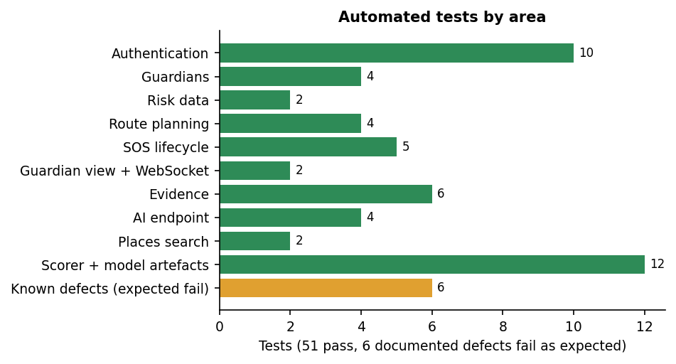
Fig. 7.1: Automated tests by area
The web front end is exercised only by the browser walk-through of the next section. It is covered by the TypeScript compiler (npm run build runs tsc --noEmit and passes) but by no automated user-interface tests.

7.4 Functional Testing
Two functional runs were made against the live application on 26 October 2026. The first is the project's own scripts/smoke_test.py, which drives the real API through twelve steps with real external calls (OSRM for the route, Gemini for the assistant). The second is a scripted browser walk-through (Playwright driving the installed Chrome at 1440 x 900) that registers an account through the interface, adds guardians, plans routes, starts a real emergency with live position updates, uploads evidence, opens the guardian's page in a second, logged-out browser context and cancels; the screenshots in Chapter 8 are its captures. The browser's geolocation is set by the test script to fixed city centres and its microphone is Chrome's built-in test tone, so position and audio are injected, not taken from a phone.
Table 7.4: Smoke test of the live API
No. | Smoke-test step | Observed
1 | Health check | Pass
2 | Register a new user | Pass: token returned
3 | Log in | Pass
4 | Add a guardian | Pass
5 | Read risk areas | Pass: 467 districts
6 | Plan a route (Hyderabad to Secunderabad, real OSRM) | Pass: one route returned, risk score 1.0
7 | Start SOS | Pass: session and share token; delivery report telegram false, email false (no credentials configured)
8 | Push a location update | Pass
9 | Upload photo evidence | Pass: 64-character SHA-256
10 | Read the public tracking page | Pass: two location points
11 | Cancel the SOS and re-read the tracking page | Pass: status cancelled
12 | Ask the AI assistant | Warning, not a pass: HTTP 500 (read timeout); later probes returned 502 with Google quota error 429

Table 7.5: Functional test cases (browser walk-through)
No. | Requirement | Test performed in the browser | Observed
F1 | Register and sign in | Fill the registration form, accept the terms, create the account | Pass: lands on the dashboard
F2 | Trusted guardians | Add three guardians (name, phone, e-mail, Telegram ID) on the profile page | Pass: Trusted guardians (3) listed; the dashboard shows 3 added
F3 | Area risk at the user's position | Open the dashboard with the position set to Delhi | Pass: tile reads Medium - GURGAON (Delhi has no district of its own in the table)
F4 | Place search | Type Jaipur on Safe routes | Pass: suggestions from Nominatim
F5 | Safe route with alternatives | Select Jaipur from Delhi | Pass: two routes, 274.1 km / 204 min and 299.5 km / 205 min, both labelled HIGH risk, risk circles drawn
F6 | Single-route case | Plan Hyderabad to Vijayawada | Pass: one route, 269.1 km / 213 min, HIGH risk (20 / 0 / 80 % low / medium / high samples)
F7 | AI assistant | Send a safety question | Fail by environment: reply "The AI assistant is unavailable right now" (Gemini quota error); the route advice panel shows the same message
F8 | SafePhrase settings | Open SafePhrase, add a second cover phrase | Pass: phrase listed with a SHA-256 fingerprint, sensitivity buttons shown, two active phrases
F9 | Start an emergency | Press the SOS button | Pass: Guardian tracking active, tracking link, live map; 0 of 3 guardians reached because no Telegram or Gmail credentials are configured
F10 | Evidence | Upload a photo, record a 3-second audio clip | Pass: two rows with SHA-256 prefixes and times
F11 | Live tracking | Open the link in a clean browser context while the position moves | Pass: the guardian page shows the owner's name, status active and a growing path
F12 | Hold to cancel | Hold the cancel button for three seconds | Pass: the capture shows the progress ring part-way ("Keep holding..."), then the dashboard with the event in recent activity; the guardian page reads "has ended the emergency"

Every step passed except the assistant, which could not be demonstrated because the shared API key had exhausted its quota, and the delivery of alerts, which was not testable without credentials. The walk-through therefore proves that the session, the tracking link, the live path, the evidence list and the cancellation work from the interface, and does not prove that a guardian is actually notified.
A separate probe of the assistant with 10 fixed prompts (five general, three emergency, two off-topic; scripts/assistant_eval.py) answered 0 of 10; all 10 failed with HTTP 502 (Google quota error 429). Whether the emergency prompts get an SOS-first reply, as the system prompt requires, was therefore not measured.

7.5 Security Testing
Access control was probed against the running server with two freshly registered users, A and B (scripts/measure_api.py), and the same rules are asserted by the automated tests. The expected result in every case is a refusal.
Table 7.6: Access-control probes on the live API
Probe | HTTP status | Result
No token: guardians, SOS start, AI, route plan | 401 / 401 / 401 / 401 | Refused
Forged token; token with its signature changed | 401; 401 | Refused
User B reads, pushes a location to, cancels A's session | 404 / 404 / 404 | Refused
User B lists or uploads evidence on A's session | 404 / 404 | Refused
User B edits or deletes A's guardian | 404 / 404 | Refused
User B's own guardian list after A added guardians | 0 entries | Isolated
Guardian tracking page with a wrong token | 404 | Refused
Guardian tracking page with the right token (no login) | 200 | Allowed by design
District list without login | 200 | Public by design
Stored evidence file fetched with no token | 200 | Allowed: finding
Evidence file name guessed from the session id alone | 404 | Refused (needs the hash prefix)

Ownership checks hold in every probe, and the guardian link behaves as designed. The weaknesses are elsewhere.

7.5.1 Documented defects (expected-failure tests)
Table 7.7: The six known defects, asserted as expected failures
Test | Desired behaviour | Observed today
test_gemini_timeout_should_be_502 | A provider timeout is reported as 502 | The read timeout is not caught: HTTP 500 after about 20 s (seen live on the first two assistant calls)
test_sos_rejects_impossible_latitude | Reject latitude 999 | Accepted (HTTP 200)
test_sos_rejects_unknown_trigger | Only manual or safephrase | Any string is stored
test_websocket_rejects_unknown_token | Refuse a token that matches no session | Connection accepted
test_evidence_has_a_size_limit | Refuse very large uploads | A 20 MB file was accepted (HTTP 200) in 0.24 s
test_evidence_files_not_served_as_html | Never serve uploads as HTML | An .html upload labelled photo is served back as text/html from the API origin

7.5.2 Further findings
- Login has no lock-out: 25 consecutive wrong passwords all returned 401 and none 429.
- A six-character password such as aaaaaa is accepted; the only rule is a minimum length of six.
- After cancellation the tracking page still returns the full location trail (91 points in the probe) and never expires, although its 404 message says "expired".
- Stored evidence is retrievable without a token by anyone who has the link; CORS allows every origin; the JWT secret in use is not the development default.
- Evidence integrity: the stored hash matches the stored file and one flipped bit changes the hash, but there is no verification endpoint and the hash sits in the same database as the file path.
- Location push after cancellation is correctly refused (400).
Not tested: penetration testing, cross-site scripting in the front end, brute-force limits beyond the 25 attempts, token replay, HTTPS deployment and the Telegram and Gmail channels.

7.6 Validation and Edge Cases
The SafePhrase matcher is the only component with a pass-or-fail behaviour that is not covered by the API tests. Its real TypeScript was transpiled and run unchanged (scripts/safephrase_eval.mjs) on hand-written transcripts: 24 that should trigger (two phrases, five kinds of utterance) and 40 ordinary sentences checked against both phrases (80 negative checks). No audio and no speech recogniser were involved, so the figures describe the matching rule only; how well Chrome's recogniser hears "sheguard" was not measured.
Table 7.8: SafePhrase matcher on written transcripts
Sensitivity | Recall on 24 phrase transcripts | False triggers on 80 ordinary-speech checks
Low (100 % of words) | 13/24 = 54.2 % | 0/80 = 0.0 %
Medium (85 % of words) | 13/24 = 54.2 % | 0/80 = 0.0 %
High (75 % of words) | 18/24 = 75.0 % | 0/80 = 0.0 %
Ultra (60 % of words) | 24/24 = 100.0 % | 8/80 = 10.0 %

Table 7.9: Triggered transcripts per kind and sensitivity
Kind of transcript | Low | Medium | High | Ultra
Exact phrase | 5/5 | 5/5 | 5/5 | 5/5
Phrase inside a sentence | 5/5 | 5/5 | 5/5 | 5/5
One word dropped | 0/6 | 0/6 | 3/6 | 6/6
One word misheard | 0/5 | 0/5 | 2/5 | 5/5
Words reordered | 3/3 | 3/3 | 3/3 | 3/3

Exact and embedded phrases and reordered words trigger at every level. The default, Medium (85 %), behaves exactly like Low for the three-word default phrase, because two words of three is 0.67: one misrecognised word blocks the alert and recall is 54.2 %. Ultra (60 %) catches every test phrase but also fires on 8 of 80 ordinary checks, for example "can you help me with my homework" and "tell me about sheguard". There is no setting that is both tolerant and quiet. One match costs about 1.47 microseconds.
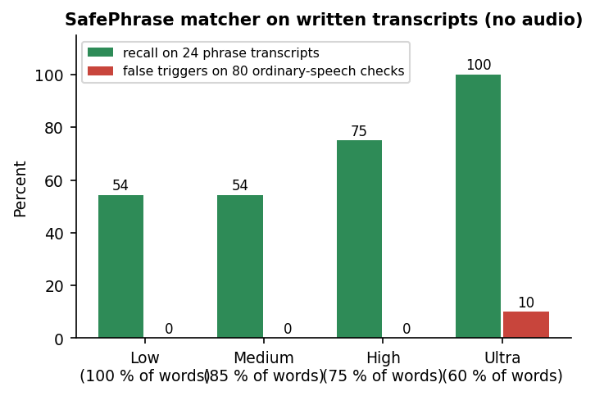
Fig. 7.2: SafePhrase recall and false triggers by sensitivity (written transcripts)
Table 7.10: Validation and edge cases
Case | Behaviour observed | Result
Registration with a 5-character password | HTTP 422 | Pass
Registration with a malformed e-mail or a duplicate | HTTP 422 and 400 | Pass
SOS start without a latitude | HTTP 422 | Pass
SOS start with latitude 999 | Accepted (HTTP 200) | Gap (xfail)
Evidence of kind video | HTTP 400 | Pass
Empty evidence file | HTTP 400 | Pass
Location push after the session is cancelled | HTTP 400 | Pass
AI request with no question | HTTP 422 | Pass
Route between points with one OSRM alternative | Six of 16 real city pairs returned a single route; it is recommended and labelled | Pass, nothing to compare
Route through a city far from any district | Scored with a district up to 231.3 km away (Lucknow); Hyderabad 149.0 km | Gap: no distance limit
Daytime and night-time scoring | Same order for all 16 pairs; scores differ by exactly 1.6 | As designed
Route planning when OSRM is down | HTTP 502 with a message | Pass (stubbed test)

7.7 Performance Testing
Response times were measured against the live server over 127.0.0.1 with one sequential client (scripts/measure_api.py) on an Intel Core i5-12500 (6 cores, 12 threads) with 15.7 GB of memory and no discrete GPU, running Windows 11, with other work present on the machine, so the figures are indicative rather than a benchmark. (The address 127.0.0.1 is used because localhost adds about two seconds of IPv6 fallback per call on this machine.)
Table 7.11: API response times (live server)
Request | Runs | Median (ms) | 95th percentile (ms) | Max (ms)
Health check | 30 | 2.1 | 4.1 | 5.5
District list (467 rows) | 30 | 31.1 | 81.3 | 87.8
Log in (bcrypt verification) | 15 | 279.0 | 314.6 | 330.0
Current user | 30 | 4.9 | 6.7 | 9.4
Add a guardian | 30 | 10.9 | 13.3 | 16.0
List guardians | 30 | 6.9 | 10.8 | 11.0
Start SOS (30 guardians, no alert channel configured) | 15 | 34.2 | 137.4 | 181.6
Push a location | 30 | 14.7 | 20.4 | 22.2
Guardian tracking page | 30 | 8.3 | 15.3 | 15.5
Upload evidence, 100 KB | 10 | 13.3 | 24.0 | 24.0
Upload evidence, 1 MB | 10 | 18.4 | 23.8 | 23.8
Upload evidence, 5 MB | 10 | 61.0 | 117.9 | 117.9
List evidence | 30 | 8.7 | 15.3 | 18.0
Plan a route (live OSRM call) | 5 | 1591.1 | 2001.5 | 2001.5

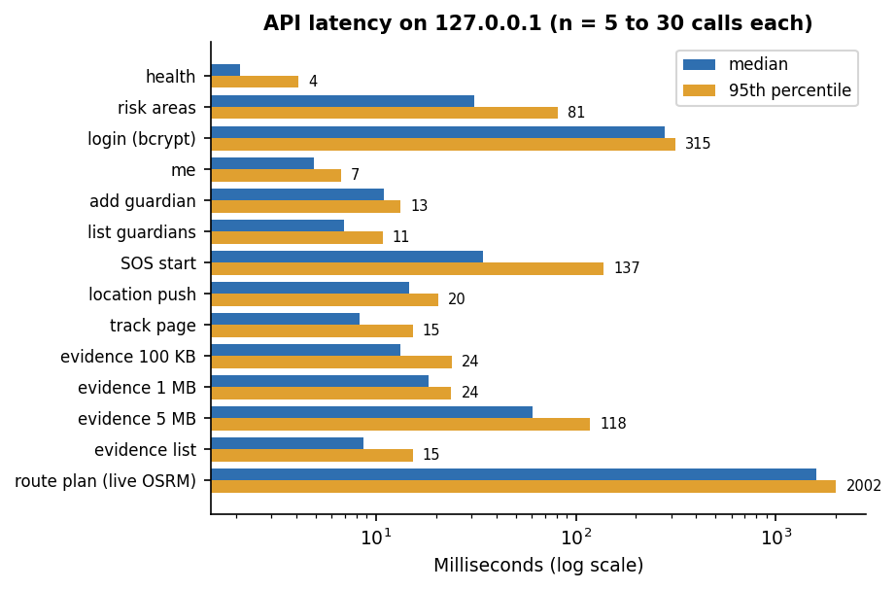
Fig. 7.3: API latency, median and 95th percentile (logarithmic axis)
A location update reaches a guardian's WebSocket quickly: measured from the moment the owner's POST is sent to the moment the viewer receives the frame, the mean is 15.4 ms with one viewer (median 13.2 ms, 95th percentile 17.2 ms, maximum 77.1 ms) and 14.6 ms until all of five viewers have it (95th percentile 18.8 ms), over 30 trials each. Every ordinary request completes in under 70 ms at the median except log-in, which takes about 279 ms because bcrypt is deliberately slow, and route planning, which takes a median of 1.6 s because it waits for the public OSRM server and then scores each alternative in pure Python (about 304 ms per route). Computing the SHA-256 of 1 MB takes about 1.1 ms, so hashing is not the cost of an evidence upload.
The SOS-start figure excludes any real alert: no Telegram or Gmail credentials were configured, so the time to deliver a message to a guardian was not measured. With real channels the request waits for each Telegram call and each SMTP exchange in turn (10 s timeout each), and the blocking SMTP call would also stall the event loop; this is read from the code. Not measured: many simultaneous users, more than five viewers per session, memory use under load, a large database, the front end's load time on a phone, battery drain of continuous speech recognition or position watching, and other hardware.

7.8 User Acceptance Testing
No user-acceptance test was carried out: no woman, guardian or other external user tried the product, and no usability or comprehension measure was collected. The browser walk-through described under functional testing was written and run by the project team; it shows that the intended flow works end to end on one machine, not that real users find it understandable, trustworthy or fast enough in a frightening situation. A field trial with consenting volunteers, on real phones and a real mobile network, with working Telegram and e-mail delivery, is the most important piece of future work. It should also measure how long it takes a guardian to notice an alert and how often a spoken phrase is recognised by the browser's recogniser in a noisy street.

7.9 Limits of the Testing Done
- The risk model has no ground truth: silhouette 0.580 and Davies-Bouldin 0.531 describe how well one number separates into three groups, not how well the tiers predict danger on a street. No correlation with real incidents, and no population-normalised comparison, was measured.
- The data are district counts for 2001-2012, 56.5 % of districts were geocoded, 11 of 35 states and union territories have no district in the table (including Uttar Pradesh, West Bengal and Delhi), and the nearest district to Hyderabad is 149 km away; route scores in uncovered areas reflect a distant district.
- The route scorer was exercised on 16 real city pairs, of which six had no alternative route; recommended routes cost on average 3.7 extra minutes when there was a choice, and the night factor cannot change the choice at all.
- The SafePhrase results are on hand-written transcripts of two phrases. They say nothing about speech-recognition accuracy, accents, background noise, a locked phone or a backgrounded browser tab.
- The AI assistant was never observed returning an answer in this run (quota error 429, earlier 503 and a read timeout); its behaviour, including the SOS-first rule for emergencies, is untested. The Telegram and Gmail alert channels were never run with real credentials.
- The 57 automated tests use stubs for all outside services and a temporary database; there are no automated front-end tests, no load or concurrency tests beyond five WebSocket viewers, no penetration tests, no iOS Safari or screen-reader check and no test over a real phone and mobile network.
- Position and microphone input in the browser walk-through were injected by the test script (fixed city centres and a test tone), the evidence photo is one of the application's own screenshots, and all timings come from one machine that was not idle.
- No user study was carried out. Six defects are recorded as expected failures; the further weaknesses (public evidence URLs, no login lock-out, a trail that never expires, an unbounded nearest-district lookup, a blocking e-mail call) were found by probing or reading the code.

CHAPTER 8
RESULTS AND OUTPUT SCREENS

8.1 Output Screens
Every screen below is a real capture of SHEGUARD running on 26 October 2026 with real data in it: an account registered through the form, three guardians added through the profile screen, real OSRM routes and Nominatim place search, a real SOS session with a moving position, evidence saved with its hash, and the guardian's page opened in a second, logged-out browser. The browser position was set by the test script to the centres of Delhi and Hyderabad (a phone's GPS was not used), the microphone was Chrome's built-in test device and the evidence photograph is one of the application's own screenshots. The captures are 1440 by 900 pixels.
Fig. 8.1: Dashboard

Dashboard. The signed-in home screen: the large SOS button, three status tiles (3 guardians added, area risk here "Medium - GURGAON" because the browser position was set to central Delhi and the nearest district in the table is Gurgaon, battery 100%), the SafePhrase tile (one active phrase, listening off) and shortcuts to the AI Guardian, Safe Routes, the guardian tracker and a local siren.
Fig. 8.2: Delhi to Jaipur: two scored alternatives
Two real OSRM driving routes from Delhi to Jaipur on the Leaflet map with the district risk circles: the "Safest route" of 274.1 km and 204 min (samples 33% low, 25% medium, 42% high) and "Alternative 1" of 299.5 km and 205 min (19% low, 5% medium, 76% high).
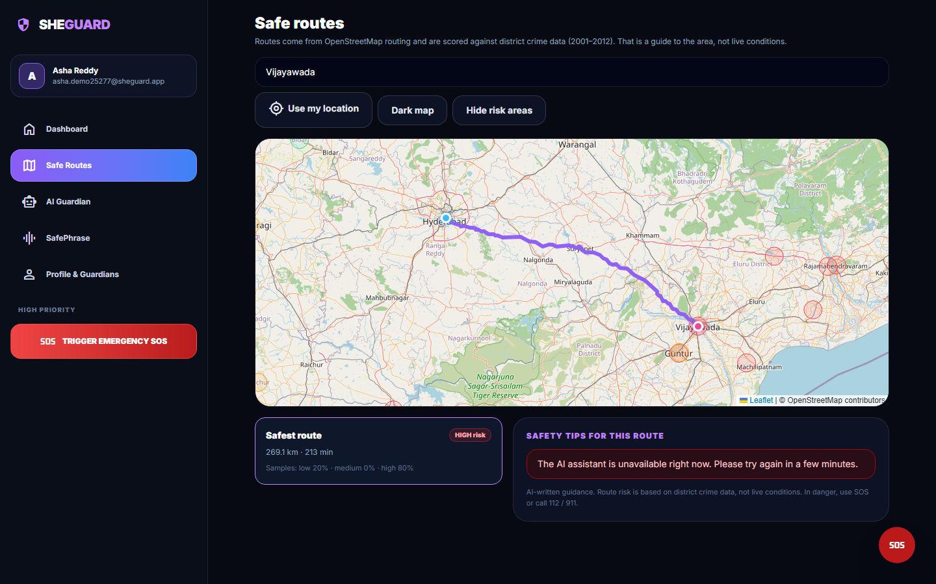  Fig. 8.3: Hyderabad to Vijayawada | 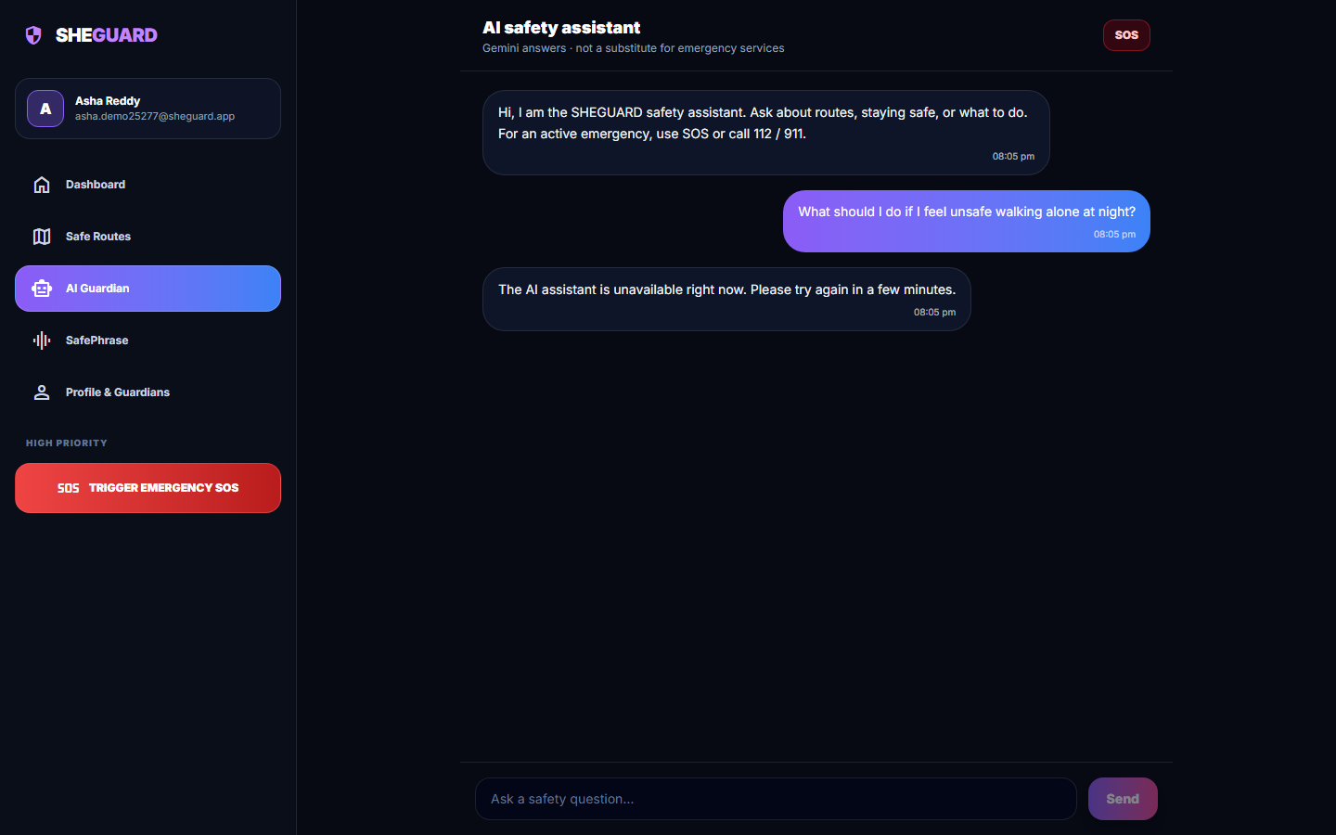  Fig. 8.4: AI Guardian chat

Hyderabad to Vijayawada. A single route of 269.1 km and 213 min with 20% low, 0% medium and 80% high samples, labelled HIGH risk. Only one alternative was returned by OSRM, so there is nothing to choose between.
AI Guardian chat. The assistant screen after the question "What should I do if I feel unsafe walking alone at night?" was sent. The reply bubble is the failure message "The AI assistant is unavailable right now" (the backend returned HTTP 502 for Google's quota error 429).
Fig. 8.5: SafePhrase settings

SafePhrase settings. The SafePhrase screen: the Turn listening on button, a Test a phrase panel that never sends an alert, the default phrase "help me sheguard" with its SHA-256 fingerprint prefix, the form for a new cover sentence and the four sensitivity levels (Low 100% of words, Medium 85%, High 75%, Ultra 60%).
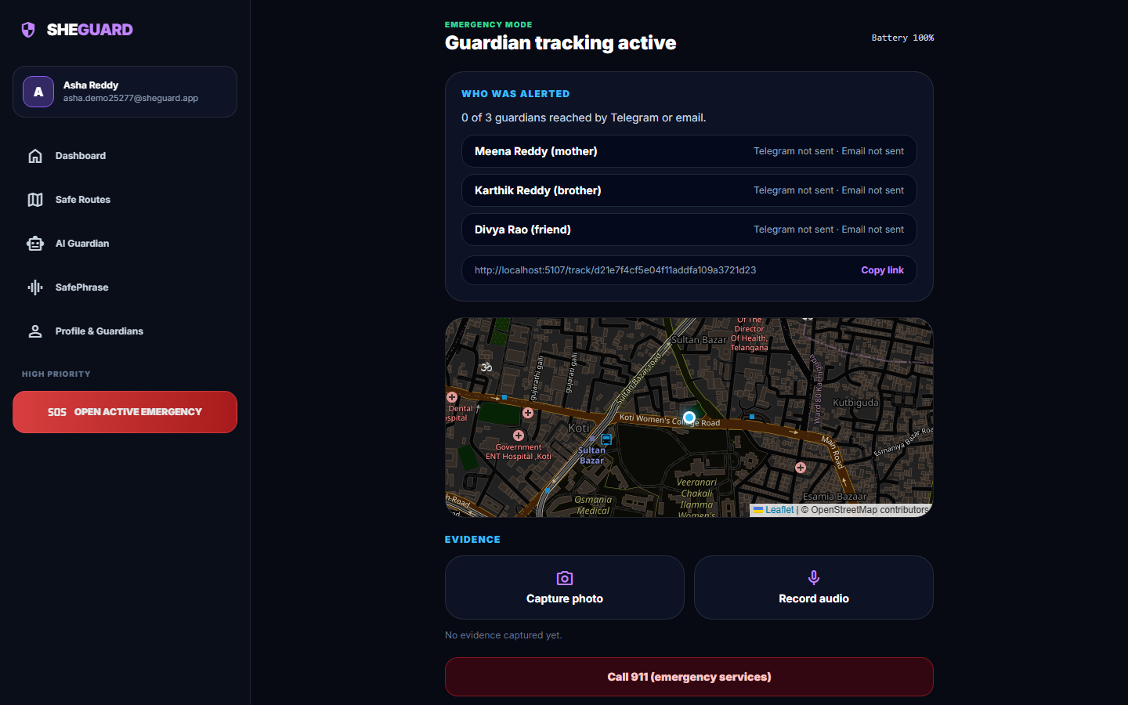
Fig. 8.6: Emergency screen after SOS
One tap on SOS at the Hyderabad position opened the emergency screen: "Guardian tracking active", the delivery report 0 of 3 guardians reached by Telegram or email (no Telegram bot token or Gmail credentials are configured, so each channel reports not sent), the live tracking link http://localhost:5107/track/... with a Copy link button, the live map, the Capture photo and Record audio buttons and the call button.
Fig. 8.7: Evidence captured

Evidence captured. A photograph and a 3-second audio clip were saved: each row shows a green tick, the kind, the beginning of the SHA-256 hash and the time stamp.
Fig. 8.8: Guardian's live tracking page
The read-only page a guardian opens from the link, in a second browser with no login: "Asha Reddy may need help", status active with start and last-update times, "Live - position updates as it changes", the map with the moving position and the pink trail, and the note to contact emergency services (112 / 911).
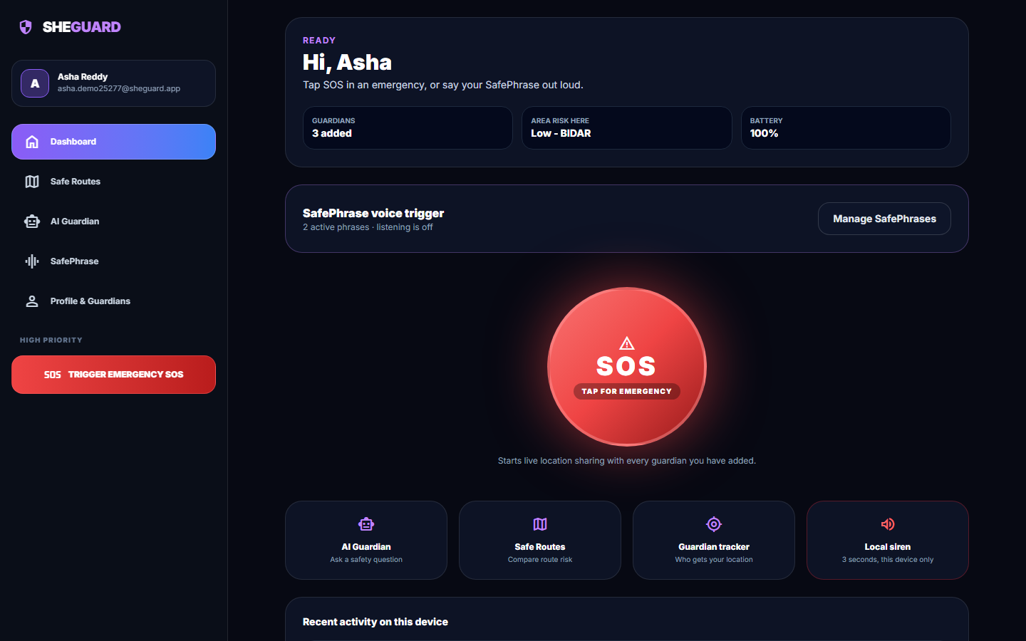  Fig. 8.9: Dashboard after cancelling | 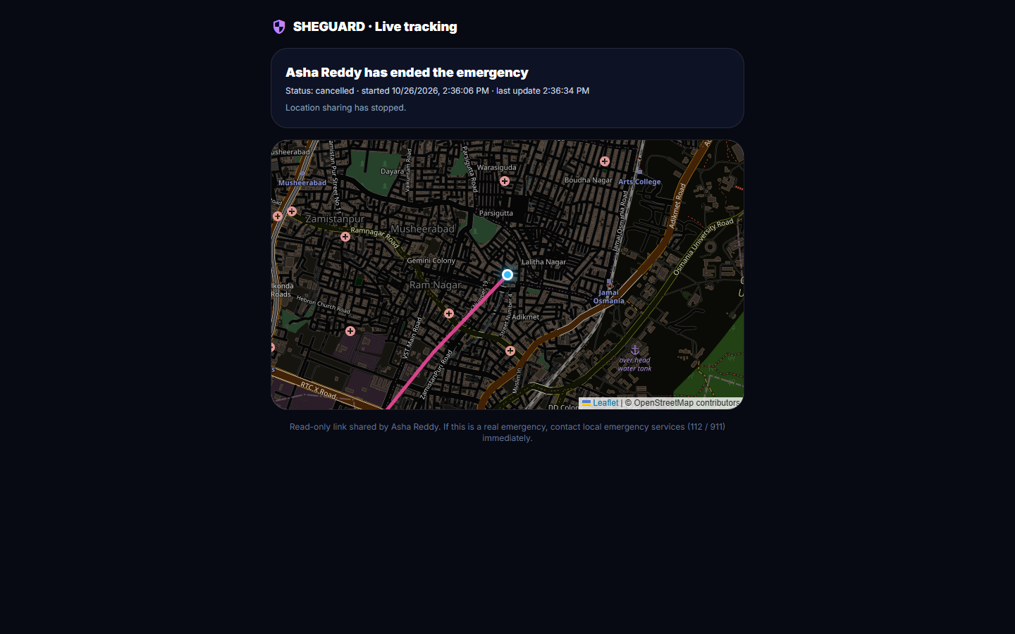  Fig. 8.10: Guardian's page after cancel

Dashboard after cancelling. After the three-second hold the app returned to the dashboard: two active phrases, the SOS button ready again and, under Recent activity on this device, the entries "Emergency cancelled - Confirmed safe by hold-to-cancel", "Audio evidence saved" and "Photo evidence saved" (hashed and time-stamped).
Guardian's page after cancel. The same tracking page after the user confirmed safety: "Asha Reddy has ended the emergency", status cancelled, "Location sharing has stopped", with the full trail kept on the map.

8.2 Model Performance
SHEGUARD contains one trained model, the area-risk model: K-Means with three clusters on a single number per district, the average number of recorded crimes against women per reporting year. Everything else that is scored (the route score, the SafePhrase matcher) is rule-based. There is no ground truth for "how risky a district is" and therefore no accuracy, precision or recall for this model and no train/test split: the model is fitted on all 467 districts, and the only measures available are internal cluster-quality indices, which describe how well one number separates into groups, not whether the groups predict harm. All figures come from experiments/metrics.json, experiments/eval/metrics.json and the re-run in experiments/study/metrics.json, produced on an Intel Core i5-12500 with 15.7 GB RAM and no GPU; fitting takes well under a second.
Table 8.1: Headline results of the area-risk model and the route scorer
Measure | Result | Data
Districts clustered | 467 of 827 (56.5% geocoded) | district file 2001-2012
Silhouette (shipped, k = 3) | 0.5798 | 467 districts
Davies-Bouldin (lower is better) | 0.531 | 467 districts
Calinski-Harabasz | 1155.4 | 467 districts
Tiers low / medium / high | 278 / 148 / 41 | mean 97.76 / 327.92 / 720.93 crimes per year
Re-run agrees with the shipped table | 100% | district_risk.csv
Stability over 30 random starts (adjusted Rand index) | min 0.659, mean 0.790 | k = 3, n_init = 1
Route scoring sanity check | all-high route 5.0, all-low route 1.0 (pass) | ml/eval.py
Routes scored (16 real city pairs) | 16 routed, 10 with an alternative | OSRM demo server
Time to score one route | 304 ms | pure Python, 467 districts
Automated tests | 51 passed, 6 documented defects fail as expected | pytest

8.2.1 Choice of the number of clusters
Table 8.2: Cluster-quality indices for k = 2 to 8 on the standardised crime rate
k | Silhouette | Davies-Bouldin | Inertia
2 | 0.6616 | 0.5507 | 159.78
3 | 0.5798 | 0.5310 | 78.09
4 | 0.5955 | 0.4932 | 41.78
5 | 0.5598 | 0.5181 | 29.63
6 | 0.5615 | 0.5400 | 20.49
7 | 0.5557 | 0.5382 | 14.86
8 | 0.5525 | 0.5018 | 11.34

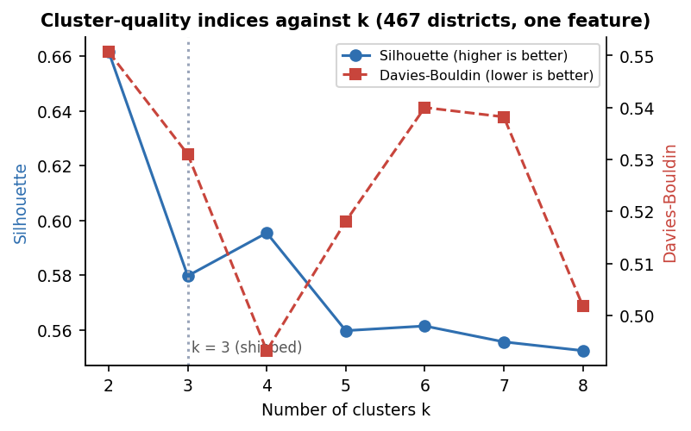
Fig. 8.11: Silhouette and Davies-Bouldin index against the number of clusters
The shipped k = 3 is a design choice, not the optimum of either index: k = 2 has the highest silhouette (0.662) and k = 4 has both a higher silhouette (0.596) and a lower Davies-Bouldin value (0.493) than k = 3 (0.580, 0.531). Three tiers were chosen because the interface shows low, medium and high. The differences between k = 3 to 8 in silhouette are small (0.553 to 0.596), so the data do not strongly prefer one number.

8.2.2 What the tiers are
Table 8.3: Value ranges of the three tiers
Tier | Crimes per year (min to max) | Districts | Share
Low | 0.0 to 212.0 | 278 | 60%
Medium | 215.5 to 522.0 | 148 | 32%
High | 537.7 to 1191.6 | 41 | 9%

Fig. 8.12: Distribution of the crime rate with the two cut-offs that K-Means found
Because the only feature is one number, K-Means is equivalent to two thresholds: 213.75 and 529.83 crimes per year, which reproduce the K-Means tiers for 100% of districts. The model is therefore a data-driven pair of cut-offs, not a multi-feature classifier. The silhouette of 0.58 means that these three groups are cleanly separated along this one axis; it does not mean that the groups describe safety.
Other ways of cutting the same number disagree with K-Means for many districts (Figure on tiering agreement): Ward hierarchical clustering agrees for 83.3%, a Gaussian mixture for 72.6%, fixed cut-offs of 100 and 300 for 54.6% and equal-count terciles for 49.2%. Across 30 random starts the adjusted Rand index against the shipped clustering ranges from 0.66 upward (mean 0.79), so districts near the cut-offs change tier with the initialisation. The size of the 41-district "high" group is a property of the method chosen.

8.2.3 What the score counts
The crime rate adds seven recorded categories. Cruelty by husband or relatives is 40.0% of everything counted, assault on modesty 25.8%, rape 13.0%, kidnapping and abduction 11.7%, insult to modesty 5.2% and dowry deaths 4.2%. A district's tier is therefore driven mainly by recorded domestic-violence counts, which say little about the safety of a street at night. The measure is also a raw count, not a rate per head of population: the highest values are West Godavari (1,191.6), Vijayawada (1,059.0), Guntur (1,032.5), Jaipur (1,001.4) and Krishna (895.2), and large or well-reporting districts rank high. Vijayawada, Jaipur and Mumbai are averages over only 5 reported years.

8.2.4 Coverage of the district table
Only 467 of 827 district entries (56.5%) could be geocoded; the others were dropped rather than guessed. The table has no district at all for Uttar Pradesh (77 entries), West Bengal (30), Delhi (24), Uttarakhand (13), Tripura (10) and six small union territories. The consequence appears when the nearest district to a city centre is measured (40 cities): the median is 8.1 km, but 7 cities are more than 100 km from any district, among them Hyderabad (149 km), Secunderabad (147 km), Warangal (195 km), Kolkata (191 km), Lucknow (231 km) and Kanpur (164 km). The scorer takes the nearest district however far away it is.
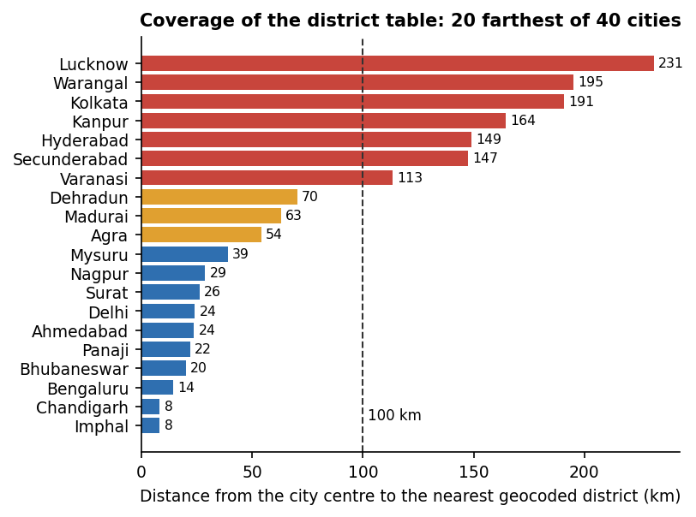
Fig. 8.13: Distance from city centres to the nearest district in the risk table (20 farthest of 40 cities)

8.2.5 Route scoring on real routes
Sixteen real city pairs were routed through OSRM and scored. 10 pairs returned two alternatives and 6 returned one, so for 37.5% of trips there was nothing to choose between. The recommended (lowest-score) route was also the OSRM-fastest in 11 of 16 pairs, and where an alternative existed the safest pick cost 3.7 minutes more on average. Along the 16 routes the mean distance to the nearest district was 61.9 km (maximum 231.3 km).
Table 8.4: Scores of eight of the 16 routed pairs (lower is safer; the first number is OSRM's first route)
Pair | Routes | Km | Score by day | Score at night | Nearest district, mean km
Hyderabad - Warangal | 2 | 149 / 157 | 2.87 / 2.52 | 4.60 / 4.03 | 185
Delhi - Jaipur | 2 | 285 / 312 | 3.20 / 4.22 | 5.13 / 6.75 | 23
Delhi - Agra | 2 | 203 / 210 | 4.54 / 4.43 | 7.27 / 7.09 | 45
Mumbai - Pune | 1 | 145 | 1.85 | 2.95 | 22
Kolkata - Patna | 2 | 605 / 636 | 1.15 / 1.36 | 1.84 / 2.18 | 61
Lucknow - Kanpur | 2 | 94 / 96 | 1.02 / 1.02 | 1.64 / 1.64 | 199
Bhopal - Indore | 2 | 188 / 256 | 3.99 / 3.11 | 6.38 / 4.97 | 21
Chandigarh - Delhi | 2 | 269 / 288 | 2.63 / 1.95 | 4.21 / 3.12 | 18

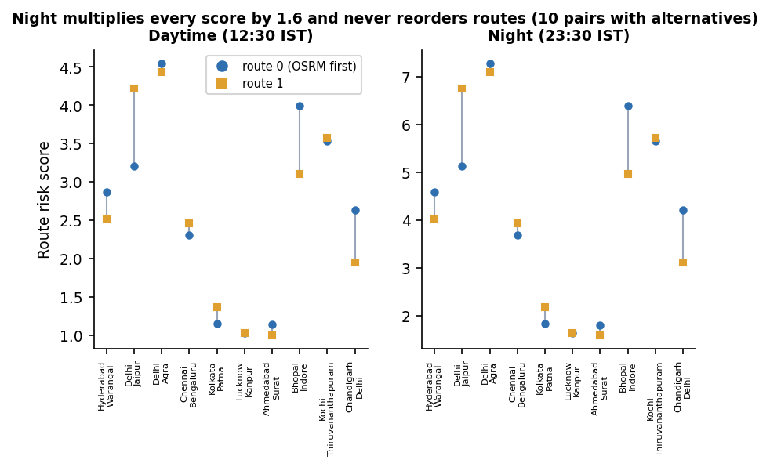
Fig. 8.14: Route scores by day and at night for the pairs that returned two alternatives
The night factor changes the numbers but never the choice. The same route scores 2.5 by day and 4.0 at night (ratio 1.6); because the multiplier of 1.6 is applied to every sampled point of every route, the ranking was identical by day and at night for all 16 of 16 pairs. It affects only the displayed value and the route label. Changing the tier weights to 1/2/3 or 1/3/9 changed the recommended route in 0 of 10 pairs, and changing the sampling step (1, 4, 16, 32 instead of 8) changed it in 1 of 10.
Scoring one route takes about 304 ms because every sampled point is compared with all 467 districts in Python; a live POST /api/routes/plan including the OSRM call took 1.6 s on average (see the table of response times).

8.3 Software Verification Results
The project has a pytest suite in tests/ that uses a throw-away SQLite database and replaces OSRM, Gemini, Telegram and Gmail by stubs, so it runs offline in about 14 s. 51 of 57 tests pass; the other 6 are expected failures that assert the behaviour a hardened system should have and fail on the shipped code. They are kept visible instead of being deleted.
Table 8.5: Automated test results by area
Area | Tests | What is checked
Authentication | 10 | register, duplicate e-mail, validation (short password, bad e-mail, missing field), login and wrong password, bcrypt hash stored, token required, forged and expired token rejected
Guardians | 4 | create, list, update, delete; another user's guardian cannot be read, edited or deleted
Risk data | 2 | 467 districts served with three tiers and scores in 0-100; tier counts 278 / 148 / 41
Route planning | 4 | alternatives sorted by risk, first one recommended; login required; OSRM failure gives 502; no route gives 404
SOS lifecycle | 5 | session and tracking link, alert fan-out to every configured channel, ordered location trail, cancel and no updates afterwards, owner-only access, login and coordinates required
Guardian view and WebSocket | 2 | public page with owner name and last position; unknown token 404; WebSocket pushes a location and the cancel message
Evidence | 6 | SHA-256 equals the hash of the stored file; one flipped bit changes it; audio accepted, other kinds and empty files rejected; count on the session; other users get 404
AI endpoint | 4 | answer returned, login and question required, provider error gives 502, missing key gives a clear error
Places search | 2 | login required, one-character query rejected
Scorer and model artefacts | 12 | haversine distance, nearest district, tier weights 1.0 / 2.5 / 5.0, night factor 1.6 on every route, no reordering at night, empty route, no-district fallback, night window in UTC, shipped model loads, district table consistent, tiers are threshold bands
Known defects (expected fail) | 6 | see the next table

Table 8.6: The six documented defects
Defect (test that documents it) | Observed behaviour
Gemini timeout | An httpx.ReadTimeout is not caught, so the API answers HTTP 500 instead of 502 (seen live: the first two assistant calls returned 500 after 20 s)
Latitude 999 | POST /api/sos/start with latitude and longitude 999 is accepted (HTTP 200)
Unknown trigger | trigger is a free string: any value is stored
WebSocket token | /ws/track/{token} accepts a token that matches no session
Upload size | No limit: a 20 MB "audio" upload was accepted in 0.24 s
Evidence served as HTML | A file named page.html uploaded as a photo is served back from /evidence-files/ as text/html on the API origin

8.3.1 Response time
Table 8.7: API response times (server and client on 127.0.0.1, one client, sequential calls)
Endpoint | n | Mean (ms) | Median (ms) | 95th percentile (ms)
Health check | 30 | 2.3 | 2.1 | 4.1
Risk areas (467 rows) | 30 | 36.2 | 31.1 | 81.3
Log in (bcrypt) | 15 | 285.2 | 279.0 | 314.6
Profile | 30 | 5.1 | 4.9 | 6.7
Add guardian | 30 | 11.0 | 10.9 | 13.3
Start SOS (30 guardians, no channel configured) | 15 | 50.7 | 34.2 | 137.4
Push a location | 30 | 15.3 | 14.7 | 20.4
Guardian tracking page | 30 | 9.4 | 8.3 | 15.3
Upload evidence 100 KB | 10 | 15.0 | 13.3 | 24.0
Upload evidence 1 MB | 10 | 19.1 | 18.4 | 23.8
Upload evidence 5 MB | 10 | 68.2 | 61.0 | 117.9
Plan a route (live OSRM) | 5 | 1628.6 | 1591.1 | 2001.5

Every call except log-in and route planning answers within a few tens of milliseconds. The bcrypt log-in takes about 279 ms, which is intended, and a route plan about 1.6 s because it waits for the public OSRM server. The time from a location being posted to a guardian's page receiving it over the WebSocket was 15.4 ms on average for one viewer (95th percentile 17.2 ms) and 14.6 ms until all five of five viewers had it (95th percentile 18.8 ms), 30 trials each. The time to deliver an alert by Telegram or e-mail was not measured, because no credentials are configured; with real channels the start-SOS request would wait for each guardian's send in turn, and send_email is a blocking call inside an asynchronous route. No load test with many concurrent users was run.

8.3.2 Access control and input handling
Table 8.8: Access-control and input probes against the live API
Probe | Result
No token on guardians, SOS start, AI and route planning | HTTP 401 on all four
Forged or tampered JWT | HTTP 401
User B reads, pushes to, cancels, lists evidence of or uploads to user A's session | HTTP 404 on all five
User B edits or deletes user A's guardian; B's own list | HTTP 404 on both; B sees 0 guardians
Public tracking page with a wrong / the right token | HTTP 404 / 200
Stored evidence file requested with no token | HTTP 200 (file name needs the 16-hex hash prefix; a guessed name gives HTTP 404)
25 consecutive wrong passwords | all HTTP 401, no lockout or rate limit
Password of six characters, "aaaaaa" | accepted: the only rule is a minimum length of six
Location push after cancel | HTTP 400 (correct)
Tracking page after cancel | HTTP 200 with the whole trail (91 points); there is no expiry
Evidence kind video; empty file | HTTP 400 on both

Evidence integrity. The hash is computed on the server when the file arrives. Recomputing it from the stored file gives the same 64-character value, and flipping one bit of the stored file changes it; hashing 1 MB takes about 1.1 ms. There is no verification endpoint, and the hash is stored in the same database as the file path, so tampering is detected only if someone recomputes and compares.

8.3.3 SafePhrase matcher
Table 8.9: The product's SafePhrase matcher on written transcripts
Sensitivity (share of words needed) | Recall on 24 phrase transcripts | False triggers on 80 ordinary-speech checks
Low (100%) | 13/24 = 54.2% | 0/80 = 0.0%
Medium (85%) | 13/24 = 54.2% | 0/80 = 0.0%
High (75%) | 18/24 = 75.0% | 0/80 = 0.0%
Ultra (60%) | 24/24 = 100.0% | 8/80 = 10.0%

The matcher in frontend/src/lib/safephrase.ts was run unchanged on hand-written transcripts of two phrases ("help me sheguard" and "please call my brother now"): exact, embedded in a sentence, one word dropped, one word misheard and reordered, plus 40 ordinary sentences. No audio and no speech recogniser were involved, so the accuracy of Chrome's recogniser on the phrase was not measured. Exact and embedded phrases trigger at every level (10 of 10). At the default Medium level the recall is 54.2%, because for a three-word phrase one missing word (2 of 3 = 0.67) is below 0.85, so Medium behaves like Low. Ultra finds all 24 but also fires on sentences such as "can you help me with my homework" and "tell me about sheguard" (8 of 80). A match costs 1.5 microseconds.

8.3.4 AI safety assistant
Ten fixed prompts (five general, three emergencies, two off-topic) were sent once each through POST /api/ai/ask. 0 of 10 were answered. All 10 returned HTTP 502 because Google replied with error 429 (quota exceeded). Earlier in the same run the first two calls returned HTTP 500 after a 20 s read timeout and one returned a 503 "high demand" error from Google. The questions the evaluation was designed to answer, whether the first line of an emergency answer points to SOS or emergency services as the system prompt demands and whether answers stay under 150 words, could therefore not be measured. The endpoint, its error mapping and its login check are covered by the stubbed tests only.
The end-to-end flow was also executed in the browser as shown in the output screens: registration, guardians, route planning, SOS with a moving position, evidence, the guardian's live page and hold-to-cancel; and the earlier scripts/smoke_test.py passes all 12 live steps (the Gemini step only warns).

8.4 Comparison with the Base Paper
The base paper [1] (SafeRoutes, IEEE Access 2024) clusters regions for women's safety from public Indian data: 2001 and 2011 district population, the 2013 IPC crimes against women, literacy, per-capita expenditure, police strength and forest cover. After imputation, scaling and a Pearson and Spearman correlation analysis it applies K-Means and Gaussian mixture models, finds that three to four clusters suit its data, scores clusters against "dummy" data from globally safe cities and designs a cab-service integration with a 1.96x safety buffer and deviation alerts. Its results are largely "anticipated": correlation matrices and cluster-selection tables, no accuracy figures and no evaluation of the cab integration. SHEGUARD adopts the district-clustering idea and the safe-route guidance and adds a full emergency workflow. The two works use different data, different numbers of features and different sizes, so their numbers cannot be compared and no claim of being better is made.
Table 8.10: SHEGUARD and the base paper
Measure | Base paper [1] (as printed in its tables) | SHEGUARD
Features clustered | Many (crime, population, literacy, expenditure, police, forest cover) | One (average crimes per year)
Data year | IPC 2013 and census data | District crimes 2001-2012
Number of districts | Not stated | 467 (of 827 entries)
Algorithms compared | K-Means, Gaussian mixture, hierarchical (Ward) | K-Means in the product; Gaussian mixture and Ward only in this project's study
Preferred number of clusters | 3-4 | 3 (design choice; k = 4 scores better)
Silhouette at k = 3 | 0.416 (Table 3) | 0.580
Davies-Bouldin at k = 3 | 0.970 (Table 5) | 0.531
Calinski-Harabasz at k = 3 | 221.0 (Table 4) | 1155.4
Travel integration | Cab vendors, deviation alerts (designed, not evaluated) | OSRM alternatives scored by risk (implemented, 16 pairs scored)
Emergency features | None | SOS, SafePhrase, live guardian link, hash-stamped evidence, assistant (implemented; delivery channels and assistant not verified live)

The paper's silhouette column is headed "Explained Variance" and its Figure 11 shows silhouette values near 0.25-0.31, which differ from Table 3; the table values are quoted as printed. SHEGUARD's indices are higher because a single count is inherently easier to separate into groups than a multi-feature space, which is not evidence of a better safety model. What SHEGUARD lacks compared with the paper: population and per-capita normalisation, police-presence and socio-economic features, a cluster-selection analysis inside the product and cab-vendor deviation alerts.
The other papers read for this project give context rather than comparable numbers. The IoT review [2] (2016-2022 studies) found that pulse-rate and pressure sensors dominate wearable devices and that systems with automatic activation and little human interaction are still needed, which motivates SafePhrase and one-tap SOS. The ESP32-camera application [6] reports SOS delivery in 4-6 seconds and 93% accuracy on crime-zone classification of pre-defined test locations, on its own hardware and data; SHEGUARD's alert delivery was not measured. The batch survey entries [3], [4] and [5] could not be retrieved, so no result from them is used.

8.5 Sample Inputs and Outputs
The following are real exchanges with the running application on 26 October 2026 (coordinates and identifiers as stored; long coordinate lists are omitted).
Table 8.11: Sample inputs and outputs
Input | Output
Hyderabad (17.385, 78.4867) to Vijayawada (16.5062, 80.648), POST /api/routes/plan | One route, 273.5 km, 217 min, risk score 4.246 by day; 91 low, 0 medium and 392 high samples; recommended
One tap on SOS at (17.385, 78.4867), trigger manual | Session 44 with a 32-character share token and tracking URL; delivery report for three guardians: Telegram false, e-mail false
Four location updates while moving north-east, then (17.412, 78.512) | Seven stored points in the trail; last position and last-update time kept on the session
Photo and a 3-second audio clip uploaded | Two evidence rows with 64-character SHA-256 values and the capture location and time
Guardian opens the tracking link | Public read-only payload with name, status, last position and the full path
Hold the cancel button for three seconds | Status cancelled, end time set, WebSocket message cancelled pushed to the guardian page
Question to the assistant | HTTP 502 with Google quota error 429; the interface shows the unavailable message

Listing: A real route-plan response (coordinates shortened)
POST /api/routes/plan {"origin_lat": 17.385, "origin_lng": 78.4867, "dest_lat": 16.5062, "dest_lng": 80.648}
{"routes": [{"index": 0, "distance_m": 273495.9, "duration_s": 13023.3, "risk_score": 4.246,
"risk_tiers": {"low": 91, "medium": 0, "high": 392}, "is_night": false,
"recommended": true, "coordinates": [[17.385, 78.4867], ... 3857 points]}],
"safest_index": 0}

Listing: The start-SOS response of the captured session (read back from the database and the screenshot)
POST /api/sos/start {"lat": 17.385, "lng": 78.4867, "trigger": "manual"}
{"session_id": 44, "share_token": "d21e7f4cf5e04f11addfa109a3721d23",
"tracking_url": "http://localhost:5107/track/d21e7f4cf5e04f11addfa109a3721d23",
"started_at": "2026-10-26T14:36:06.208981",
"delivery": [{"guardian": "Meena Reddy (mother)", "telegram": false, "email": false},
{"guardian": "Karthik Reddy (brother)", "telegram": false, "email": false},
{"guardian": "Divya Rao (friend)", "telegram": false, "email": false}]}

Listing: The guardian's tracking payload after the session was cancelled (timestamps rounded to seconds)
GET /api/track/d21e7f4cf5e04f11addfa109a3721d23 (no login)
{"status": "cancelled", "trigger": "manual", "started_at": "2026-10-26T14:36:06", "ended_at": "2026-10-26T14:36:55",
"last_lat": 17.412, "last_lng": 78.512, "last_update_at": "2026-10-26T14:36:44", "user_name": "Asha Reddy",
"path": [{"lat": 17.385, "lng": 78.4867}, {"lat": 17.385, "lng": 78.4867}, {"lat": 17.3895, "lng": 78.4905},
{"lat": 17.395, "lng": 78.496}, {"lat": 17.401, "lng": 78.502}, {"lat": 17.4075, "lng": 78.5075}, {"lat": 17.412, "lng": 78.512}]}

Listing: The two evidence records of the session (capture times omitted)
GET /api/sos/44/evidence
[{"id": 77, "kind": "photo", "sha256": "894273f4fafd77e1b2a310395099313a0b15b6f2a520edec769b0ac36d191dd7", "lat": 17.385, "lng": 78.4867},
{"id": 78, "kind": "audio", "sha256": "aa9433e57325c5438bcb36665386ee822892d42d8fd91054d6ecbdc13f0d9bc1", "lat": 17.385, "lng": 78.4867}]

8.6 Success and Failure Analysis

8.6.1 Where it works
- The emergency workflow runs end to end in a browser: register, add guardians, start an SOS, stream a moving position, save hashed evidence, let a guardian follow without an account and cancel with a deliberate three-second hold; the guardian's page receives location and cancel messages in about 15 ms on this machine.
- User data are separated: every probe of another user's session, evidence or guardians returned 404, unauthenticated calls returned 401, and 51 automated tests pass.
- The risk model is reproducible (shipped numbers re-created exactly) and the route scorer ranks an all-high-risk route above an all-low-risk route (5.0 against 1.0).
- Evidence hashing detects a single flipped bit, and uploads of 100 KB to 5 MB take 13 to 61 ms (median).
- The interface is honest about its limits: the landing page and route screens say that risk comes from 2001-2012 district data, and failures (no alert channel, assistant unavailable) are shown as such.

8.6.2 Where it fails or is weak
Table 8.12: Failure and weakness analysis
Observation | Cause | Effect / handling
Hyderabad is 149 km, Warangal 195 km, Kolkata 191 km and Lucknow 231 km from the nearest district in the table | Only 56.5% of districts were geocoded; Uttar Pradesh, West Bengal and Delhi have none; the scorer has no distance limit | Routes through these cities are scored with a district hundreds of kilometres away; extend geocoding and cap the distance
The night multiplier never changes which route is recommended (16 of 16 pairs) | The same factor 1.6 multiplies every sampled point of every route | Night only changes the displayed number; use time-dependent tier weights or night-specific data
37.5% of the trips tested returned a single route | OSRM demo server returns alternatives only when they exist | Nothing to compare; add waypoints or another routing engine
Guardians reached: 0 of 3 in every captured emergency | TELEGRAM_BOT_TOKEN, GMAIL_ADDRESS and GMAIL_APP_PASSWORD are empty | Only the in-app link works; alert delivery is unverified, and send_email blocks the event loop
The AI assistant answered 0 of 10 prompts | Gemini quota exhausted (429), 503 under load, and a 20 s read timeout that returns 500 | Interface shows a friendly message; map timeouts to 502 and add retries or a fallback
SafePhrase Medium recall 54.2%; Ultra false triggers 10.0% | Word-window rule: one wrong word fails a three-word phrase at Medium; 60% of words is too loose | Use phrases of five or more words, test with real speech, add a confirmation step
Stored evidence is retrievable by URL with no login; an .html upload is served as text/html; no size limit | Static mount of the evidence folder and the client's extension is kept | Serve files through an authorised route, force a safe content type, cap upload size
Impossible coordinates, free-text trigger and unknown WebSocket tokens are accepted; no login lockout | No range validation, no rate limiting | Add schema validation and throttling
A district's tier follows raw counts dominated by domestic-violence reports (40% of the counted total) | Single feature, no population normalisation | Use rates per population and street-level categories

8.7 Limits of the Results
- No ground truth. The cluster indices (silhouette 0.58, Davies-Bouldin 0.53) measure separation of one number, not agreement with real danger; no train/test split exists and no field validation was done.
- Old, coarse data. The district file covers 2001-2012, counts are not per head of population, 56.5% of districts are geocoded and several large states are missing.
- Written transcripts, not speech. The SafePhrase figures test the matching rule on hand-made text; the recogniser was not measured.
- Injected position and stand-in media. The screenshots use a position set by the test script, a test-tone microphone and the application's own screenshot as the photograph; no phone, GPS or camera was used.
- Unverified channels. Alert delivery by Telegram and e-mail and the Gemini assistant could not be demonstrated returning results in this run.
- Small single-machine measurements. Timings come from one desktop with sequential calls (5 to 30 per endpoint), one client and no concurrent load; no user study was carried out.
- No numeric comparison with the base paper is possible, as explained in the section Comparison with the Base Paper.

8.8 Objectives Against Outcomes
Table 8.13: Objectives against outcomes
Objective | Outcome | Evidence
1. Provide Safe Route guidance using available safety information | Partly achieved | Working OSRM + district-risk scoring with a heat layer and route cards, but the data are 2001-2012 counts with 56.5% geocoding and gaps around Hyderabad, Kolkata and Lucknow; night factor never reorders routes; 37.5% of trips have one route
2. Quick emergency activation through SafePhrase and Smart SOS | Partly achieved | One-tap SOS and hold-to-cancel work; SafePhrase matcher tested on written text only (Medium recall 54.2%, Ultra false triggers 10%); no shake, power-button or automatic trigger
3. Share live location with trusted guardians during an emergency | Achieved (link); delivery unverified | WebSocket push about 15 ms, no guardian login, public tracking page; Telegram and e-mail delivery reported 0 of 3 because no credentials are configured
4. Preserve evidence (timestamps, location, audio, images) securely | Partly achieved | Photo and audio saved with time, location and SHA-256 (tamper changes the hash); files retrievable by URL without login, no size limit, no verification endpoint
5. AI-powered safety assistance using the Gemini API | Implemented, not demonstrated | Endpoint, system prompt and interface exist; 0 of 10 probe prompts answered (quota 429, timeout returns 500)
6. Protect user data with role-based access and Row Level Security | Partly achieved | bcrypt + JWT, every query scoped to the owner (all cross-user probes 404); no database RLS (SQLite) and no roles beyond user and token-based guardian

CHAPTER 9
CONCLUSION

9.1 Summary of the Work
This project built SHEGUARD, a women's safety platform that supports a user before, during and after an emergency. Before: OSRM route alternatives are scored against an area-risk table made by K-Means clustering of district crime counts and shown on a map with a heat layer. During: one tap on SOS, or a spoken SafePhrase, starts an emergency session that streams the position over a WebSocket to a read-only tracking page that guardians open from a link without an account, and that can try to alert them by Telegram and e-mail. After: photographs and audio are saved with time, place and a SHA-256 hash, and a three-second hold cancels the emergency. A Gemini-backed assistant answers safety questions. The system has 19 HTTP endpoints, one WebSocket route, six database tables, a React web application installable as a PWA and a pytest suite of 57 tests.
On the measured side: the K-Means model (k = 3) on 467 districts has silhouette 0.58 and Davies-Bouldin 0.53, but it is two cut-offs (213.8 and 529.8 crimes per year) on one number, built from 2001-2012 counts with 56.5% of districts geocoded. Guardian pages receive a position in about 15 ms locally, all cross-user access probes were refused and 51 tests pass, with six more documenting defects. Not demonstrated in this run: alert delivery by Telegram or e-mail (no credentials) and any answer from the Gemini assistant (quota exhausted).

9.2 Objectives Achieved
Of the six objectives of the project, one is achieved as far as it could be tested (live location sharing through a link), one is implemented but not demonstrated (the Gemini assistant), and four are achieved in part. Safe route guidance (objective 1) works but rests on coarse historical data with large coverage gaps. Quick activation (objective 2) has a working one-tap SOS and a SafePhrase matcher that was tested on text only. Evidence preservation (objective 4) hashes and time-stamps files but serves them by URL without a login, and data protection (objective 6) is done with owner-scoped queries rather than database Row Level Security. Chapter 8 gives the evidence for each objective.

9.3 Key Findings
1. The risk model is two thresholds. K-Means on one feature reproduces exactly as cut-offs at 213.8 and 529.8 crimes per year; a silhouette of 0.58 shows clean separation of that number, not safety.
2. The tiers depend on the method. Ward clustering agrees with the shipped tiers for 83% of districts, a Gaussian mixture for 73%, and random starts move districts near the cut-offs (adjusted Rand index down to 0.66).
3. Coverage decides usefulness. Only 56.5% of districts are in the table; Hyderabad is 149 km, Kolkata 191 km and Lucknow 231 km from the nearest one, and the scorer has no distance limit.
4. The night factor is cosmetic. It multiplies all routes by 1.6, so the recommended route is the same by day and night in 16 of 16 test pairs; and 6 of 16 trips returned only one route.
5. The score counts mostly domestic violence in raw numbers. Cruelty by husband or relatives is 40.0% of all counted crimes, and counts are not divided by population, so big districts rank high.
6. Live tracking is fast and hardware-light. A guardian's page receives a position in about 15 ms (local), every other call except log-in and route planning answers in tens of milliseconds, and guardians need no account.
7. SafePhrase trades recall for false alarms. On written transcripts Medium recalls 54.2% with no false triggers and Ultra recalls 100% with 10% false triggers; real speech was not tested.
8. Testing found real defects: uncaught Gemini timeouts (500), unvalidated coordinates and triggers, no upload limit, publicly retrievable evidence files, an HTML upload served as text/html, no login lockout and a WebSocket that accepts any token.
9. External services decide the experience. The assistant answered 0 of 10 prompts (quota 429) and no alert channel was configured, so the two features that depend on third-party accounts could not be shown working.

9.4 Practical Applications
In its present form SHEGUARD is a working prototype and a teaching platform for a women's safety application; it must not be relied on in a real emergency, and its route risk must not be read as a statement about the safety of a place. With population-normalised and more recent data, full geocoding, configured alert channels and the security fixes listed under the limitations, the same structure could support four uses: a guardian-facing live link that needs no app; a quick-activation channel for users who cannot reach a phone; a route comparison that includes safety next to time; and an evidence log that a user can later show with its hash and time stamp.

9.5 Known Limitations
- The risk model uses one feature, old data (2001-2012), raw counts and 56.5% of districts; it has no ground truth, no held-out set and no field validation.
- Uttar Pradesh, West Bengal, Delhi and Uttarakhand have no district in the table; the scorer assigns the nearest district however far away it is, and the night multiplier does not change the ranking.
- SafePhrase needs an open Chrome or Edge tab with internet speech recognition; only the matching rule was tested, on written text.
- Alert delivery by Telegram and e-mail was never exercised (no credentials) and send_email blocks the event loop; the Gemini assistant could not be demonstrated (quota 429) and a timeout returns HTTP 500.
- Evidence files are retrievable by URL without login, uploads have no size limit, there is no verification endpoint and no tracking-link expiry.
- Access control is owner-scoped queries, not Row Level Security; there is no admin role, no rate limiting, a permissive CORS setting and a minimum password rule of six characters.
- A browser-based PWA instead of a native Flutter app; SQLite on one machine; no load test beyond five WebSocket viewers; no user study and no field trial.

CHAPTER 10
FUTURE SCOPE

10.1 Improvements
- Rebuild the risk model on better data: population-normalised rates, newer years, the base paper's police-presence and socio-economic features, and a comparison of K-Means, Gaussian mixture and hierarchical clustering with the Silhouette, Davies-Bouldin and Calinski-Harabasz indices [11]-[13].
- Complete the geocoding for the 360 missing district entries (for example by district headquarters from an administrative gazetteer) and cap the distance to the nearest district, falling back to "unknown" instead of a far district.
- Make the night factor meaningful: time-dependent tier weights or incident data by hour, and the user's own time zone.
- Fix the known defects: map timeouts to HTTP 502, validate coordinates and trigger values, cap uploads, serve evidence through an authorised route with a safe content type, authenticate the WebSocket, and add login throttling.
- Verify evidence: a verification endpoint, a hash anchored outside the database (for example sent to the guardians with the alert), and an expiry for tracking links.
- Move blocking work off the request path: send Telegram and e-mail alerts concurrently or from a background task so one slow send cannot delay the others or stall the server.

10.2 Additional Features
- Shake, power-button or fall detection and a missed check-in timer, the automatic triggers that the IoT review [2] and the shake-to-alert work [4] point to.
- A native mobile build (the abstract names Flutter) that can listen with the screen off, use the camera and the real battery level, and send SMS through the phone when there is no data.
- Deviation alerts when a route is left, in the spirit of the base paper's safety buffer [1], and a safety check-in at intervals.
- Crowd-sourced incident reports and a heat map that updates, as in [7].
- Optional wearable or camera hardware for evidence [6] and an official helpline integration.
- Regional-language interface and speech recognition tuned to Indian accents.

10.3 Scalability and Deployment
The next step is a hosted deployment: HTTPS, a managed database in place of SQLite, object storage for evidence with signed URLs, a strong secret key and restricted CORS from the environment, rate limiting, a background worker for alerts, and a process manager. A paid or self-hosted routing engine and geocoder would replace the public OSRM and Nominatim demo servers, and the Gemini quota should be monitored with a fallback answer. A load test with many concurrent sessions and WebSocket viewers, a measured battery and data cost on real phones and a continuous-integration run of the 57 tests would turn the single-machine timings of this report into capacity figures.

10.4 Further Research
- Whether district-level crime statistics predict risk on a route at all: compare route scores with incident reports at street level, and study the bias of under-reporting that the base paper [1] also notes.
- Learning risk from several features with a model that can be validated against held-out incidents, instead of unsupervised clustering without ground truth.
- Speech activation under noise: false-accept and false-reject rates of on-device keyword spotting against the web recogniser, on real speakers.
- Privacy-preserving evidence and location sharing: end-to-end encrypted trails, and consent models for guardians.
- A user study with women and guardians on trust, false alarms and the effort of cancelling.

REFERENCES
[1] K. Agrawal, A. Srivastava, K. Sharma, S. K. Satapathy, S.-B. Cho, S. Mishra, A. Chowdhury, and A. Pal, "SafeRoutes: Charting a secure path - A holistic approach to women's safety through advanced clustering and GPS integration," IEEE Access, vol. 12, pp. 166368-166378, 2024, doi: 10.1109/ACCESS.2024.3488784.
[2] M. S. Farooq, A. Masooma, U. Omer, R. Tehseen, S. A. M. Gilani, and Z. Atal, "The role of IoT in woman's safety: A systematic literature review," IEEE Access, vol. 11, pp. 69807-69825, 2023, doi: 10.1109/ACCESS.2023.3252903.
[3] "A mobile-based women safety application with real-time emergency alert and location tracking," Int. Scientific J. of Engineering and Management, 2026 (listed in the batch literature survey; not independently retrieved).
[4] "Shake-to-Alert: An automated mobile safety application for women with emergency notification via motion detection," in Proc. Int. Conf. IT Innovation and Knowledge Discovery (ITIKD), 2025 (listed in the batch literature survey; not independently retrieved).
[5] "Cross-platform women safety mobile application with real-time alert system and GPS tracking," in Proc. Int. Conf. Electronic Systems and Intelligent Computing (ICESIC), 2026 (listed in the batch literature survey; not independently retrieved).
[6] A. Thawale, H. Pal, M. Thakur, M. A. Bhave, P. Asokan, and M. Amnerkar, "Women safety mobile application using ESP32 camera and real-time crime data analysis," Int. J. Electrical, Electronics and Computer Systems, 2025.
[7] R. Shinde, H. Nerkar, T. Kad, V. Gayake, and K. Chobe, "SafeGuard - Safe route recommendation system," Int. Research J. Modernization in Engineering, Technology and Science (IRJMETS), vol. 7, no. 3, Mar. 2025.
[8] Sangeeta, M. S. Prajwal, D. P. Dogra, K. V. Thakare, H. Jung, I.-J. Kim, and H. Choi, "ExtrAnom: A VAD benchmark emphasizing the need for women's safety in society," arXiv:2605.25806, 2026.
[9] J. MacQueen, "Some methods for classification and analysis of multivariate observations," in Proc. 5th Berkeley Symp. Mathematical Statistics and Probability, vol. 1, 1967, pp. 281-297.
[10] S. P. Lloyd, "Least squares quantization in PCM," IEEE Trans. Information Theory, vol. IT-28, no. 2, pp. 129-137, 1982.
[11] P. J. Rousseeuw, "Silhouettes: A graphical aid to the interpretation and validation of cluster analysis," J. Computational and Applied Mathematics, vol. 20, pp. 53-65, 1987.
[12] D. L. Davies and D. W. Bouldin, "A cluster separation measure," IEEE Trans. Pattern Analysis and Machine Intelligence, vol. PAMI-1, no. 2, pp. 224-227, 1979.
[13] T. Calinski and J. Harabasz, "A dendrite method for cluster analysis," Communications in Statistics, vol. 3, no. 1, pp. 1-27, 1974.
[14] A. P. Dempster, N. M. Laird, and D. B. Rubin, "Maximum likelihood from incomplete data via the EM algorithm," J. Royal Statistical Society: Series B, vol. 39, no. 1, pp. 1-38, 1977.
[15] J. H. Ward, "Hierarchical grouping to optimize an objective function," J. American Statistical Association, vol. 58, no. 301, pp. 236-244, 1963.
[16] F. Pedregosa et al., "Scikit-learn: Machine learning in Python," J. Machine Learning Research, vol. 12, pp. 2825-2830, 2011.
[17] D. Luxen and C. Vetter, "Real-time routing with OpenStreetMap data," in Proc. 19th ACM SIGSPATIAL Int. Conf. Advances in Geographic Information Systems, 2011, pp. 513-516.
[18] M. Haklay and P. Weber, "OpenStreetMap: User-generated street maps," IEEE Pervasive Computing, vol. 7, no. 4, pp. 12-18, 2008.
[19] M. Jones, J. Bradley, and N. Sakimura, "JSON Web Token (JWT)," RFC 7519, Internet Engineering Task Force, May 2015.
[20] I. Fette and A. Melnikov, "The WebSocket protocol," RFC 6455, Internet Engineering Task Force, Dec. 2011.
[21] N. Provos and D. Mazieres, "A future-adaptable password scheme," in Proc. USENIX Annual Technical Conf., 1999, pp. 81-91.
[22] "Secure hash standard (SHS)," Federal Information Processing Standards Publication FIPS PUB 180-4, National Institute of Standards and Technology, Aug. 2015.
[23] rajanand, "Crime in India," Kaggle dataset (district-wise crimes against women, 2001-2012), CC0 public domain. [Online]. Available: https://www.kaggle.com/datasets/rajanand/crime-in-india
[24] balajivaraprasad, "Crimes against women in India 2001-2021," Kaggle dataset, CC0 public domain. [Online]. Available: https://www.kaggle.com/datasets/balajivaraprasad/crimes-against-women-in-india-2001-2021
[25] "Web Speech API," W3C Community Group specification. [Online]. Available: https://webaudio.github.io/web-speech-api/
[26] Google, "Gemini API: generateContent," Google AI for Developers documentation. [Online]. Available: https://ai.google.dev/gemini-api/docs
[27] S. Ramirez, "FastAPI," software documentation. [Online]. Available: https://fastapi.tiangolo.com
[28] V. Agafonkin, "Leaflet: an open-source JavaScript library for interactive maps." [Online]. Available: https://leafletjs.com
[29] Nominatim contributors, "Nominatim: open-source geocoding with OpenStreetMap data" and usage policy. [Online]. Available: https://nominatim.org
[30] Telegram, "Telegram Bot API." [Online]. Available: https://core.telegram.org/bots/api
Entries [3], [4], [5] come from the batch literature survey and could not be retrieved independently; they are listed as given and no result from them is used in this report.

APPENDIX A
IMPORTANT CODE
The listings below are extracted from the source files when this report is built, so they match the code that produced the results.

A.1 Route Risk Scoring
Listing: score_route() in backend/app/services/risk.py
def score_route(route, districts, sample_every_n=8, now=None):
"""Sample points along the route, map each to its district's risk tier, and
return an overall risk score (higher = riskier) plus the tier breakdown."""
now = now or datetime.now(timezone.utc)
night = _is_night_utc(now)
coords = route["coordinates"]
if not coords:
return {"score": 0.0, "tiers": {}, "night": night}

sampled = coords[::sample_every_n] or coords
tier_counts = {"low": 0, "medium": 0, "high": 0}
total_weight = 0.0
for lat, lng in sampled:
d = nearest_district(lat, lng, districts) if districts else None
tier = d.risk_tier if d else "medium"
tier_counts[tier] += 1
w = TIER_WEIGHT[tier]
if night:
w *= NIGHT_MULTIPLIER
total_weight += w

avg_weight = total_weight / len(sampled)
return {"score": round(avg_weight, 3), "tiers": tier_counts, "night": night}

A.2 Training the Area-Risk Model
Listing: K-Means fit and tier naming in ml/train_risk_model.py
X = data[["crime_rate"]].values
scaler = StandardScaler()
X_scaled = scaler.fit_transform(X)

kmeans = KMeans(n_clusters=N_CLUSTERS, random_state=RANDOM_STATE, n_init=10)
labels = kmeans.fit_predict(X_scaled)
data["cluster"] = labels

# Map cluster id -> risk tier by sorted mean crime_rate (ascending = low risk).
cluster_means = data.groupby("cluster")["crime_rate"].mean().sort_values()
tier_map = {cluster_id: TIER_NAMES[i] for i, cluster_id in enumerate(cluster_means.index)}
data["risk_tier"] = data["cluster"].map(tier_map)

# 0-100 risk score, min-max scaled within the fitted data.
rmin, rmax = data["crime_rate"].min(), data["crime_rate"].max()
data["risk_score"] = ((data["crime_rate"] - rmin) / (rmax - rmin) * 100).round(2)

sil = silhouette_score(X_scaled, labels) if len(set(labels)) > 1 else 0.0

out_cols = ["state", "district", "lat", "lng", "crime_rate", "risk_score", "risk_tier"]

A.3 Starting an Emergency
Listing: Session creation and guardian alerts in backend/app/routes/sos.py
session = models.EmergencySession(
user_id=current_user.id,
trigger=body.trigger,
last_lat=body.lat,
last_lng=body.lng,
last_update_at=datetime.now(timezone.utc),
)
db.add(session)
db.commit()
db.refresh(session)

ping = models.LocationPing(session_id=session.id, lat=body.lat, lng=body.lng)
db.add(ping)
...
delivery = []
for g in guardians:
sent_tg = await telegram.send_telegram_message(g.telegram_chat_id, alert_text) if g.telegram_chat_id else False
sent_email = email_service.send_email(g.email, "SHEGUARD emergency alert", alert_text) if g.email else False
delivery.append({"guardian": g.name, "telegram": sent_tg, "email": sent_email})

The listings of the location broadcast, the evidence upload and the SafePhrase matcher are given in the chapter on implementation and are not repeated here.

APPENDIX B
INSTALLATION AND USER GUIDE

B.1 Installation Guide
SHEGUARD runs on Windows with Python 3.10 or newer and Node.js 18 or newer on the path. The steps below are those of the project's own run guide; the ports 8107 and 5107 are fixed in the configuration.
1. Run setup.bat. It copies .env.example to .env, creates the virtual environment venv, installs backend\requirements.txt and runs npm install in frontend.
2. Fill in .env: GEMINI_API_KEY for the assistant, TELEGRAM_BOT_TOKEN for Telegram alerts and GMAIL_ADDRESS with GMAIL_APP_PASSWORD for e-mail alerts, and a long random JWT_SECRET. The application runs without the first three; the assistant and the alert channels then report that they are unavailable.
3. Train the area-risk model (a few seconds): venv\Scripts\python.exe ml\train_risk_model.py. It writes models\risk_model.joblib, data\district_risk.csv and experiments\metrics.json; the backend loads the table into its database the first time it starts.
4. Run run.bat. It opens the backend (port 8107) and the frontend (port 5107) in two windows and the browser at http://localhost:5107.
5. Create the demo account (backend running): venv\Scripts\python.exe scripts\seed_demo.py, then log in as demo@sheguard.app with password Demo@1234, or register a new account.
6. To try it on a phone, install the tunnel once with winget install --id Cloudflare.cloudflared, run run_phone.bat and open the https://....trycloudflare.com link in the phone's Chrome; use the browser menu to Add to Home screen.
7. Check the system: venv\Scripts\python.exe scripts\smoke_test.py (12 live steps), venv\Scripts\python.exe -m pytest tests -q (57 tests, offline), cd frontend and npm run build, and venv\Scripts\python.exe ml\eval.py for the cluster indices.
8. Reproduce this report's measurements: scripts\run_experiments.py (risk model and route scoring, uses the cached OSRM answers), scripts\measure_api.py (latency and probes, needs the backend running), node scripts\safephrase_eval.mjs, scripts\assistant_eval.py and scripts\capture_screenshots.py.

B.2 User Guide
Table B.1: User guide
Task | How
Create an account | Sign up with name, e-mail and a password of at least six characters; accept the terms
Add guardians | Profile and Guardians, enter name and a phone, e-mail or Telegram chat ID (the guardian sends /start to the bot first), Add guardian
Plan a safer route | Safe Routes, allow location (or tap the map for the start), type a destination and pick a suggestion; the route cards show distance, time, tier shares and a risk label; Hide risk areas toggles the circles
Start an emergency | Press SOS on the dashboard, or turn listening on in SafePhrase and say a saved phrase; the emergency screen shows who was alerted and the tracking link
Share the link | Copy link and send it to a guardian; the page needs no login and shows the moving position
Save evidence | On the emergency screen use Capture photo or Record audio; each item is listed with its hash and time
Cancel | Hold the cancel button for three seconds; guardians see that the emergency ended
Ask the assistant | AI Guardian, type a question or choose a suggestion; in danger use SOS or call 112
Set SafePhrase | SafePhrase, add a cover sentence of several words, choose a sensitivity and use Test a phrase before relying on it

SHEGUARD is a prototype: route risk comes from 2001-2012 district data, alert delivery and the assistant depend on keys that must be configured, and the application must not be relied on in a real emergency.

APPENDIX C
ADDITIONAL SCREENS
Additional captures of the running application (26 October 2026, 1440 by 900 pixels).
Fig. C.1: Landing page | 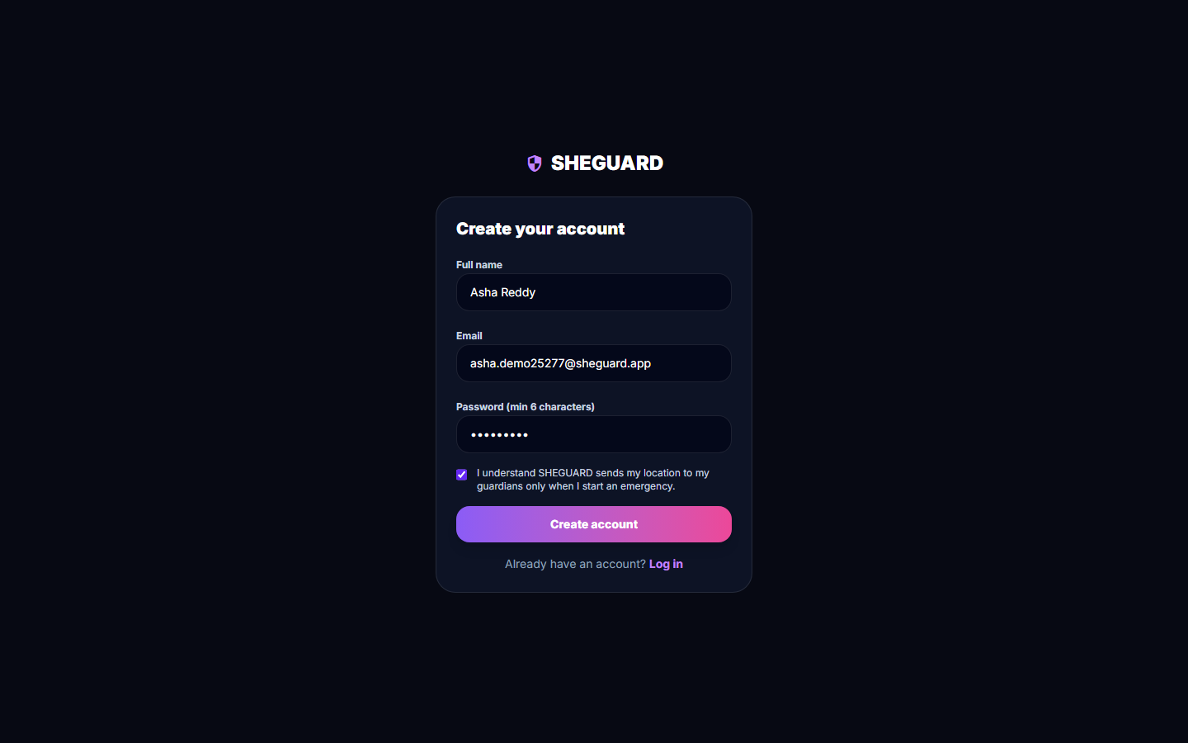  Fig. C.2: Registration form

Landing page. The public home page: "Get home safer. Alert the people who care.", the four-step explanation (add guardians, plan a route or keep SafePhrase listening, tap SOS or say the phrase, cancel with a 3-second hold) and the buttons Get started free, I have an account, Log in and Sign up. The small print states that route risk uses historical district crime data (2001-2012), not live conditions, and that SHEGUARD does not replace emergency services. The hero picture is an illustration shipped with the app.
Registration form. The Create your account form filled in for the test user: full name, e-mail, a password of at least six characters and the terms checkbox. The account was created through this form; the API answered HTTP 200 and returned a token and the profile.
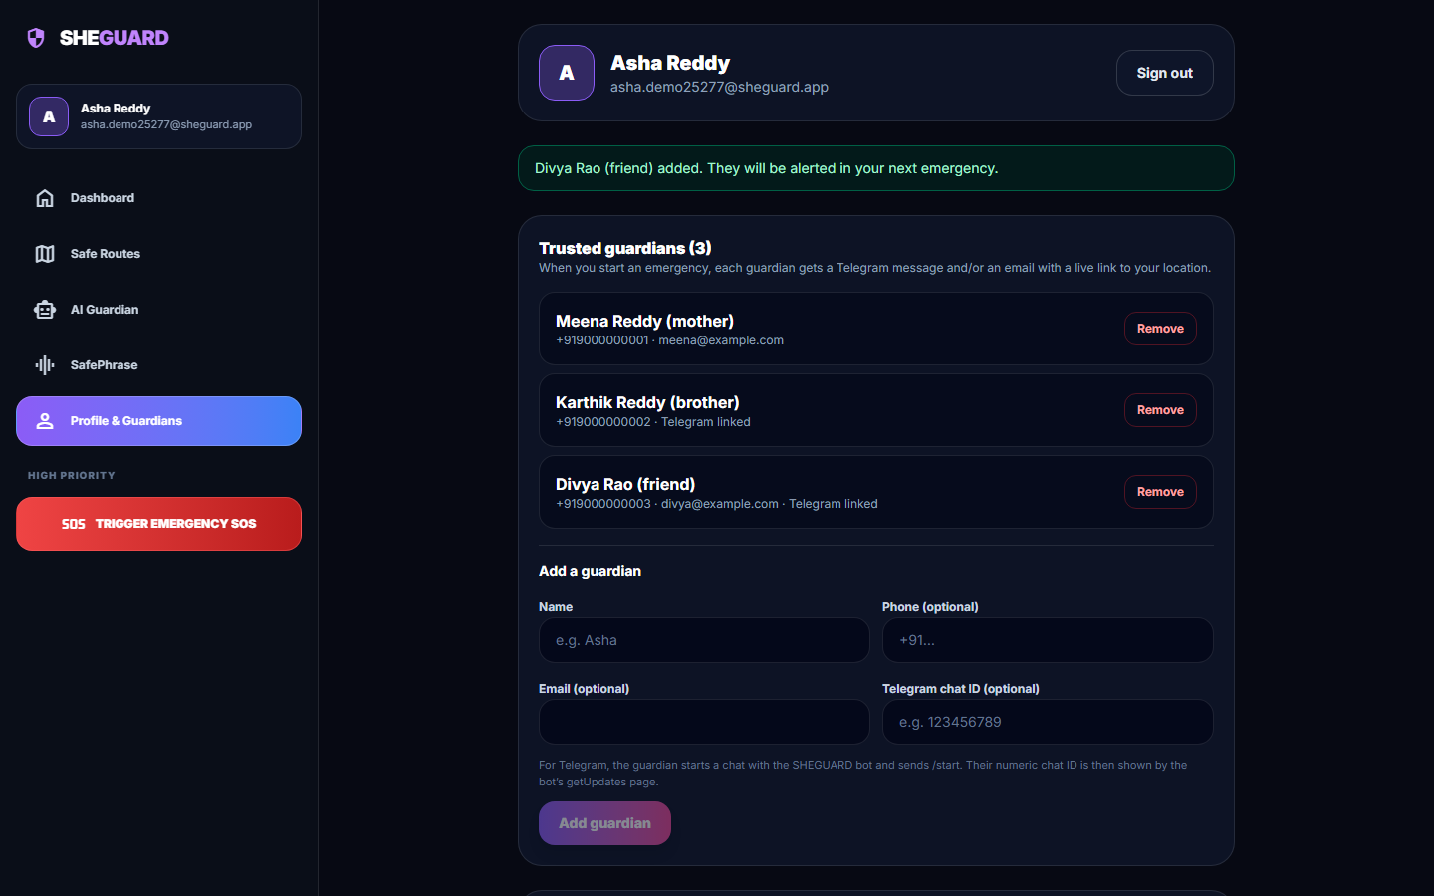  Fig. C.3: Profile with three trusted guardians | 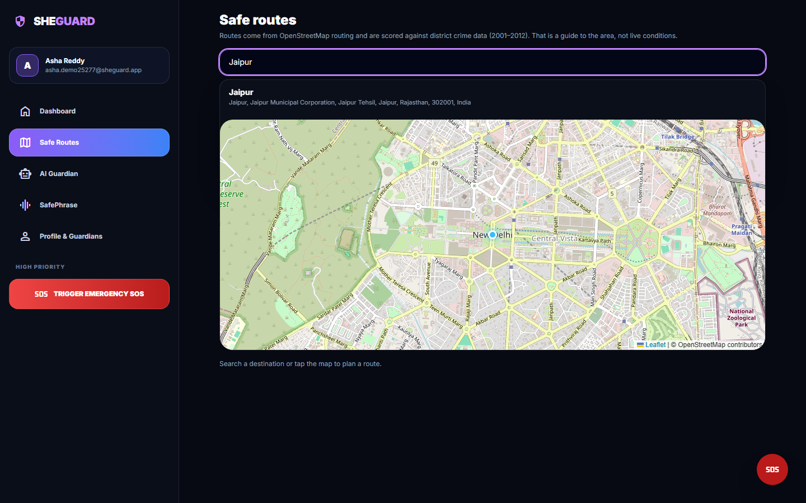  Fig. C.4: Destination search

Profile with three trusted guardians. The Profile and Guardians screen after three guardians were added through the form: Meena Reddy (mother, phone and e-mail), Karthik Reddy (brother, phone and Telegram chat ID) and Divya Rao (friend, phone, e-mail and Telegram chat ID). The banner confirms that the last guardian "will be alerted in your next emergency".
Destination search. The Safe Routes screen with "Jaipur" typed into the search box. The suggestions come from the OpenStreetMap Nominatim service through the backend (GET /api/places/search); the start point is the browser position (Delhi).
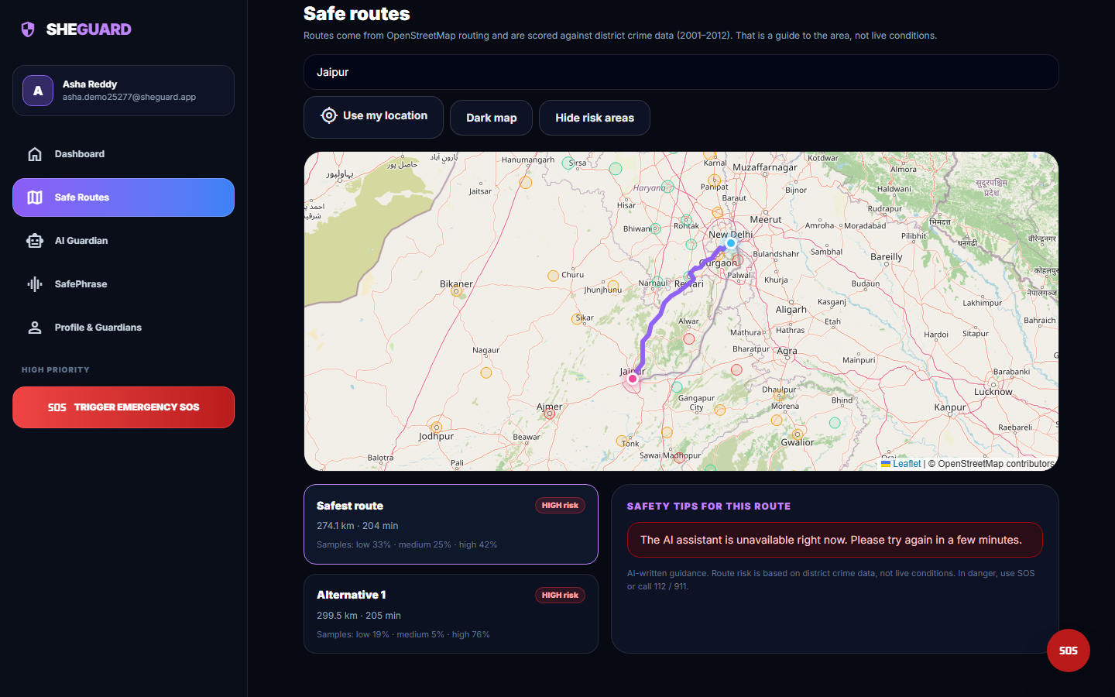  Fig. C.5: Route cards and the assistant panel | 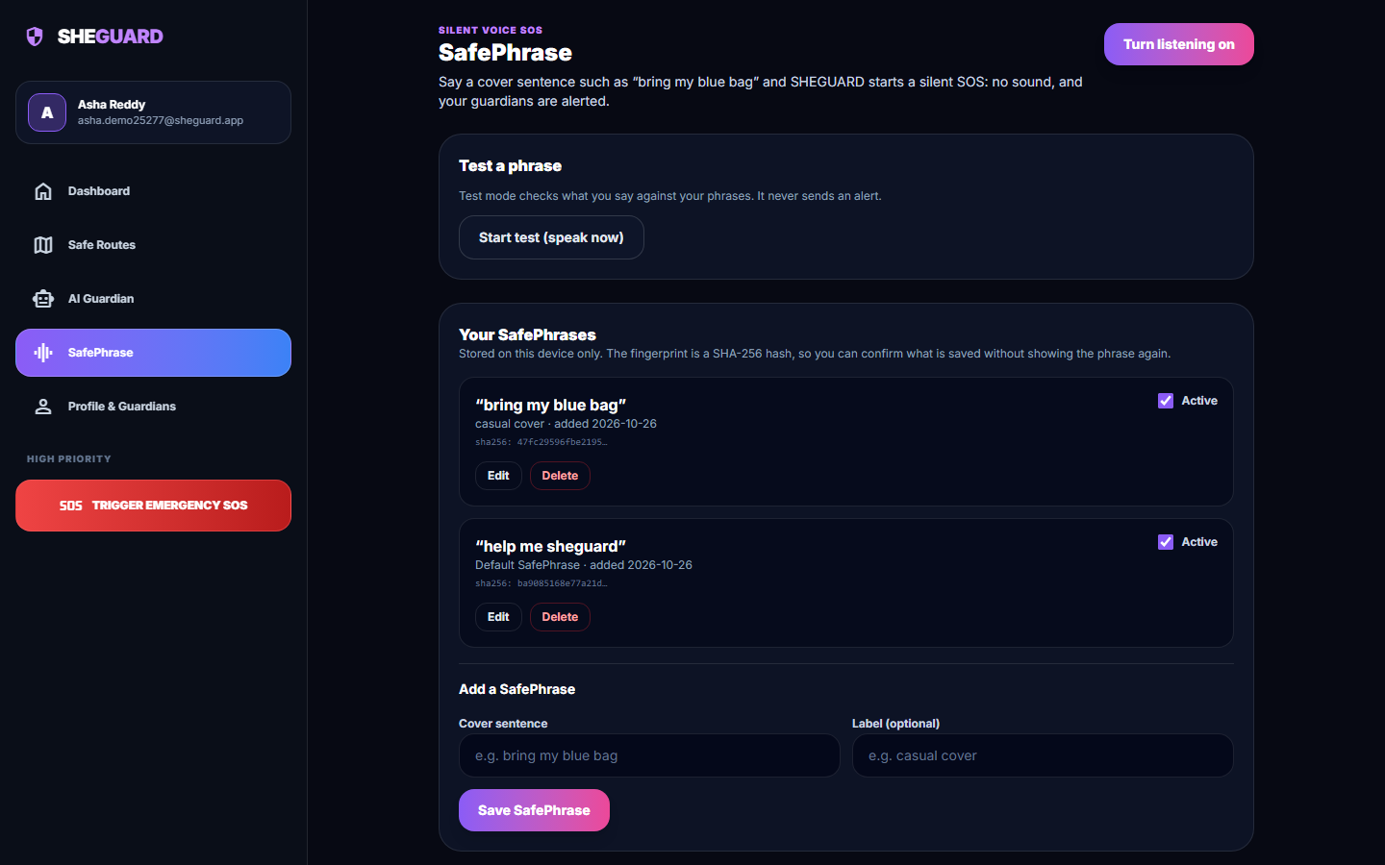  Fig. C.6: Second SafePhrase added

Route cards and the assistant panel. The same plan scrolled to the route cards and the "Safety tips for this route" panel. The panel would show Gemini-written advice; during this run the Gemini key's quota was exhausted (HTTP 429), so the interface shows "The AI assistant is unavailable right now. Please try again in a few minutes." instead of an invented answer.
Second SafePhrase added. After saving the cover sentence "bring my blue bag" (label "casual cover"): the list now holds two active phrases, the new one above the default "help me sheguard", and only the beginning of a SHA-256 fingerprint of each sentence is displayed. The sentences are stored in this browser, not on the server.
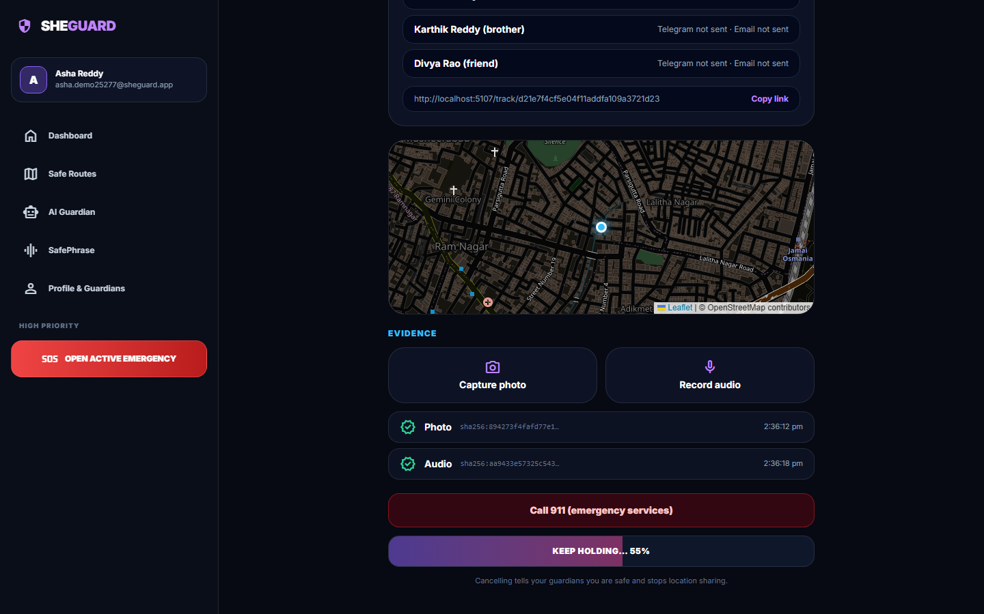  Fig. C.7: Hold-to-cancel | 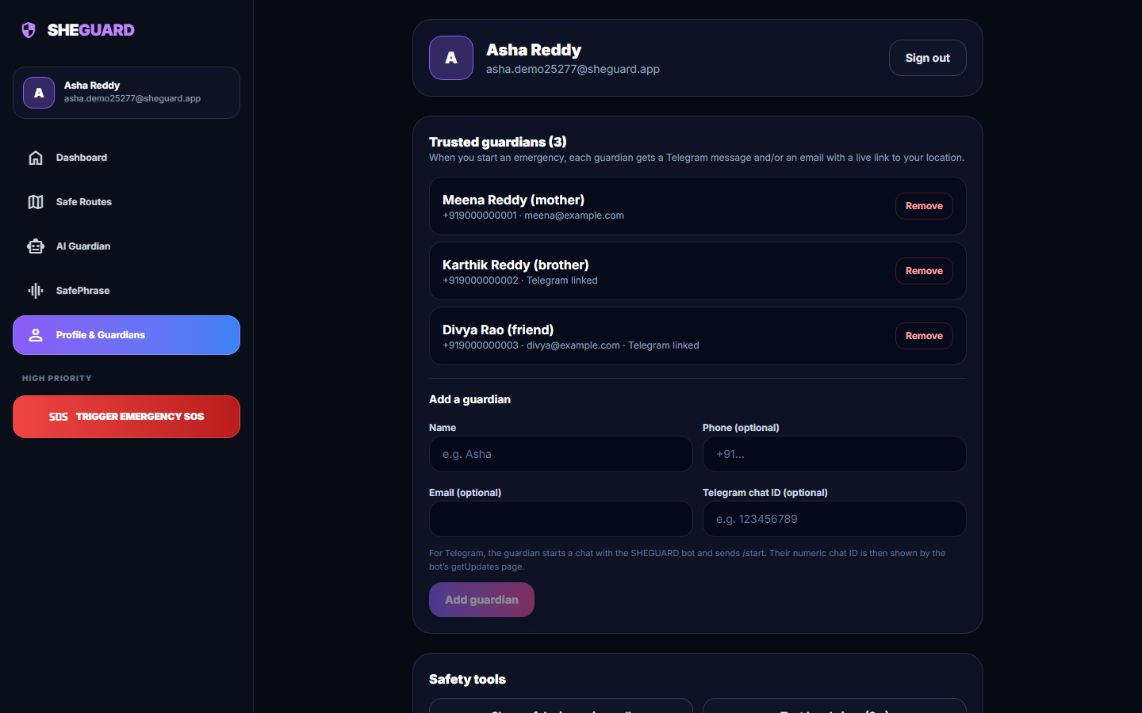  Fig. C.8: Profile with recent activity

Hold-to-cancel. The cancel button while it is being held: "KEEP HOLDING... 55%". The user must keep pressing for three seconds, so a stray tap cannot end the alert. The evidence rows and the call button are visible above it.
Profile with recent activity. The profile screen again at the end of the run: the account header with the Sign out button, the three trusted guardians with their Remove buttons, the Add guardian form (disabled until a name is typed) and, further down, the Safety tools section.

